Ethical hacking – linux

* Apps for taking notes on linux or other platform rather than windows.
* Onenote , cherrytree ,, keepnote.

Screenshot taking app for linux

* Greenshot

Networking information

--ifconfig basic command.

Ipb4 in 1991 and have four billion ip address.

Ipb6 is like unlimited ip address but no one uses it.

Anyting which uses a network interface have a mac address

Ether and first three pairs can be used to identify using mac address lookup.

Tcp – transmission control protocol – for higher reliability. – works on three way handshake. Syn > syn ack > ACK.

Udp – user datagram protocol.

Command – wireshark& -- opens wireshark which is a inbuilt tool for network traffic display.

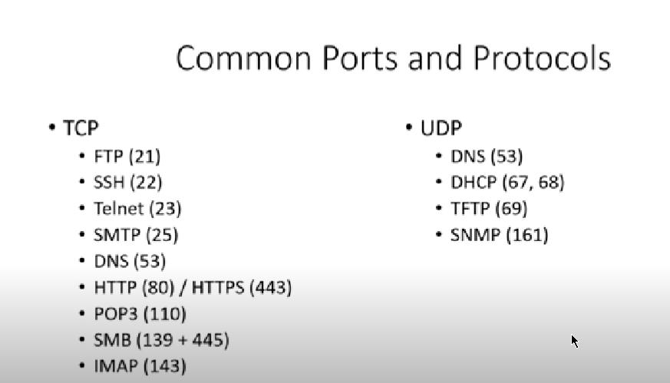

Osi model.------------------------------

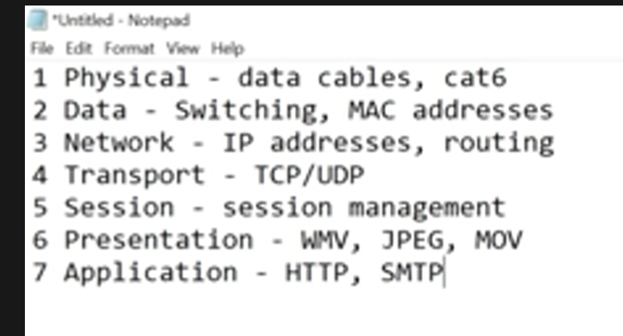

Please do not through pizza sausage away – way to learn,

Subnetting ---

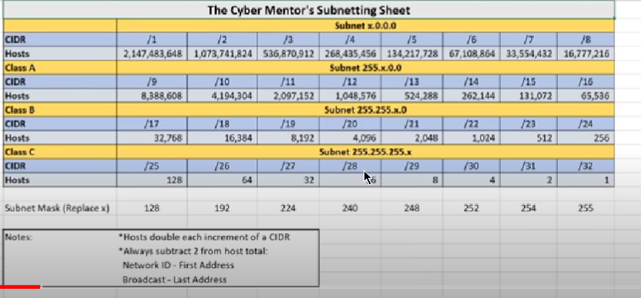

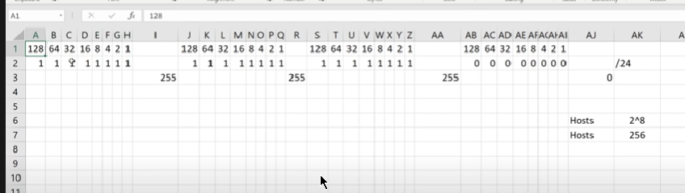

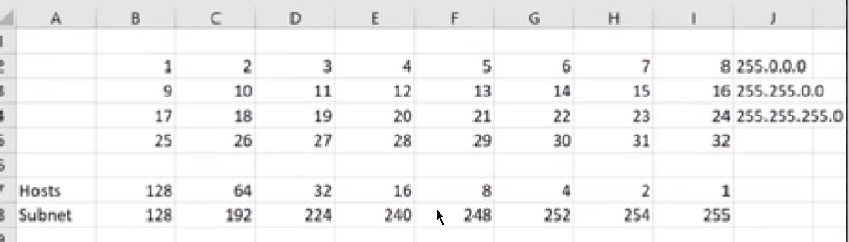

In this case how we calculate from the subnet that is – if we want to go 13 the first 8 bites is 255.0.0.0 , then next to 13 bites the subnet is 248—therefore the whole ip is – 255.248.0.0 . – this is a method to calculate subnet.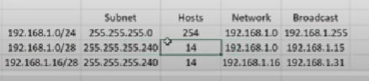

Ipaddressguide.com website for the ip address identification.

Ip address that start with 192.168 are private ip address and they are visible to us only or the user.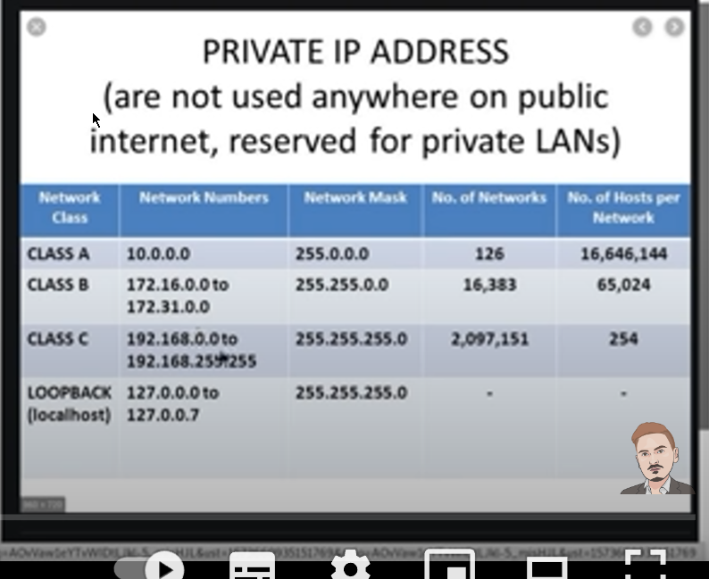

Common commands for linux networking---

Route – command – it shows the traffic accessing.

Netstat -ano -- detailed networking

Arp -a --command which is discussed before

Better commands or morden commands –

1. Ip a -- similar to ifconfig but better.
2. Ip n – similar to arp command.
3. Ip r

Other commands for installing python-pip command on linux

-apt install python-pip

-cd /opt

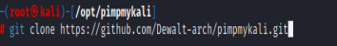

Cd pimpmykali

./pimpmykali.sh – this command will fix all the issues on python-3 which were solved by a programmer.

Mousepad <file_name> - -- is another text editor for linux

Intro to python in linux----

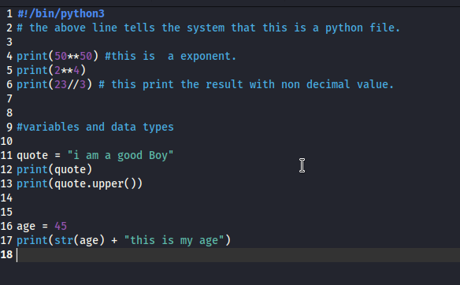

This is basic example of python in linux

And the tutorilas of thepython programming

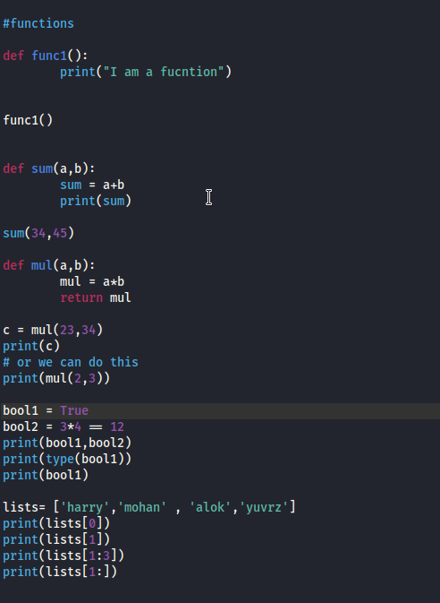

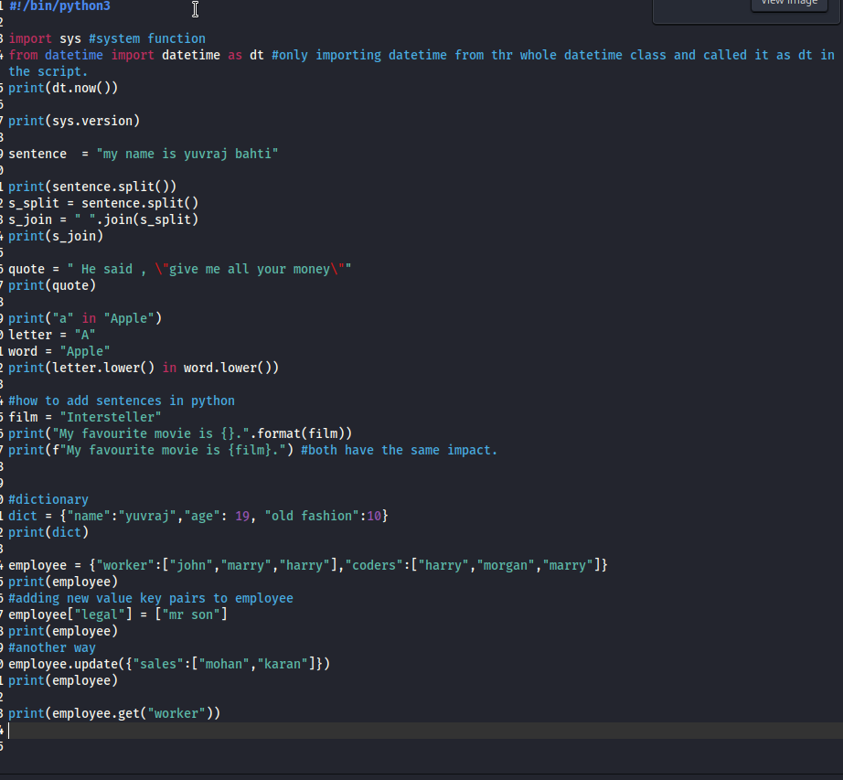

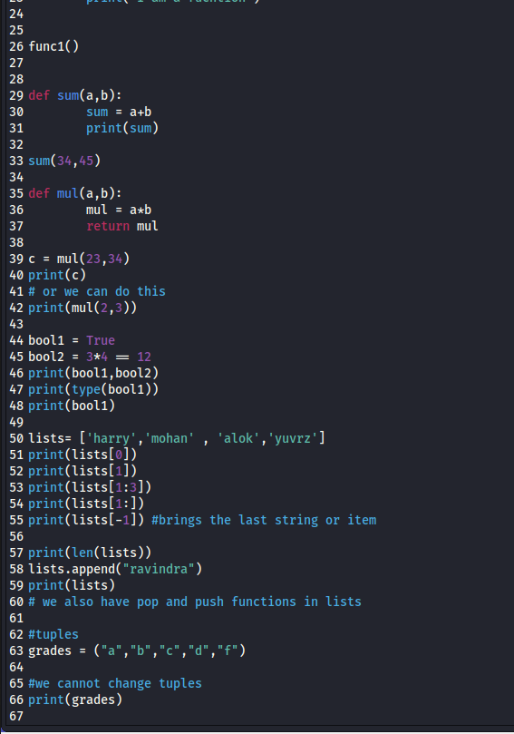

* The first command tells the system that it is a python file.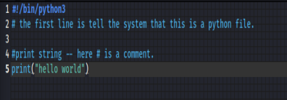
* And then we can run the file with the command
* Python3 <file_name> .
* But to make gedit run in a loop we run the command
* Gedit <file_name>& .

Socket in python

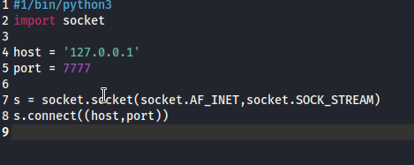

And then run the command nc -nvlp port_name

Making a file scanner.py

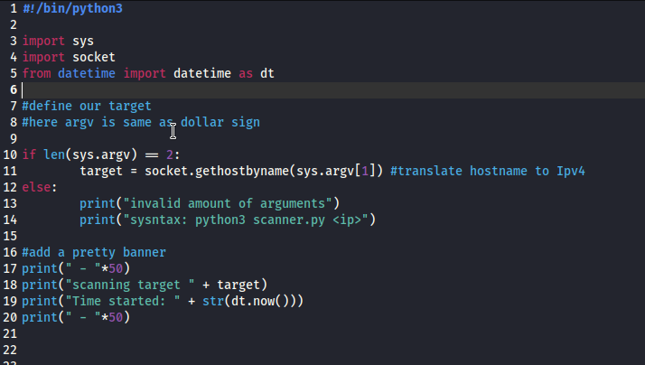

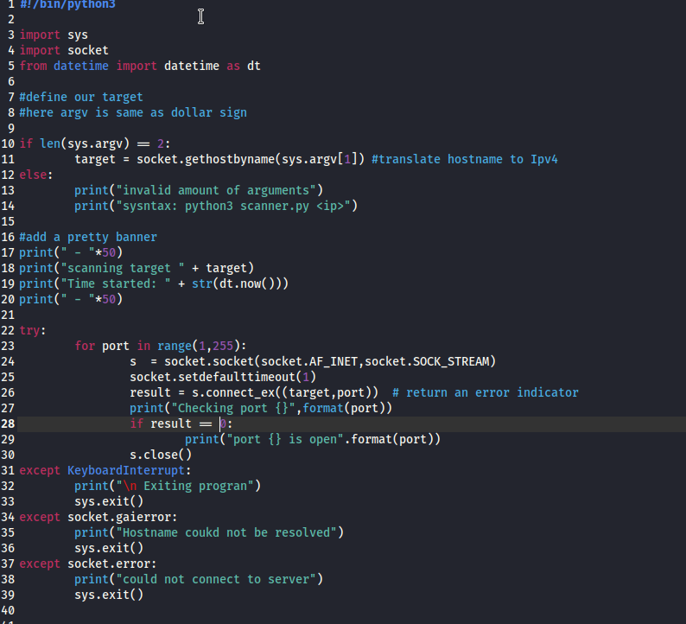

Ethical hacking begins.

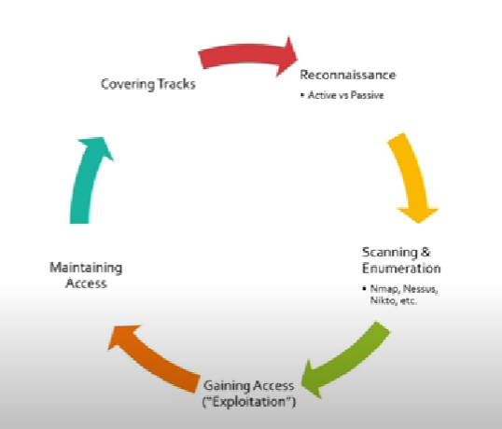

1. Information gathering (reconassiance)
2. Scanning & enumeration
3. Gaining access
4. Maintaining access
5. Covering tracks

1.information gathering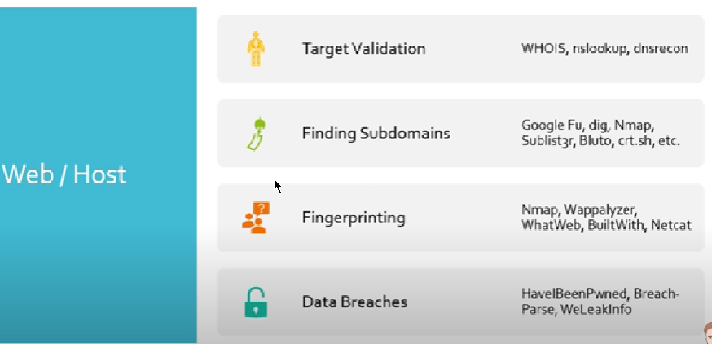

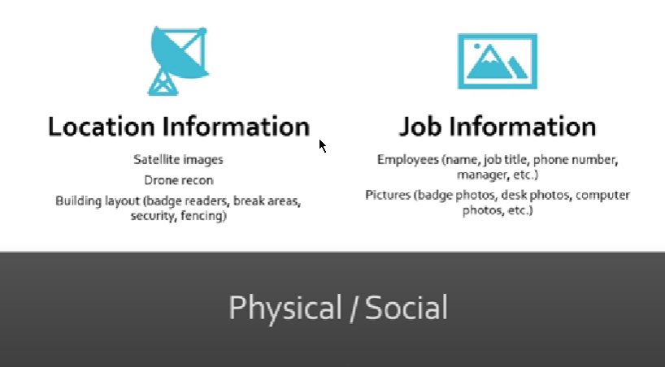

Bugcrowd.com website for attacking practices and they also pay for some infor.

* Discovering email address.
* Hunter.io website which provides searches for email address and it provide 100 searches per month free and then charges money
* Phonebook.cz another
* Voilanorbet.com
* Clearbet chrome extension for finding out the emails
* Email hippo for identifying that the desired email is correct or not
* 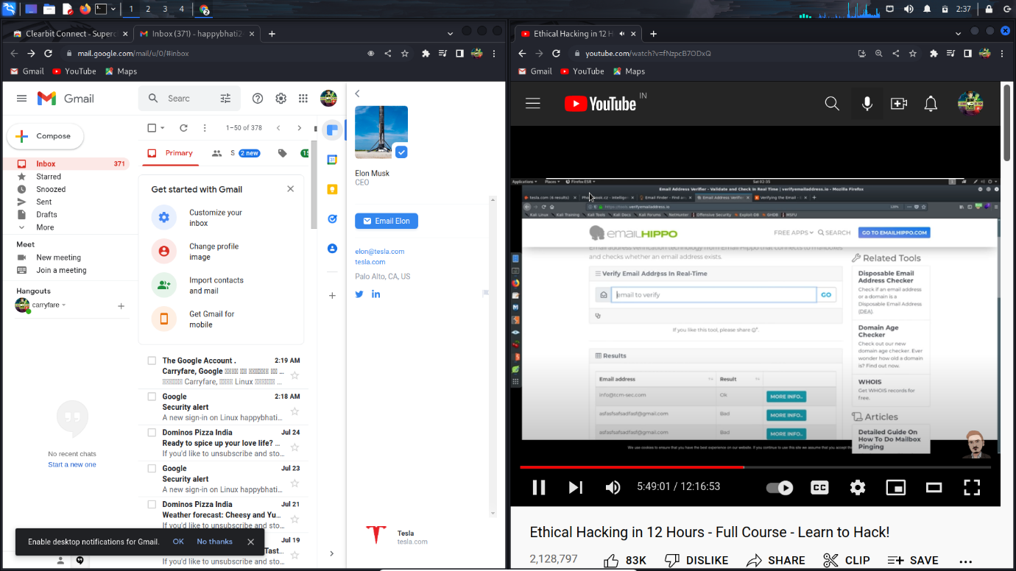
* 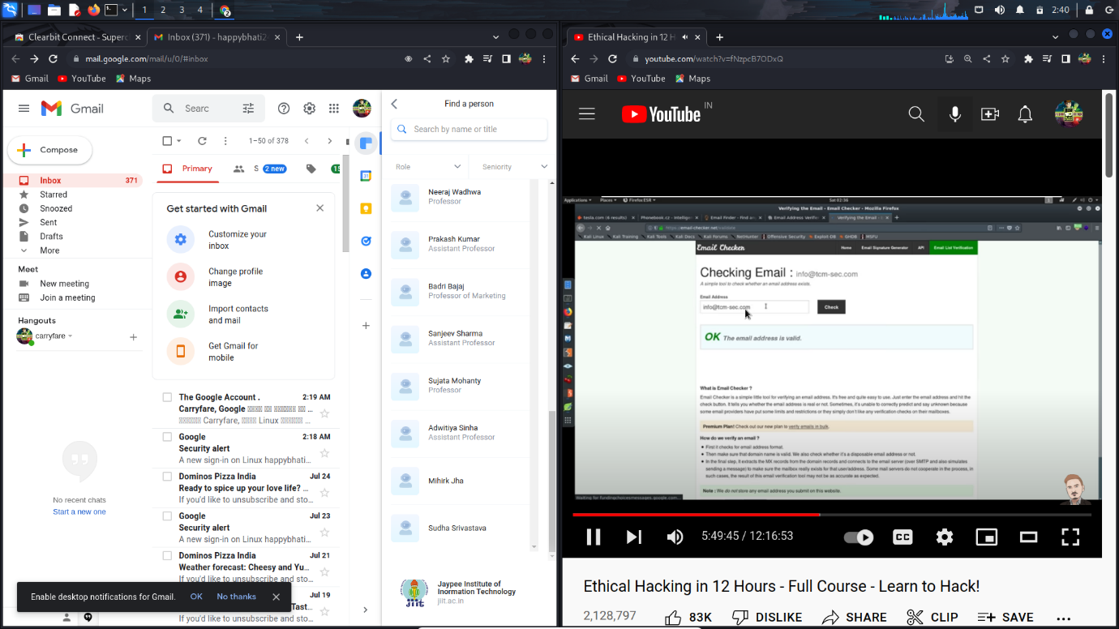
* Ctrl ++ command to zoom in the terminal
* After verifying the email you can go on google and login in by forgetting the passwd now we will get a linked account details like first name initials and the domain intials now from that we need to identify the user.
* Heath(cyber mentor) has the breach-parse tool on git which we will use .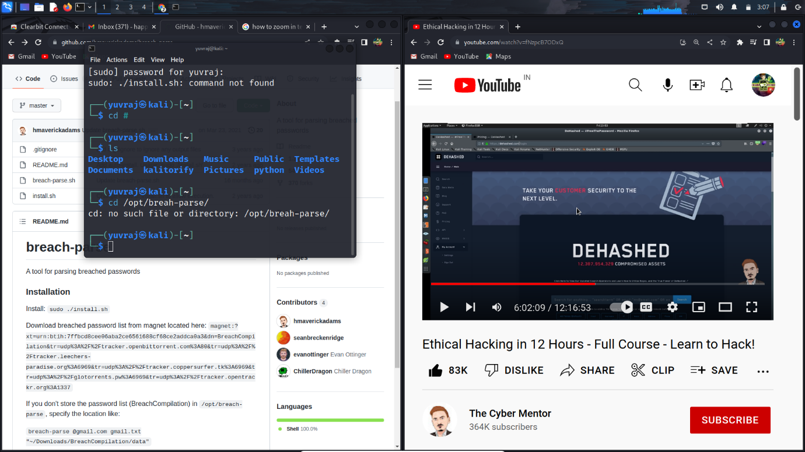
* 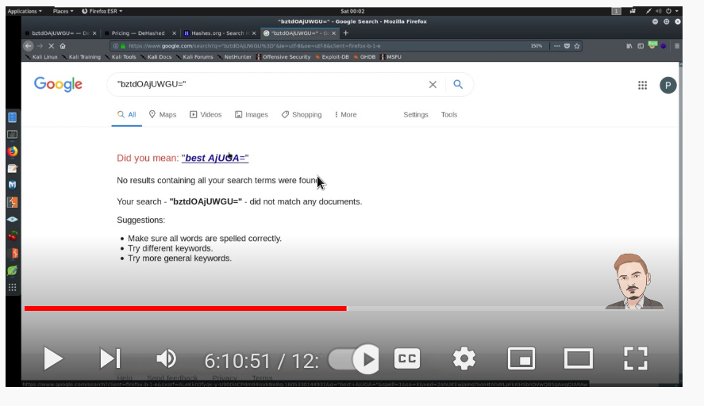
* Hashes.org can be used to verify the hashes are real or not .
* Dehashed is a website which helps to get info about email and passwd but it is not free.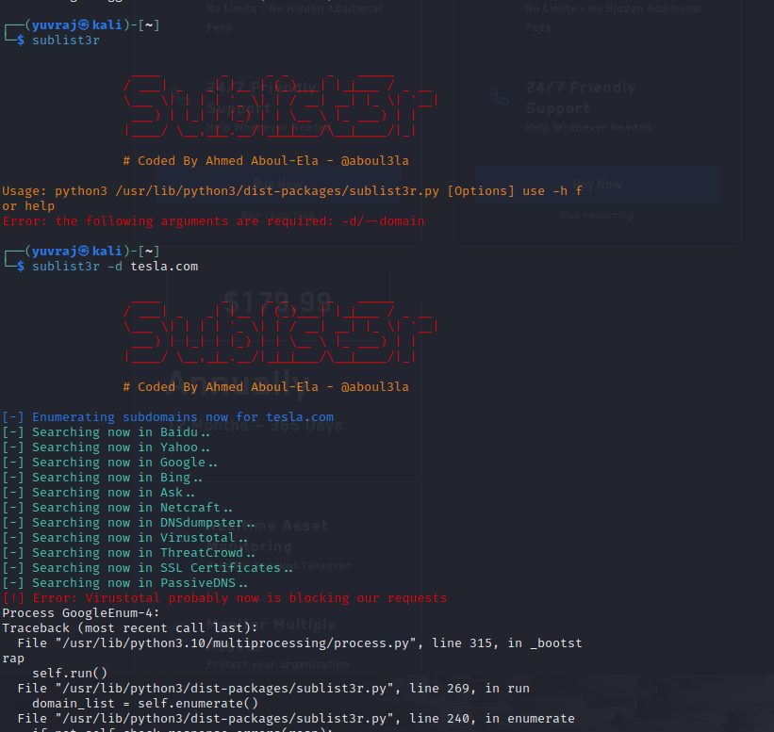
* It is a tool to get the subdomains info.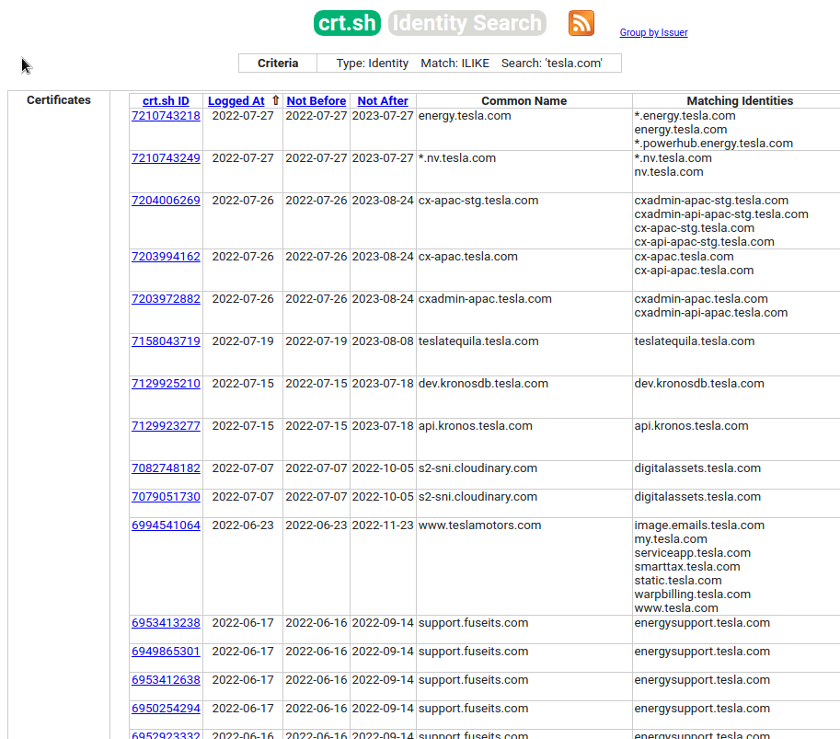
* Crt.sh is also a website to get the su-domain and sub-sub-domain.
* 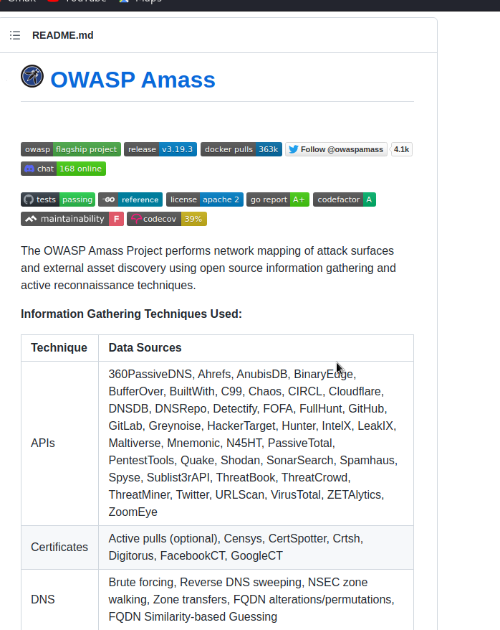
* Owassp amass is another tool for finding domains and emails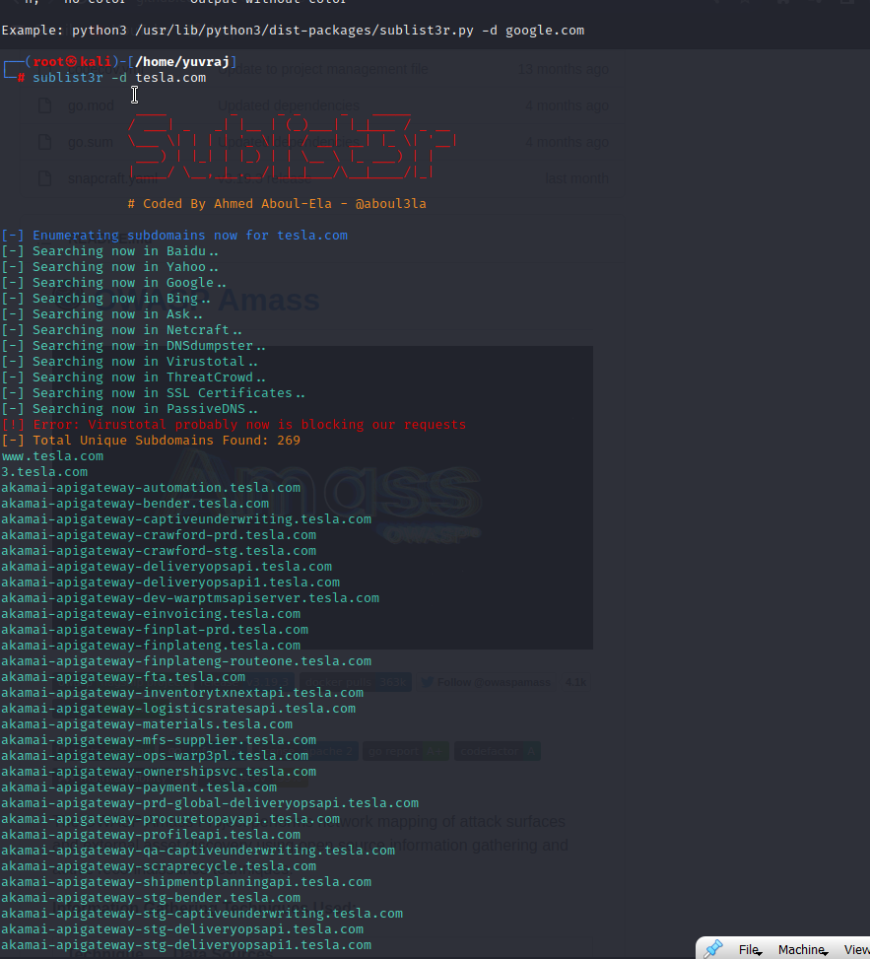
* The results as you can see sublistr provide us with number of domains for the hack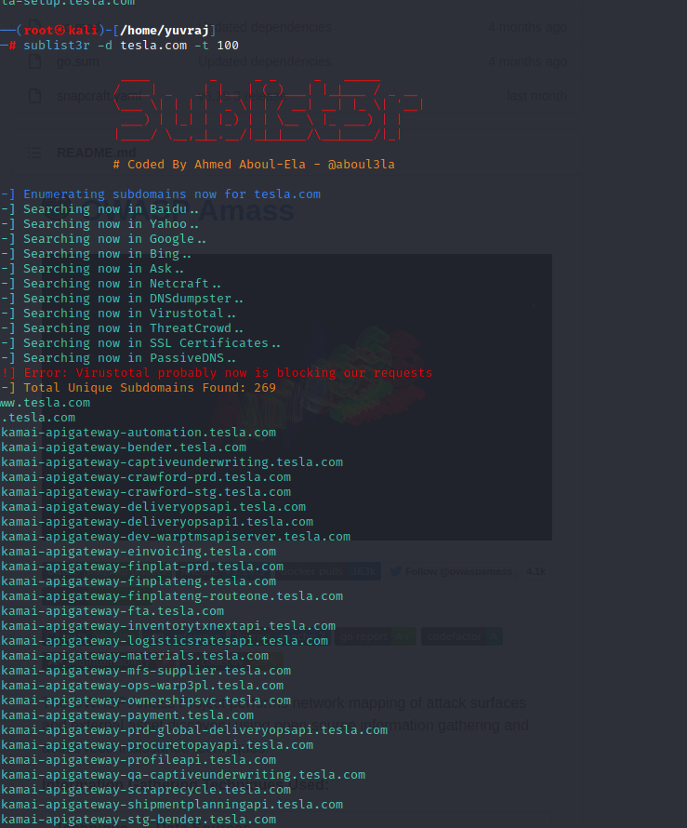
* 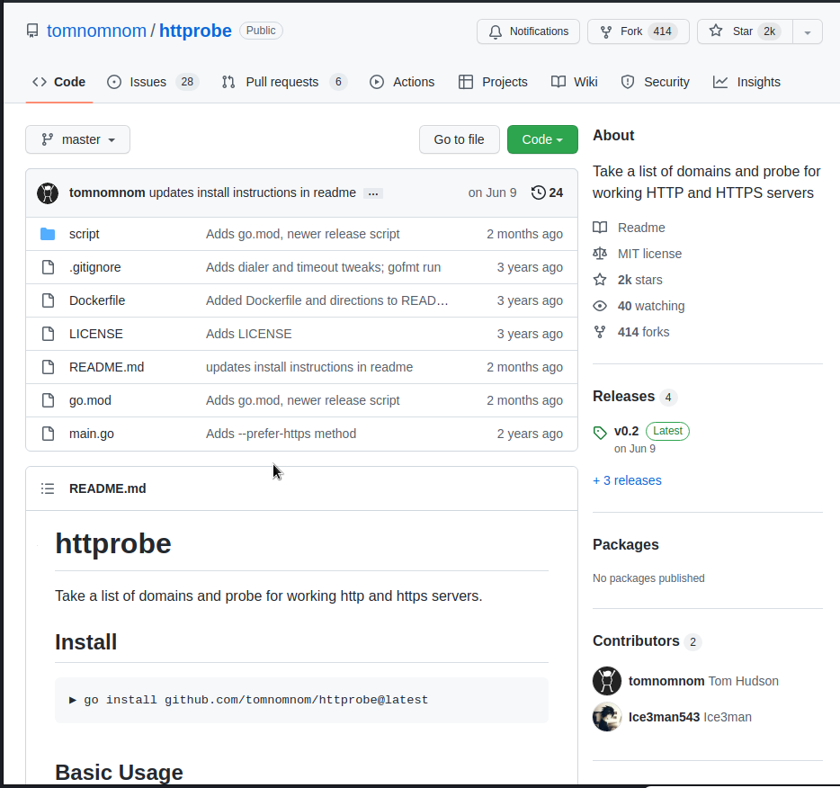
* Tomnomnom httprobe is a tool which when provide list of domains will give us that which domains are of use or alive.
* Builtwith.com is a website which tells us that the domain or website we search is associated with or using technology of other websites.
* This is a chrome extension and used to detect all the technologies associated with the website instantly.
* 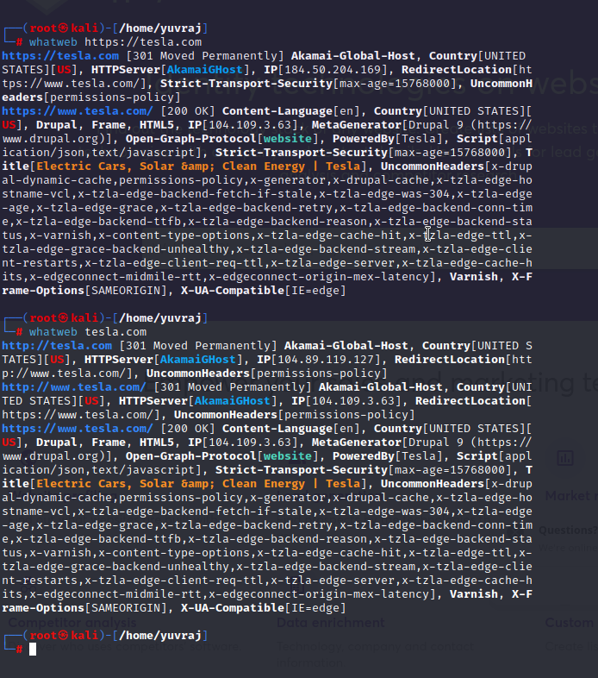

Whatweb is inbuilt tool to get the info about website technology.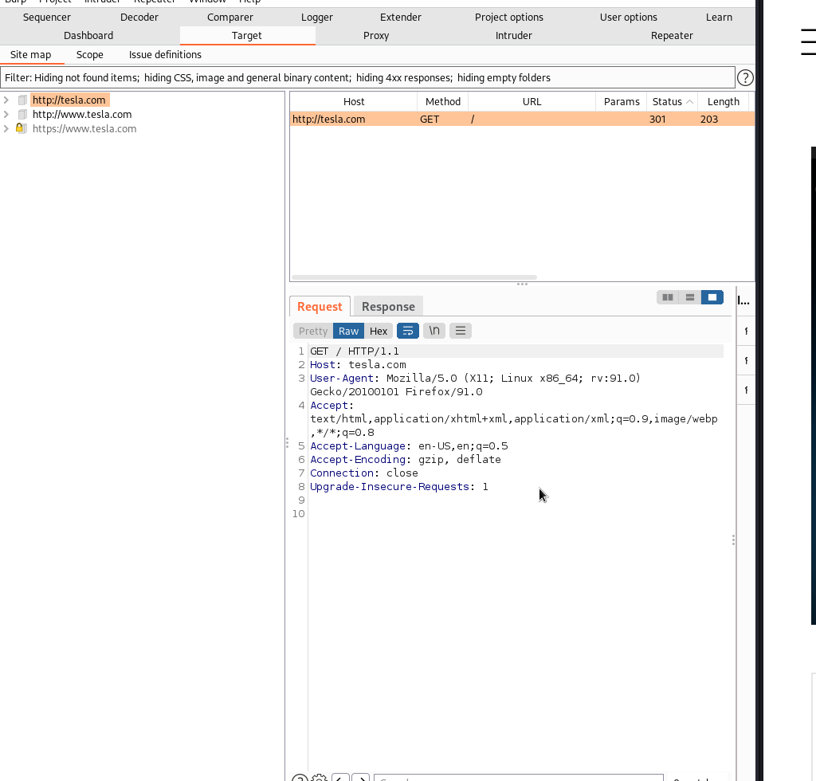

Burpsuite a website which helps us to test the security of a web application.

Better way to search on google.

A search which neglects all the www stuff

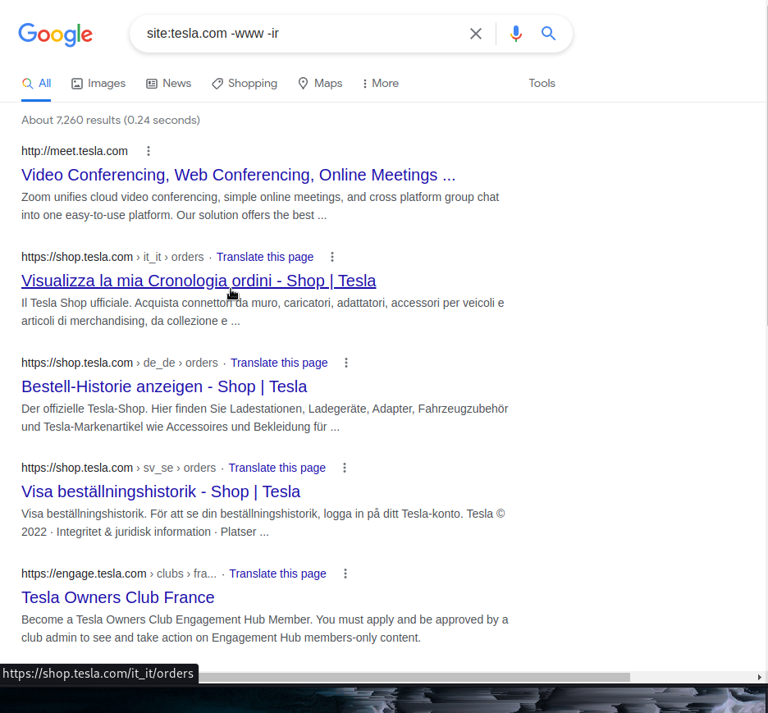

A search which neglext the ir.

For more go to google search syntax – and you will understand how to searhc advance from google.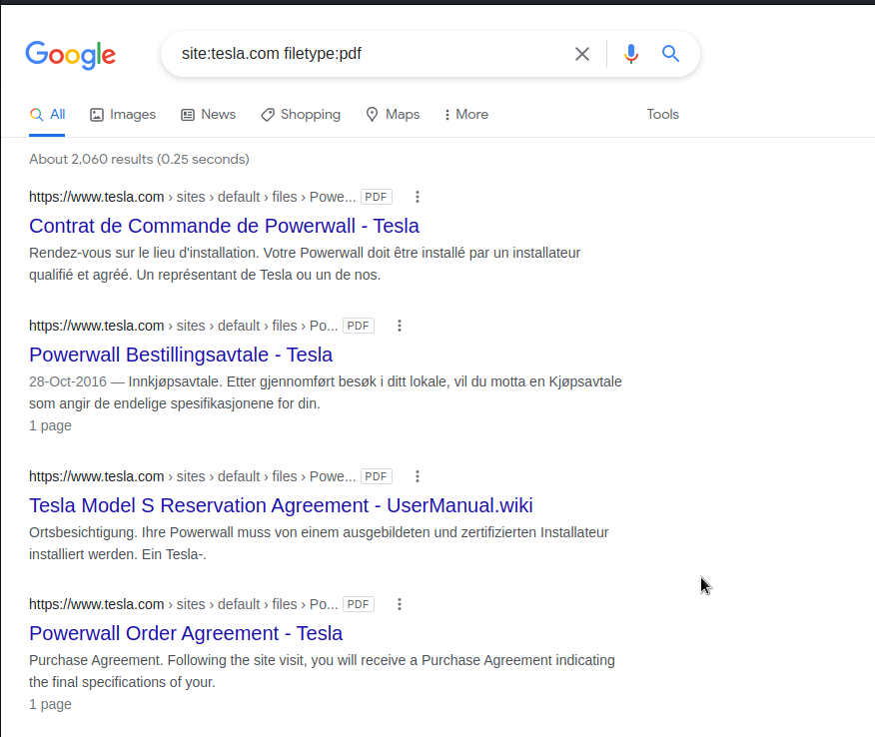

Filetype is a search which brings out the specific file we want.

Next step is to check the leads on social websites where you can find any important information on any photo or something from the company employee account and dig deep to get the info.

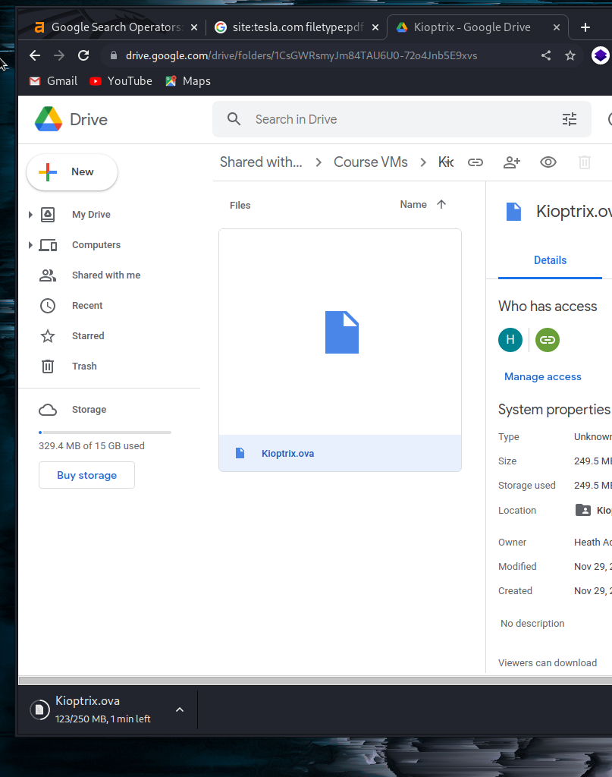

Next we will download kioptrix and run it on virtual box.

After downloading kioptrix and running it on a virtual machine

-these are the following command we will look into.

1.Arp-scan -l on linux for scanning of the ips

2. netdiscover -r <ip>(our initials).0/24

3.enum4linux <ip> -- this command will tell you everything about the ip you added.

Misllineous commands----

1.tilix – it is a command which provides multiple terminal at the same time.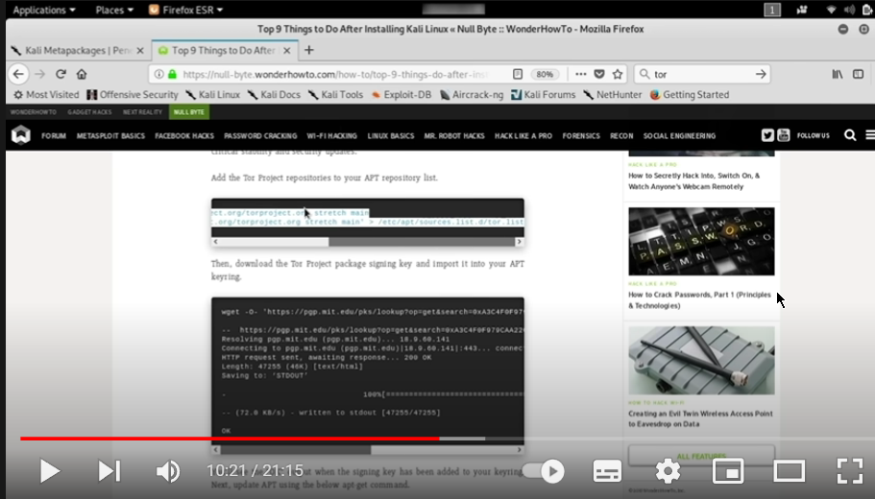

This 9 things are essential for new users so that to protect themselves from cyber attack.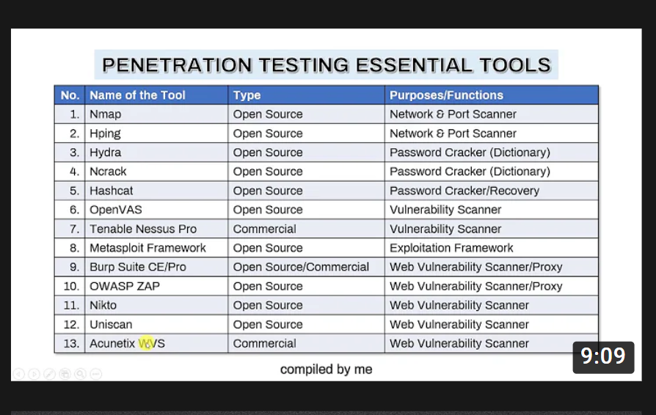

Other commands----

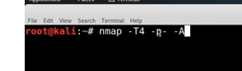

Here nmap is a command for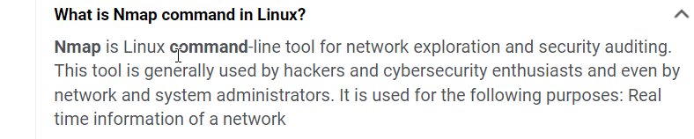

Here T4 – is for speed purpose.

For more details just do man nmap.

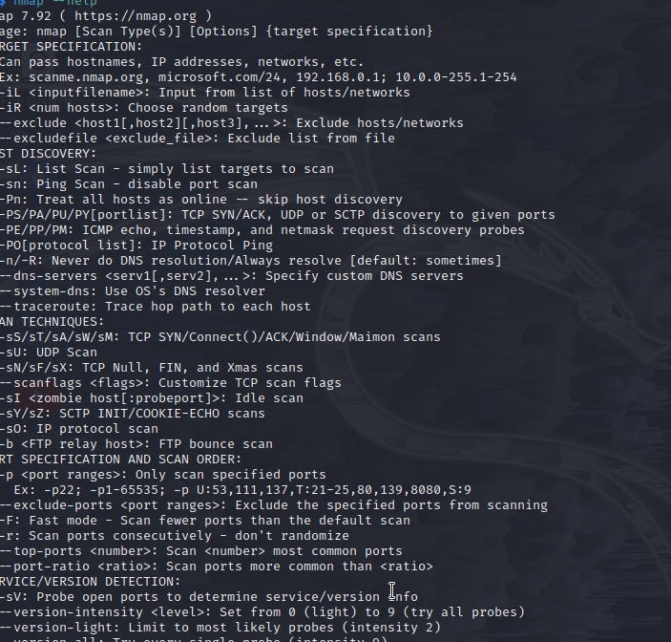

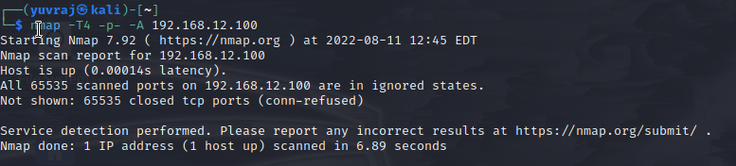

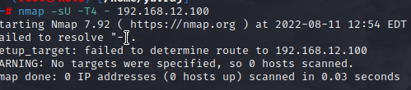

* Note we need to switch to system proxy settings in the firefox so that we can run the browser smoothly.
* 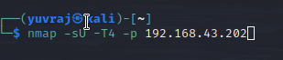
* Udp scan takes forever that’s why we remove A and and – from p.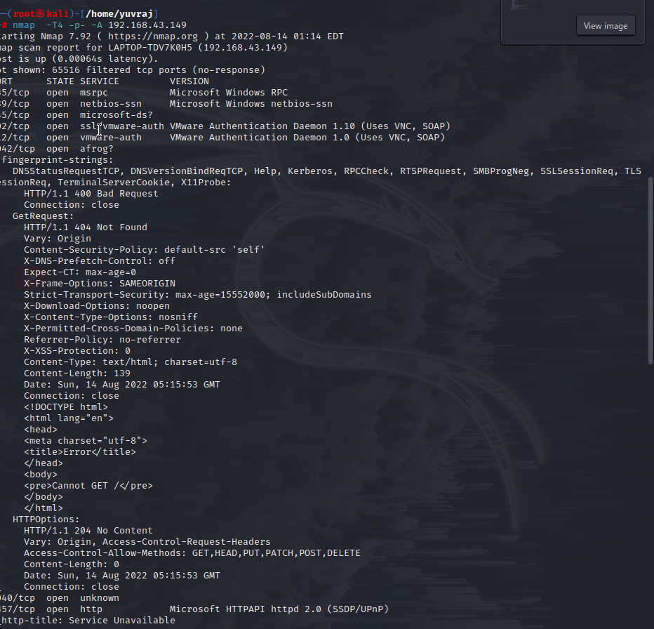
* This is the nmap scan of our ip address my laptop address.

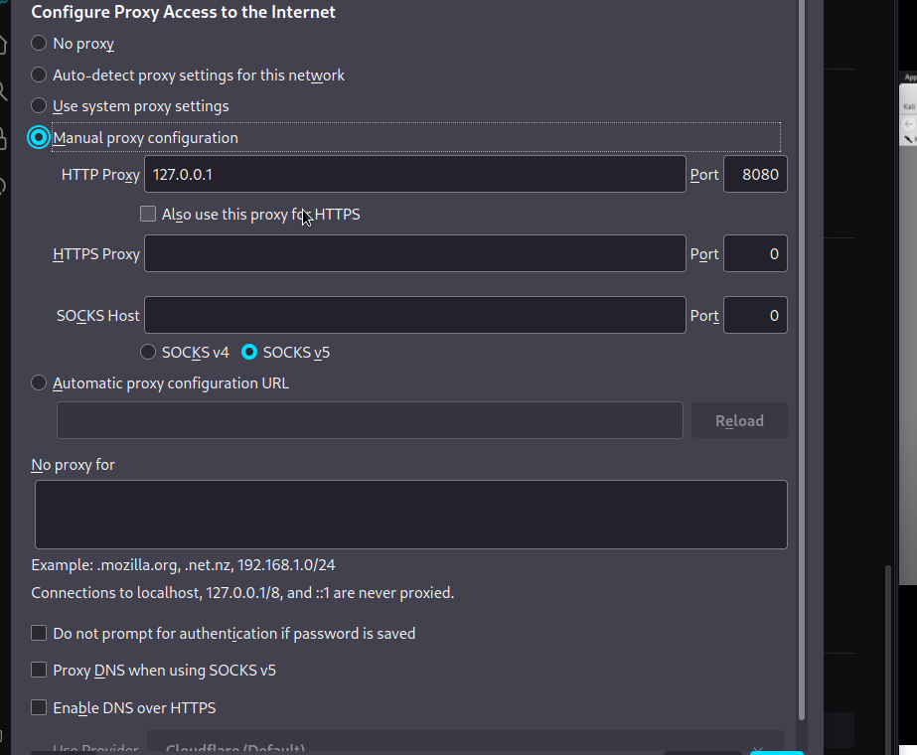

We did a manual proxy on the firefox before so we are now changing the settings so that the search go smooth.

Note take good notes of all the open ports you see while the nmap scan.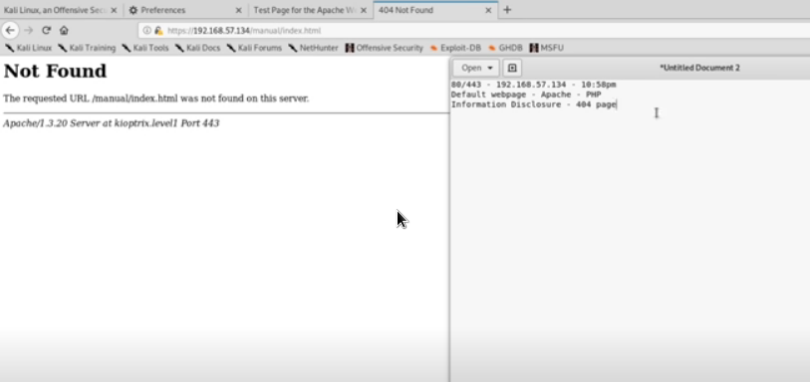

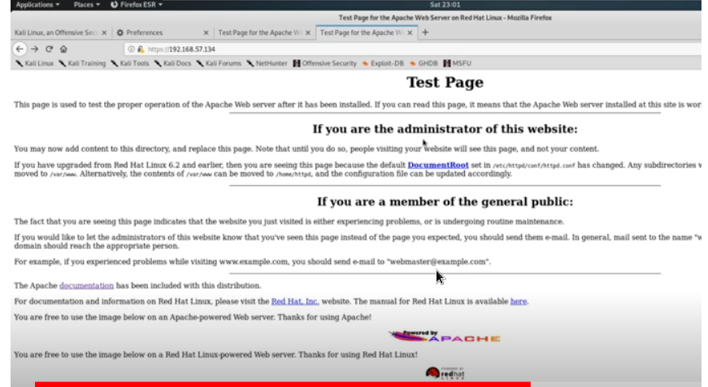

It’s the screenshot of the cyber mentor screen ,,he opened the ip which he did a nmap on and checking for a website disclosure.

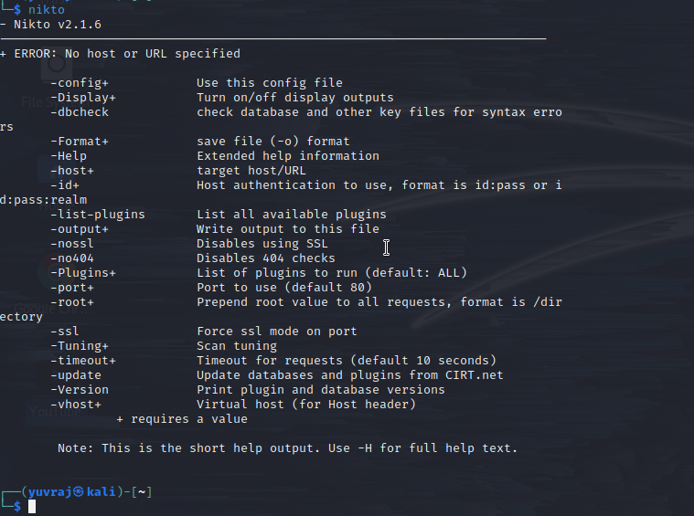

It’s a tool helpful for smaller websites or finding exploits in websites having lesser security.

Ex-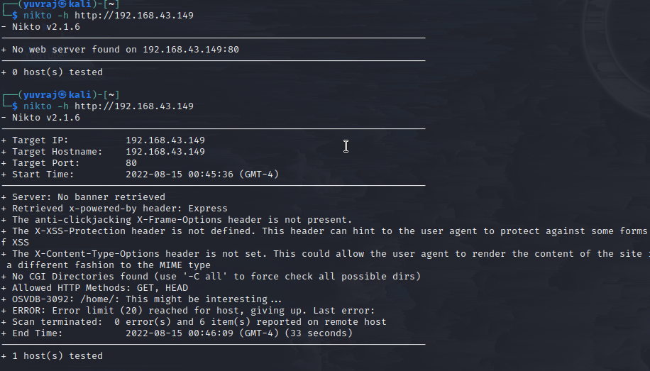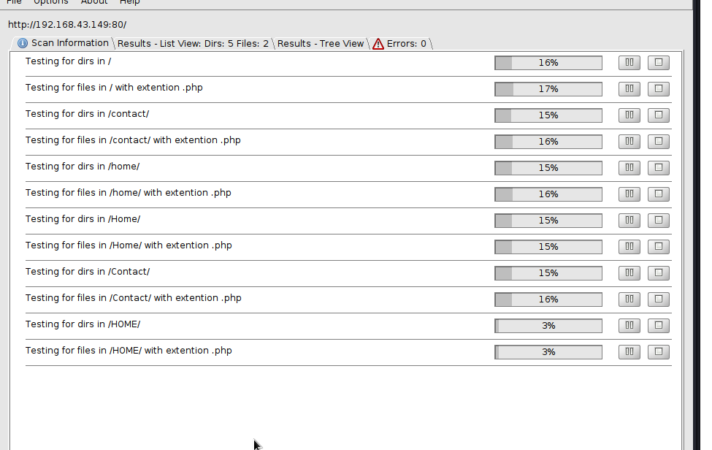

The picture above is the result view of the scan.

Now we will check the tree view—

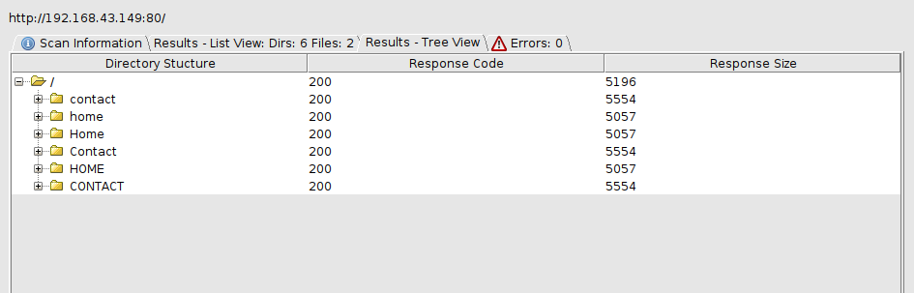

Note – burpsuite only works when you change the proxy settings to the manual.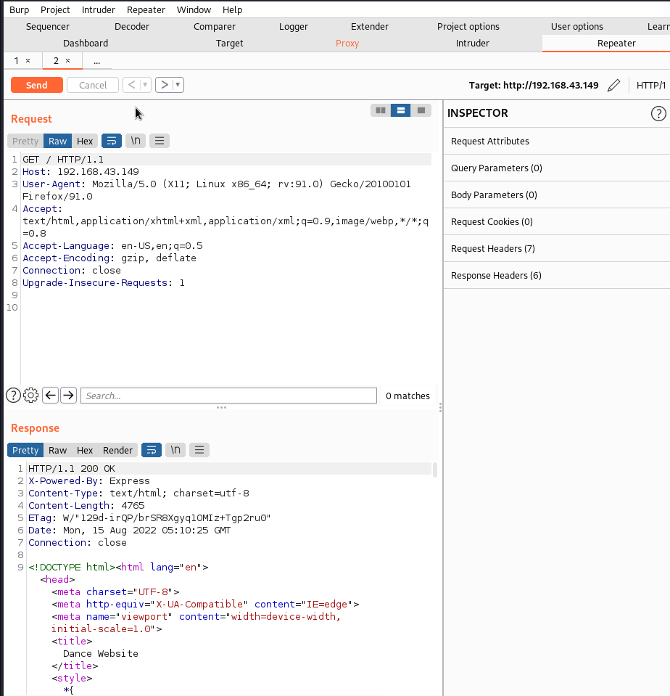

This is burpsuite repeater--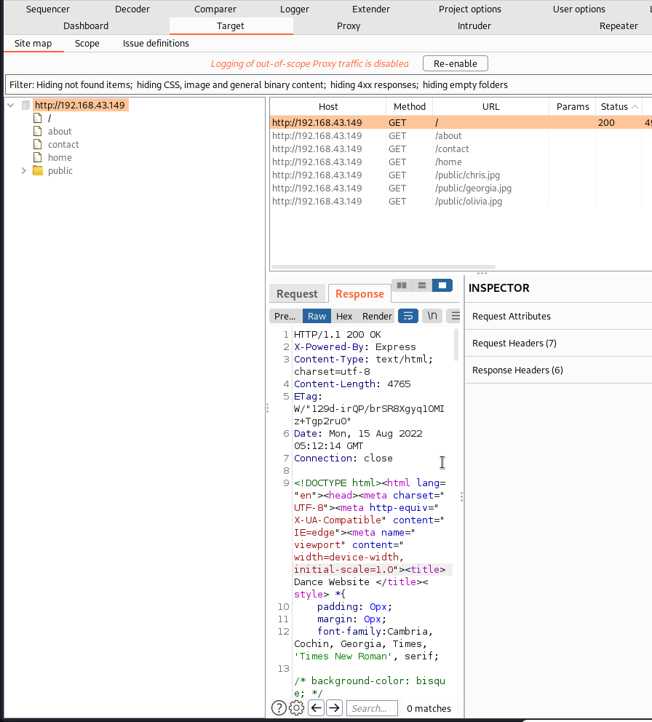

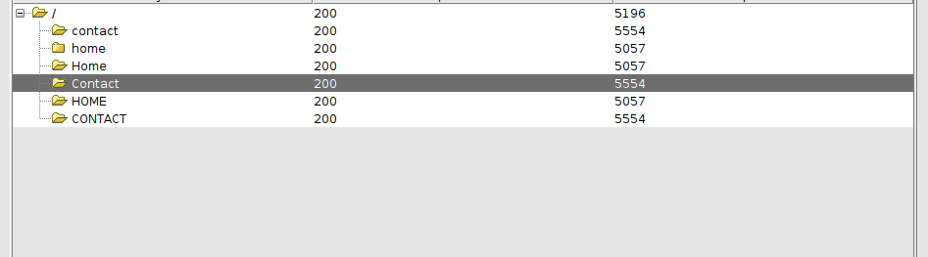

My website doesn’t have much info but when you go in the tree section in dirbuster you can find many important data that can be useful for our exploitaton

Note- smbd file is mostly used in work environments or when there is someprintig of the efile.also in internal environment.

Metasploit ---------------- --

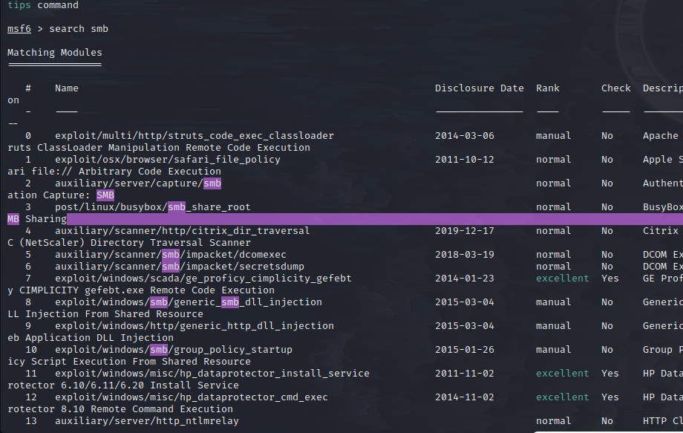

For searching anything and when you search please rember the sn no of the module or the serial number.

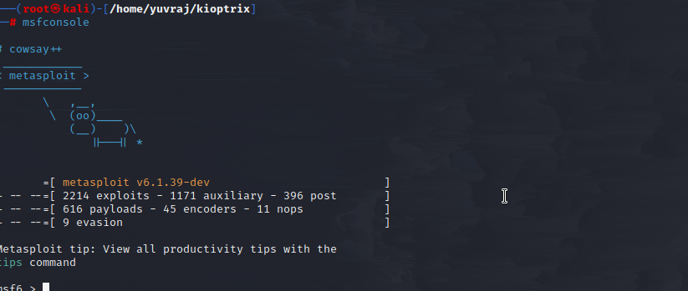

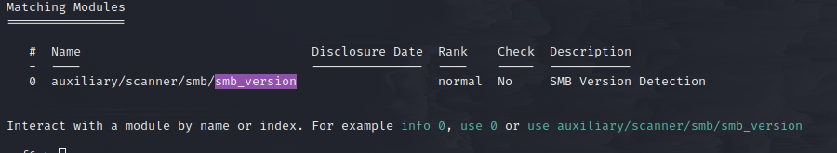

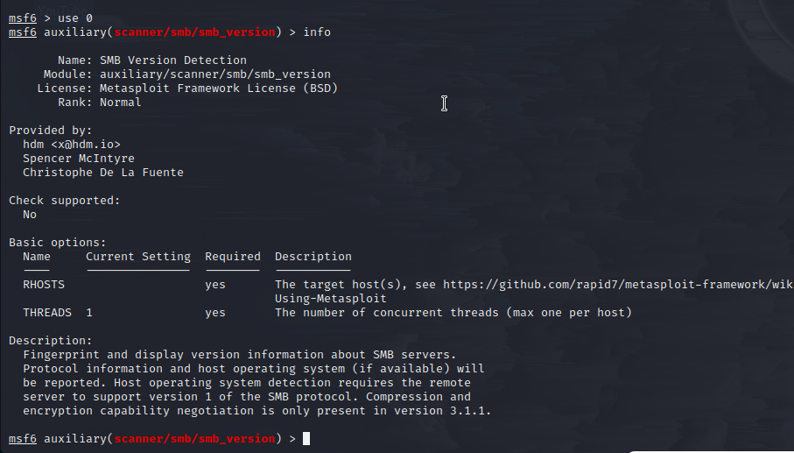

This how we use the modules.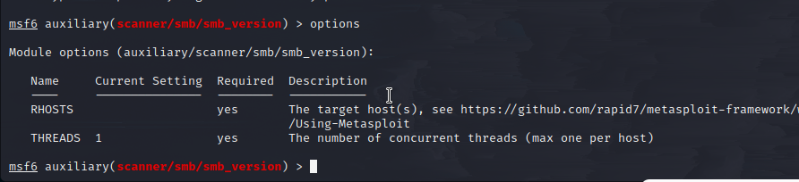

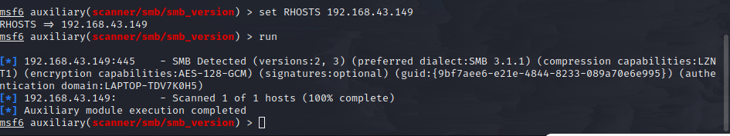

From this searches we get the smb version info--.

This is another tool called smbclient--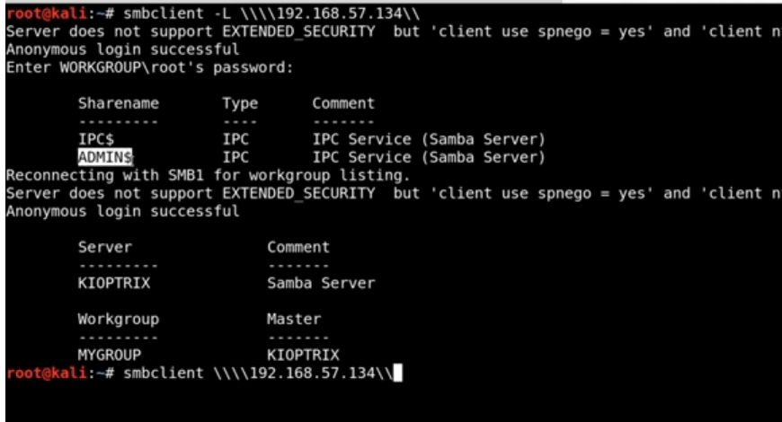

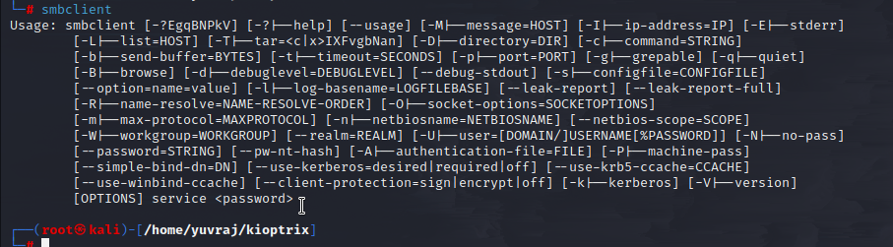

This is my website scan.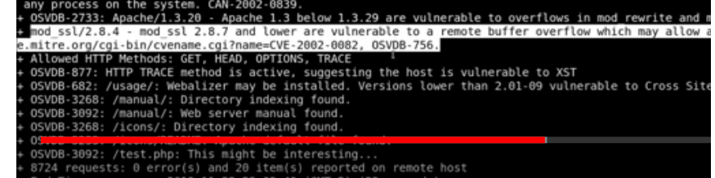

Vulnerable scan.

Note – dirb,dirbuster and gobuster are the tools from which we will use in future.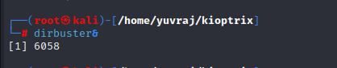

--- dirbuster—

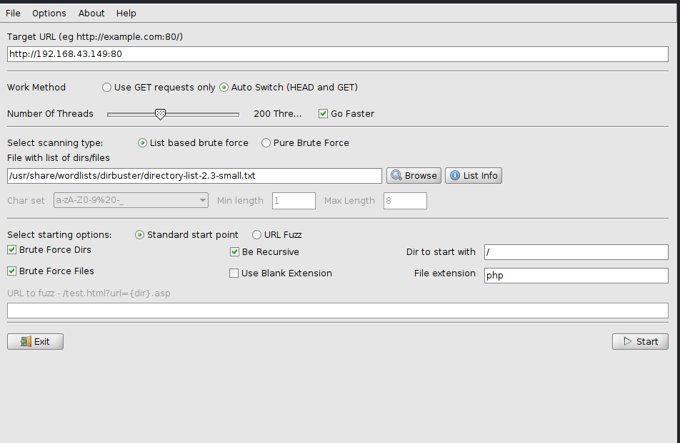

This is what dir buster looks like and in the list option the path given to the dirbuster list of directories.

------ ---- ssh ---------------------------------\

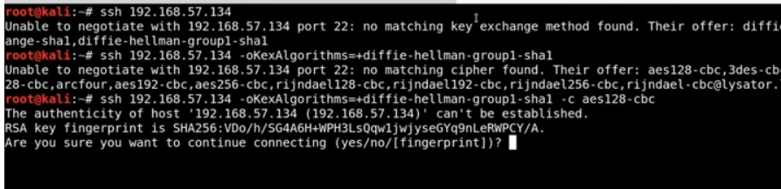

We did this because we are looking for a banner which can give us some small details.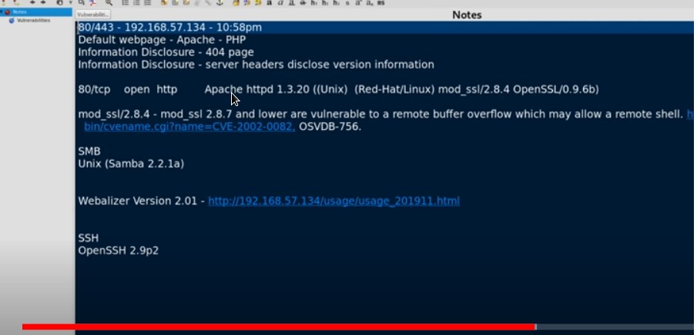

Now what we do is that the notes we ehave taken of some expolits now we will search them.

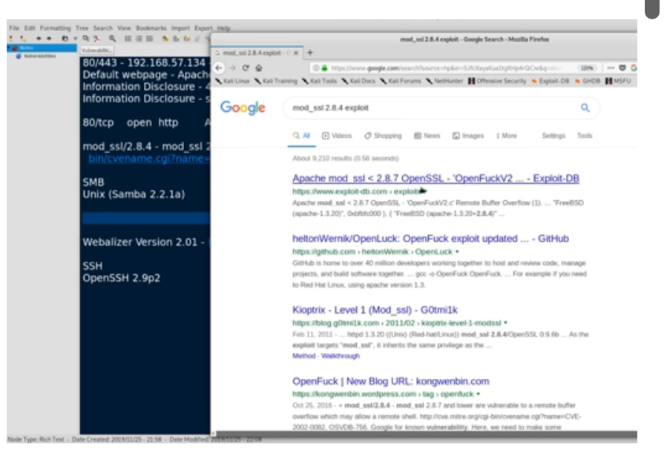

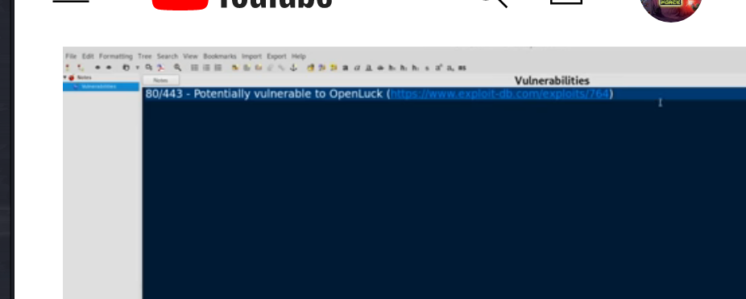

We should take notes after the search.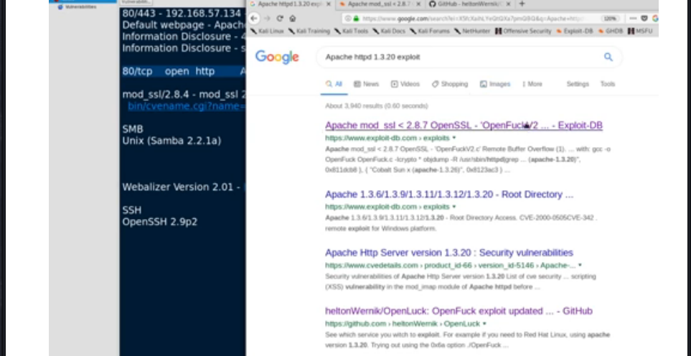

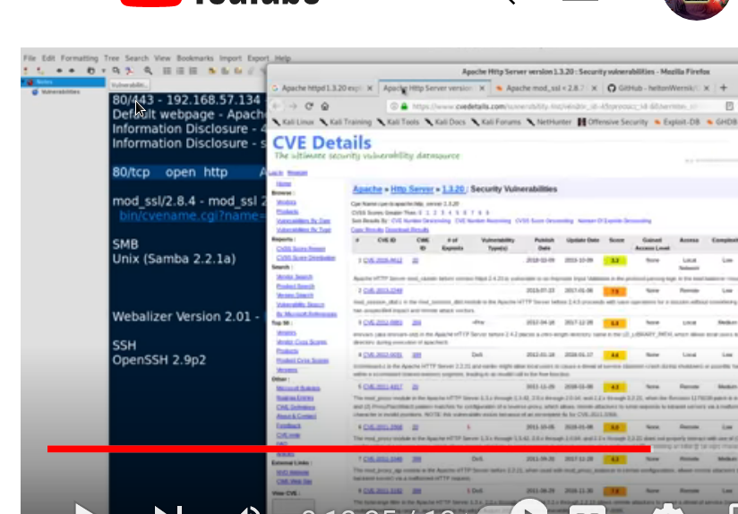

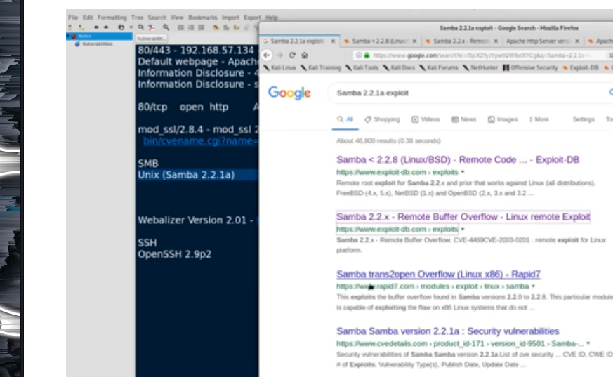

If you don’t want to search from google for some reason than there are some linux tools which are capable for the serch on terminal.

Note – you cannot be specific with searchsploit.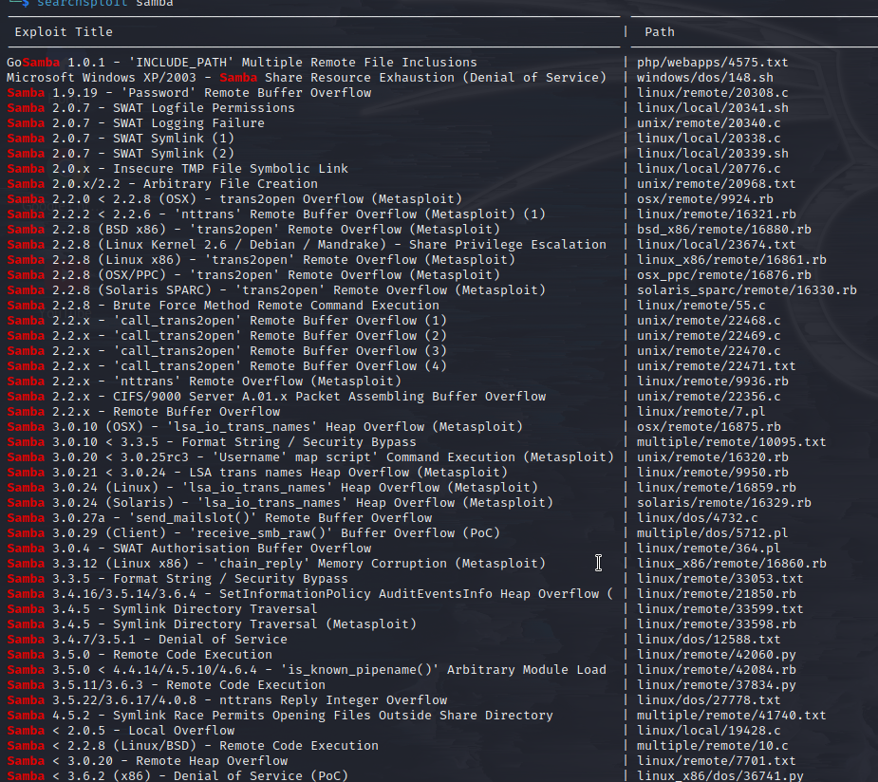

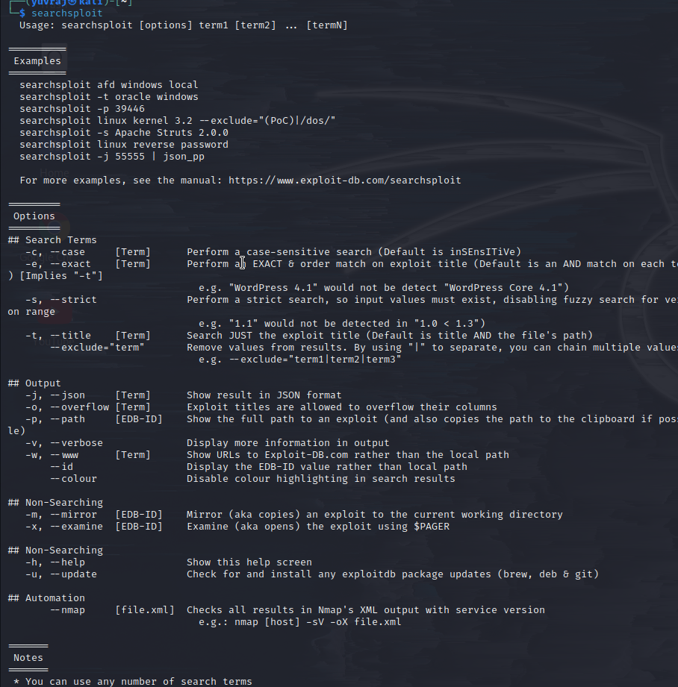

This how we search on searchsploit.

-------------------how to install something onlinux----------------

First download the file form the source then you need to go in that directory and then use command

Dpkg -I <file_name>.

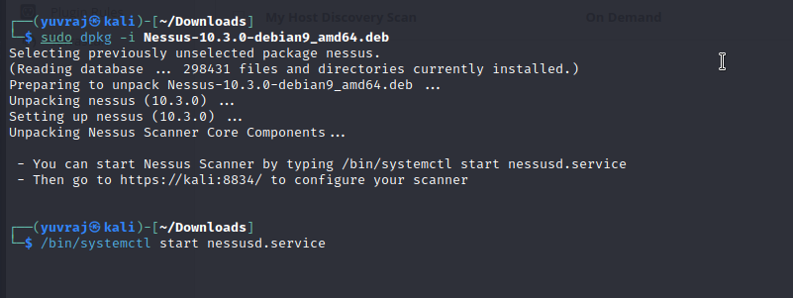

And the first step is to start nessusd service and then go to the link where you can go to the nessusd scanning.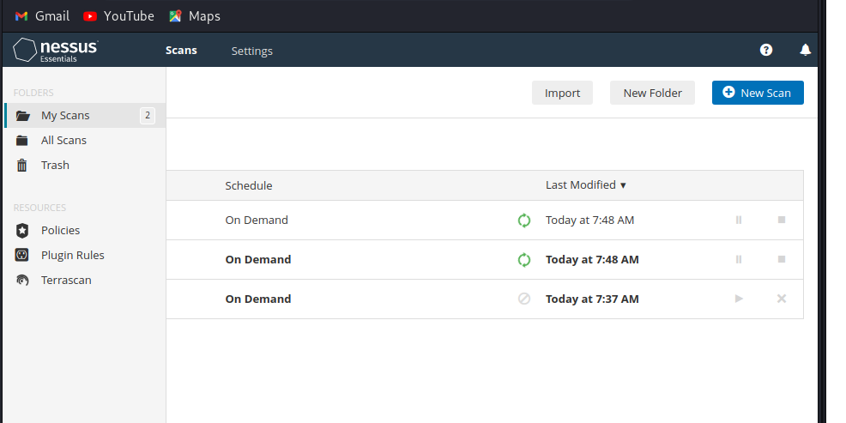

This where we can scan for number of things 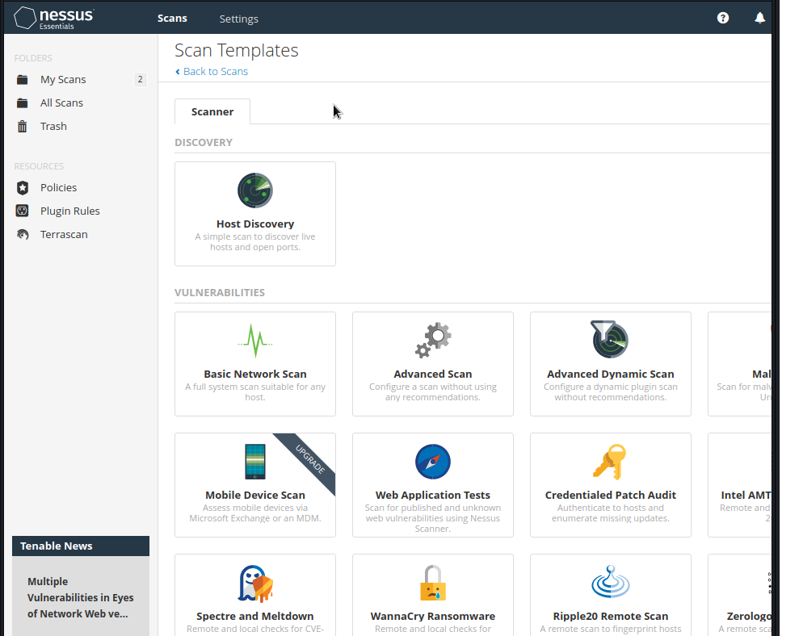

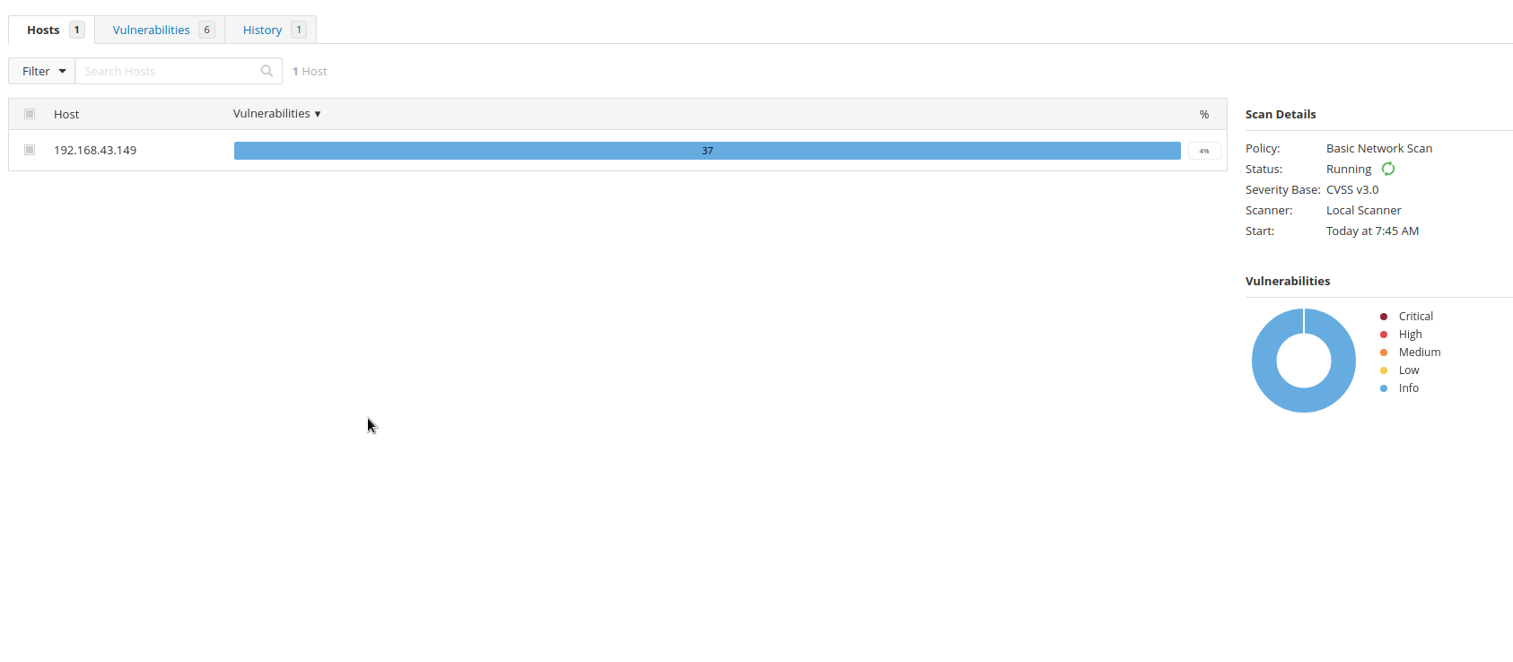

I am scanning in my own laptop – this are the results.

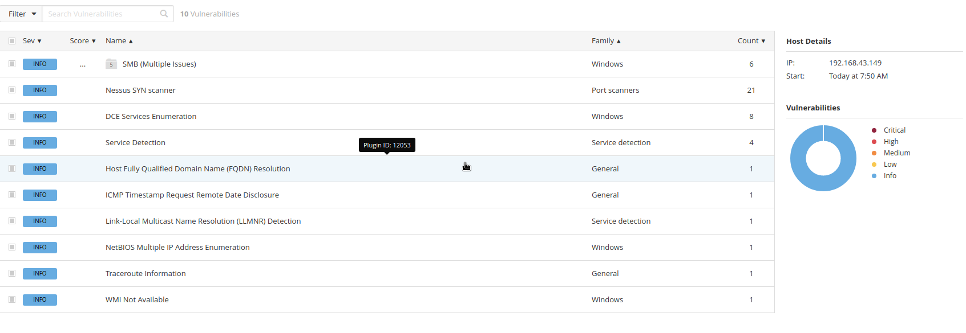

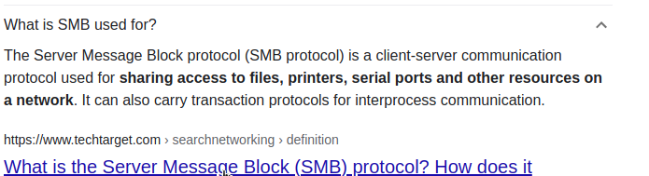

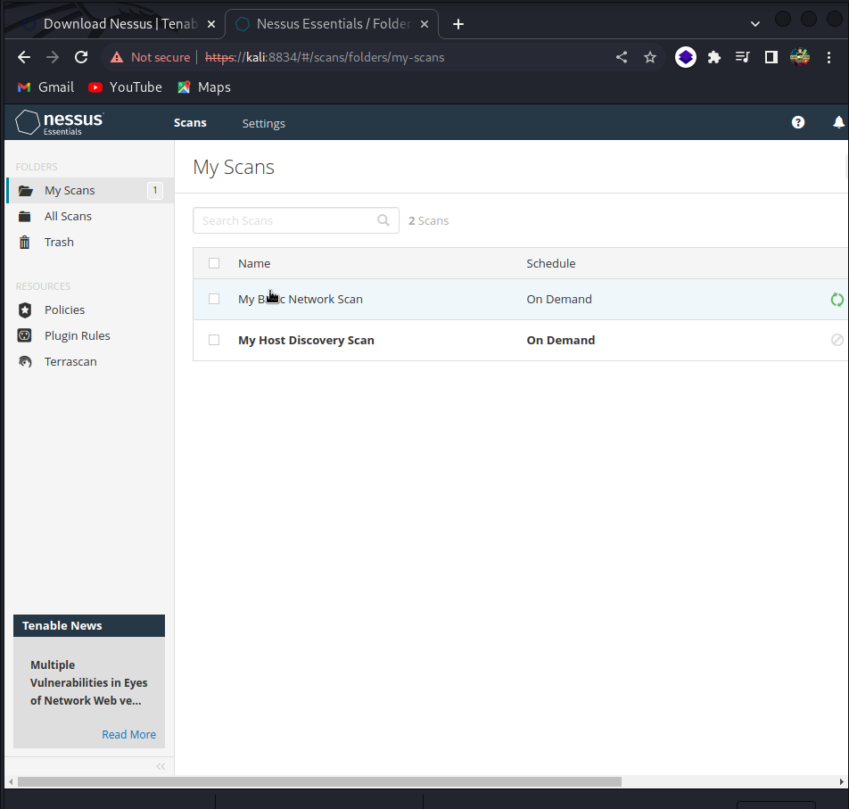

THIS IS NESSUSD WE WILL TALK ABOUT it in detail later it is just doing vulnerablitity scan though.

--------------real explotation starts here---------------------------------------------------------------------------------------------------------------------------

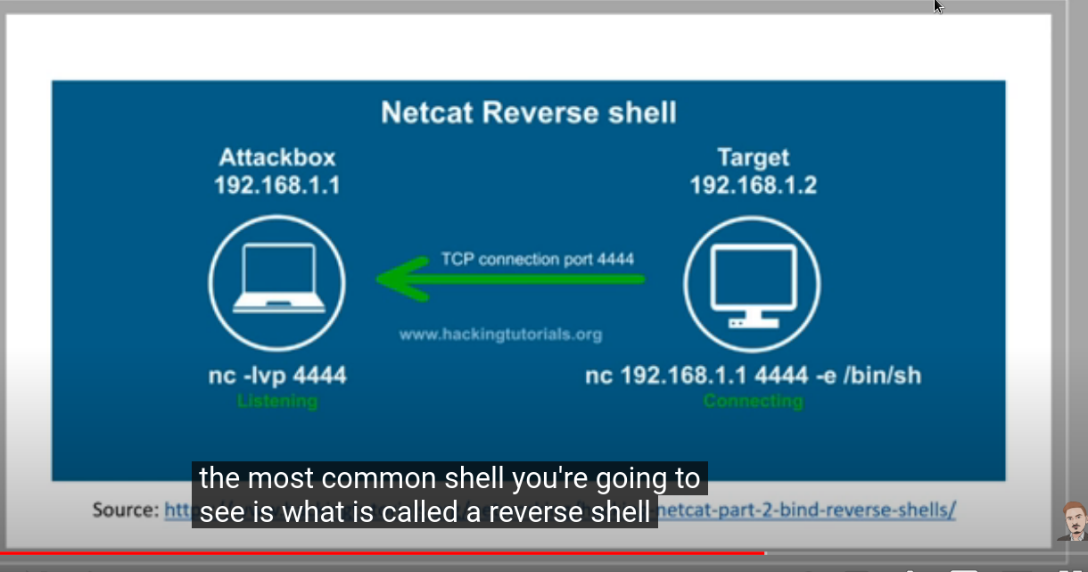

Shell is basically a access to a machine.

Reverse shell – is basically when a victim connects to us.

Here bin/shell because it is a linux machine if it was windows then we use

Command .exe

-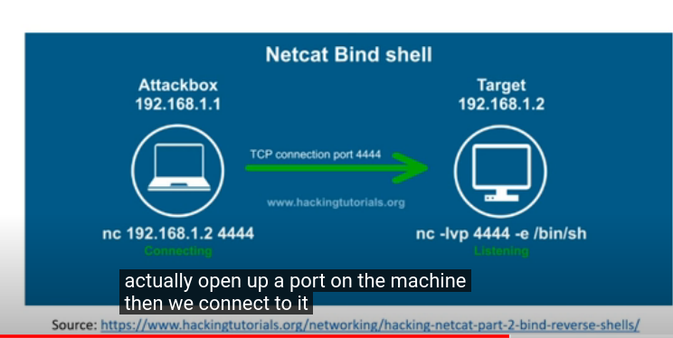

The images below are the example of reverse shell – where the attacker just starts a port and the target himself become the victim by connecting to the attackerr.

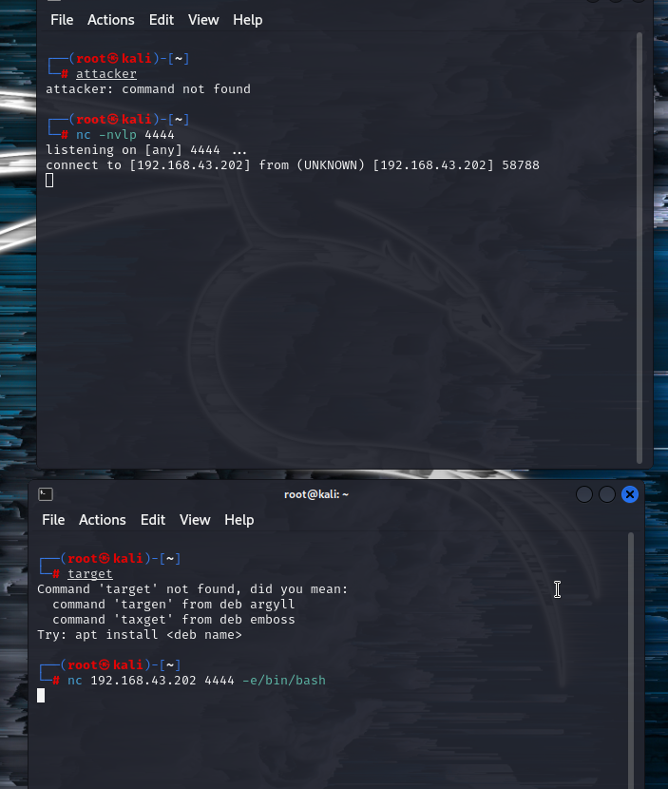

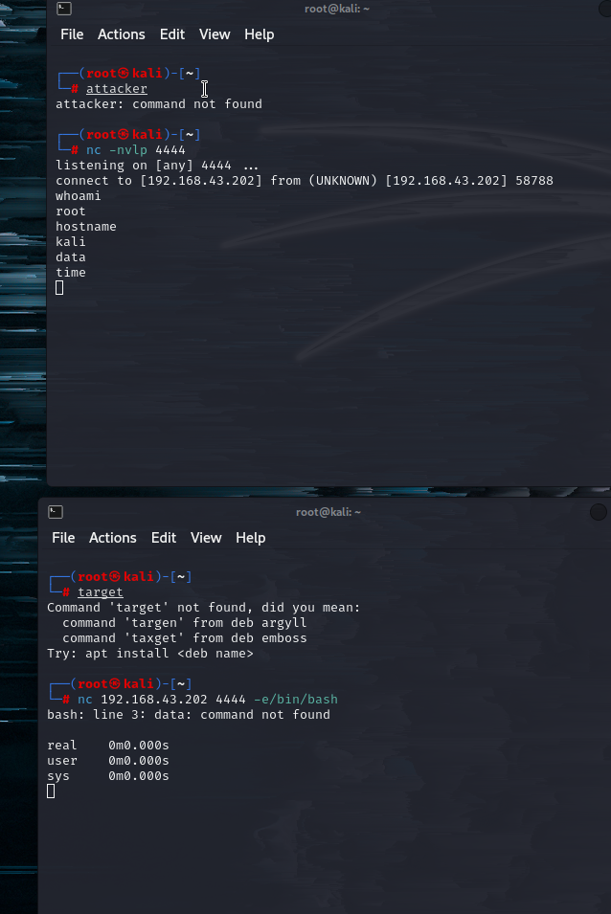

Bind shell - - the below example demostrates how bind shell works

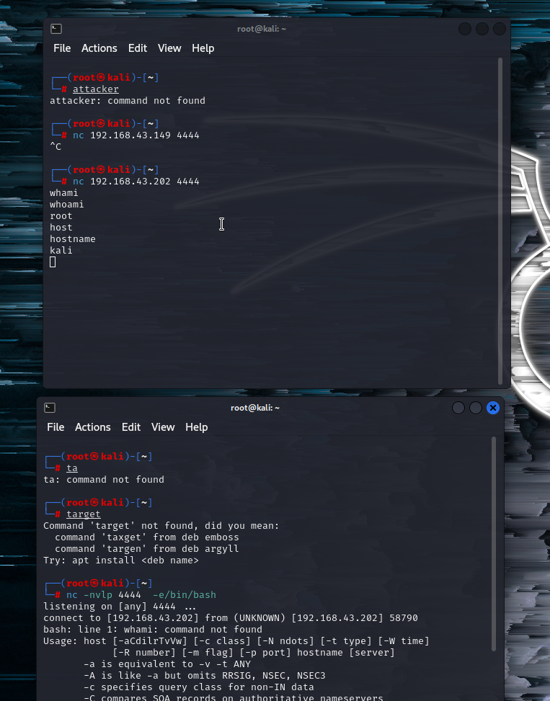

This is what netcat is---

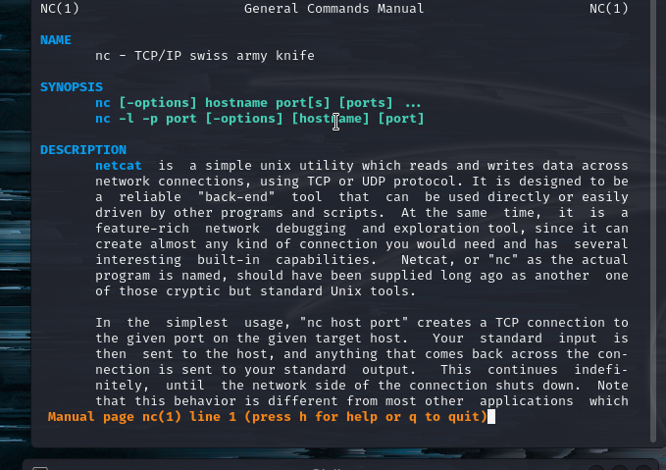

payloads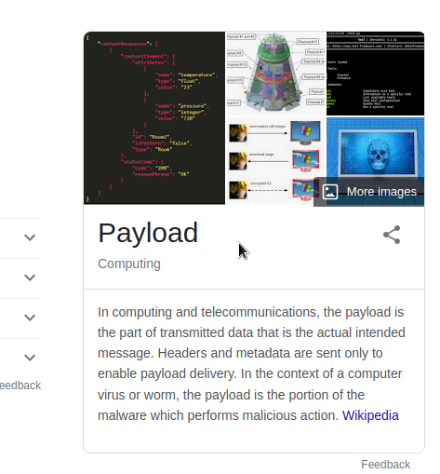

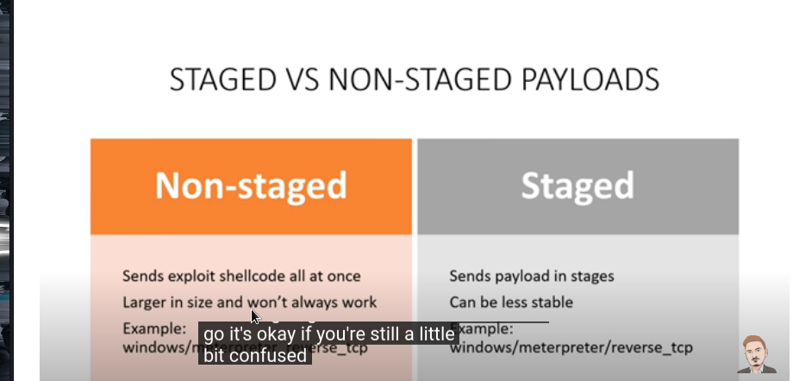



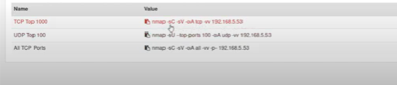

After this my issue of kioptrix lvl 1 was solved and I did get the access to root through two means---

One through metasploit

Second by downlading open source file openluck

Note -- the history are present over kioptrix folder and cmd_folder in my machine.

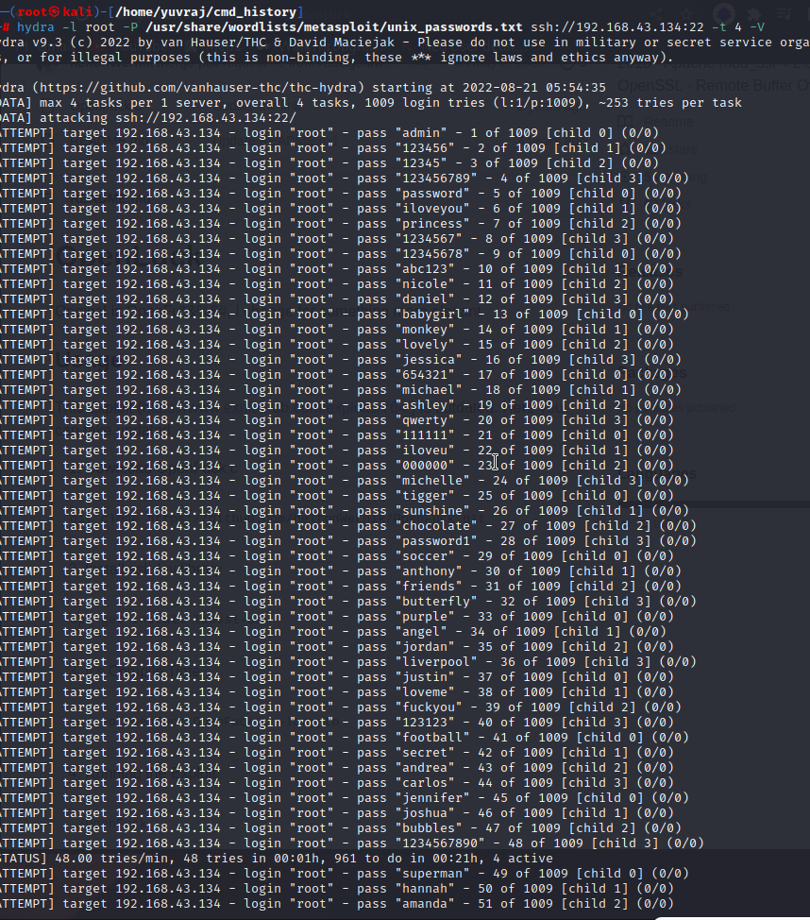

Now we are using hydra and performing various root login throught attemting all passwd as possible-

So hydra is performing mulitple passwd to gain access note that we can do this In metasploit too.

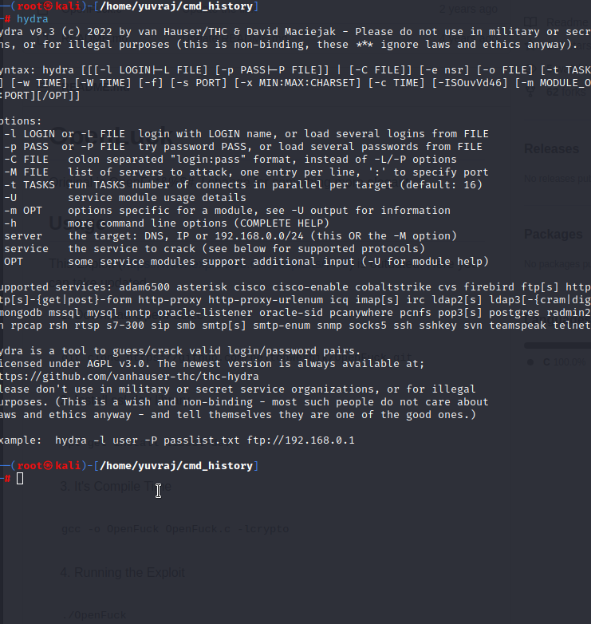

Hydra is a brut forece tool .

Kioptrix brief info ---

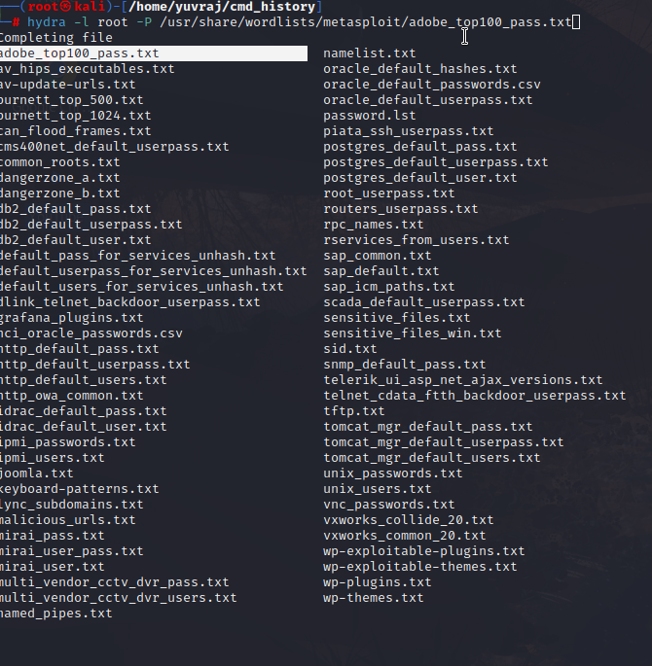

We will use the above destined folders in future and it is important.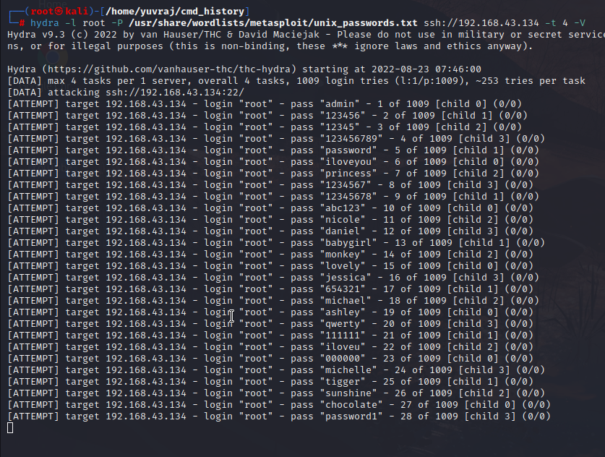

After this we have did the same thing on metasploit and saved the cdm

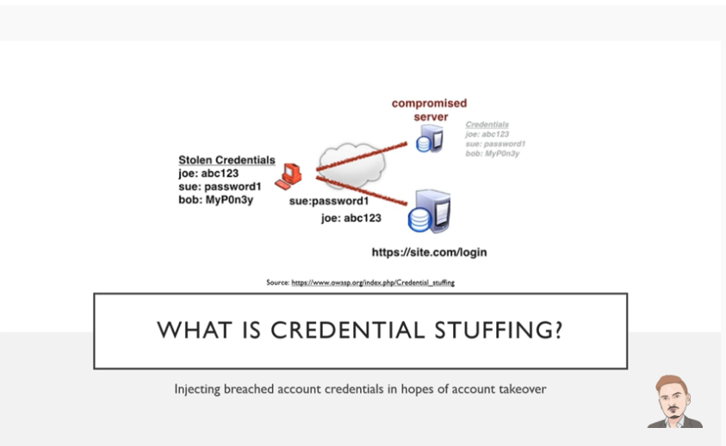history.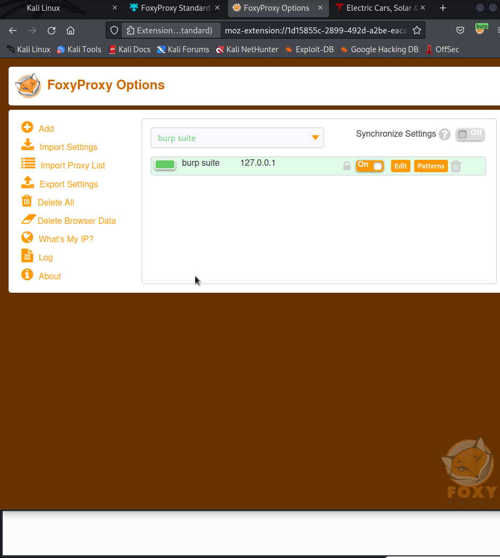

Now we are using foxy-proxy a firefox and chrome extension to drawout some important credentials of any website.

But do not do this to any website unless youre sure of it.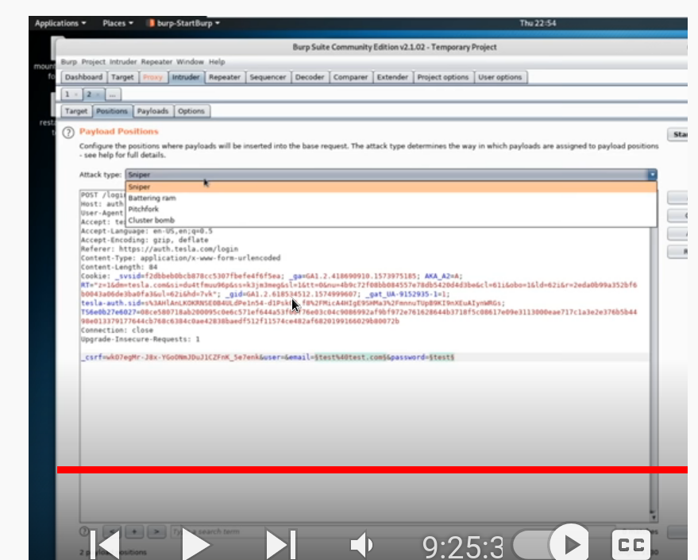

We will be using foxy-proxy and burp suite and intercept after attempt to signin and then we do this in burp.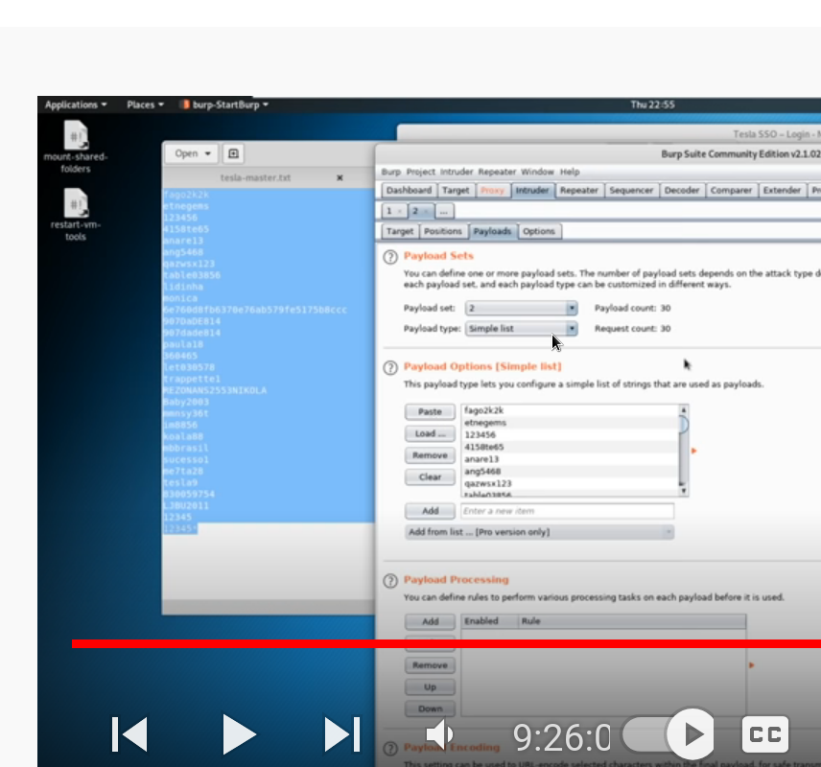

Then we go into payloads and paste the username and passwd list we get from the starting of the video by using the cyber mentor github from the breach parse tool from heath.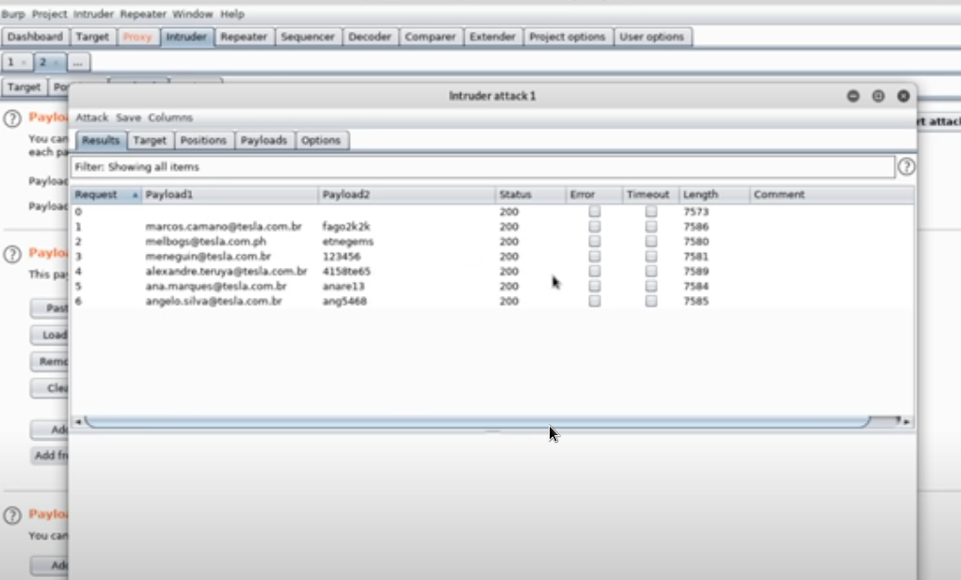

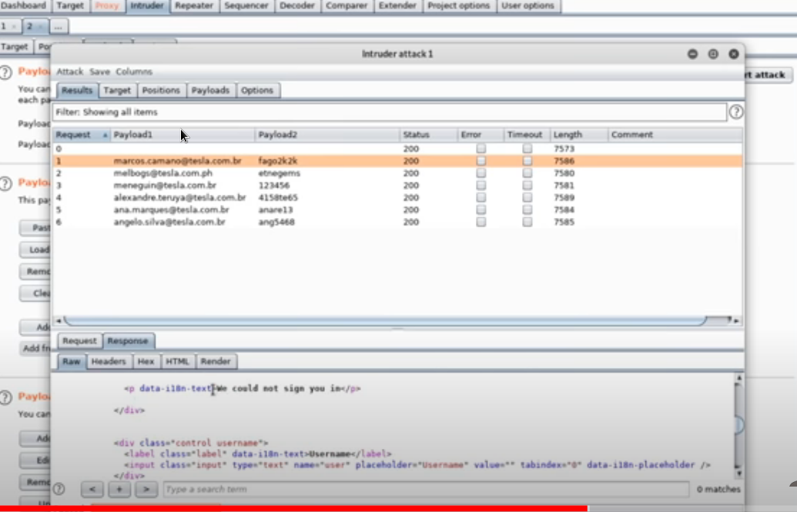

We can check the changes that if the status code change to 301 or the length changes drastically because it has some patterns.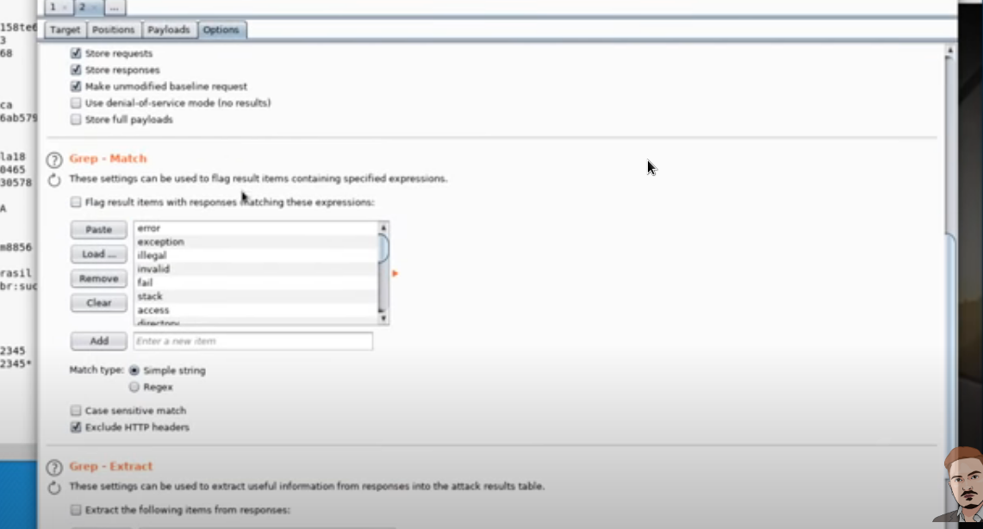

Here we could put the we couldn’t sign in from the respone of the website and put it in the grep options so that we can immediately found that we breaced or not.

Note – do not fire too much at sametime wich can lead to the lockdown policy of the website and could lead to trouble.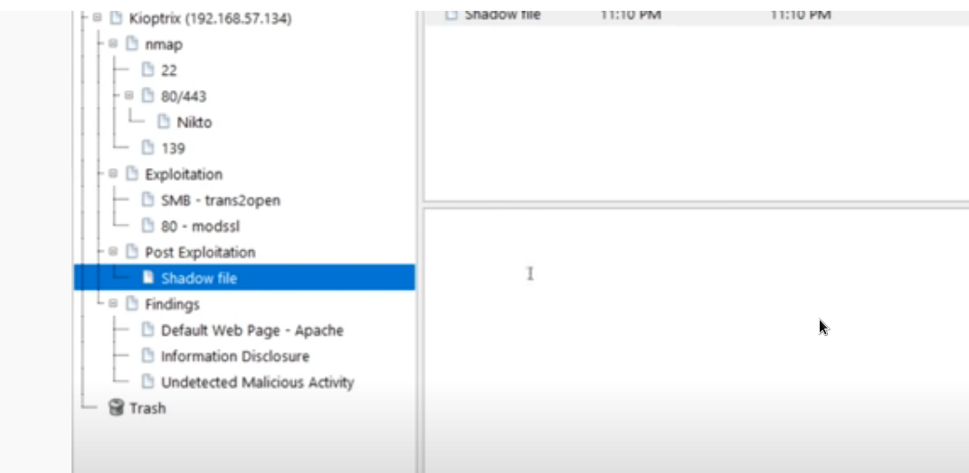

This is how we should make the notes for better understanding.



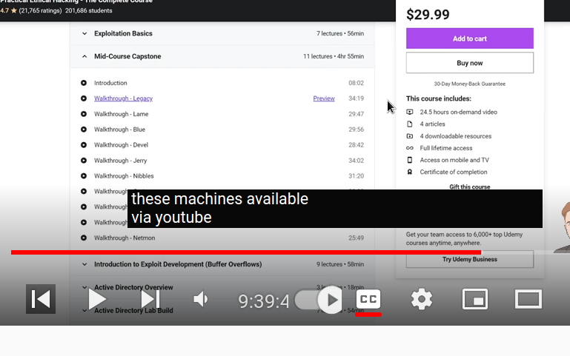

The differnet courses availabe via youtube.these are just the courses for getting the route privilledge at the desired system.

After this we have to download te blue system and then we can follow up heath.

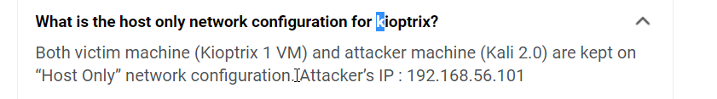

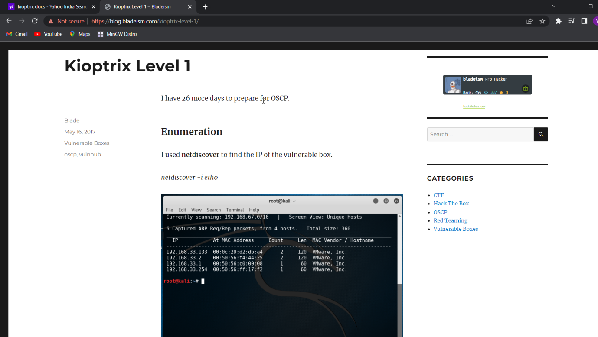

This is kiotrix docs--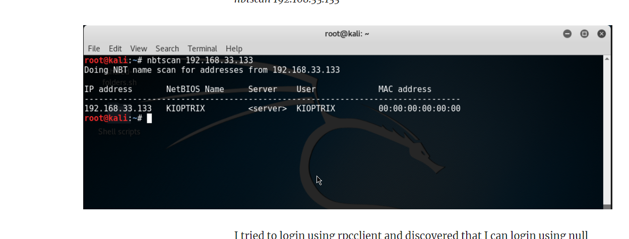

After this I did try exploit blue which is windows 7 ultimate by metasploit just follow the steps

1.seach for the ip of machine you want to exploit <netdiscover>

2.enum4linux <ip>

3.nmap scan and also aggressive one

4.from the infos I get the windows version which I did google and got eternalblue

5.from there are searched for eternal blue on metsaploit and I know how to use the metaploit.

------we can also do this manually by looking for other persons repo on github.

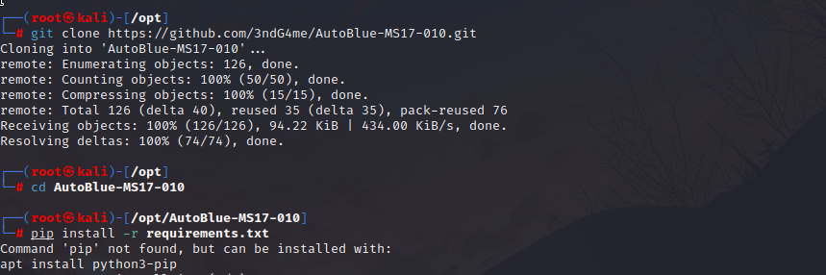

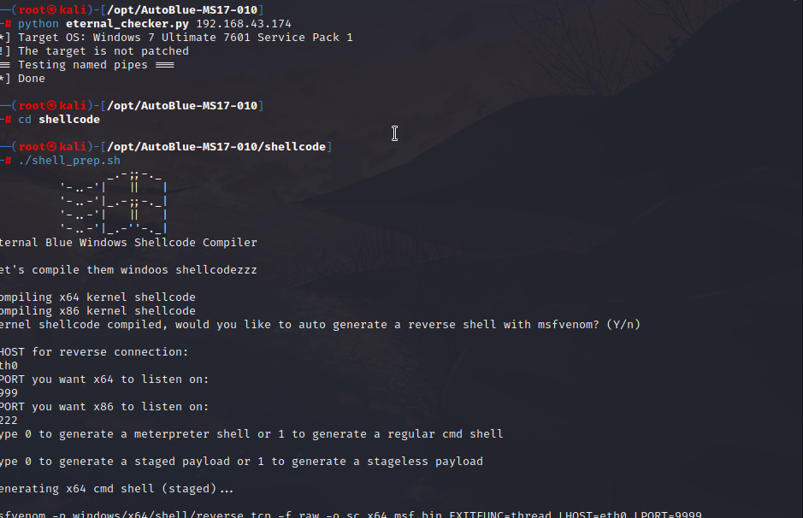

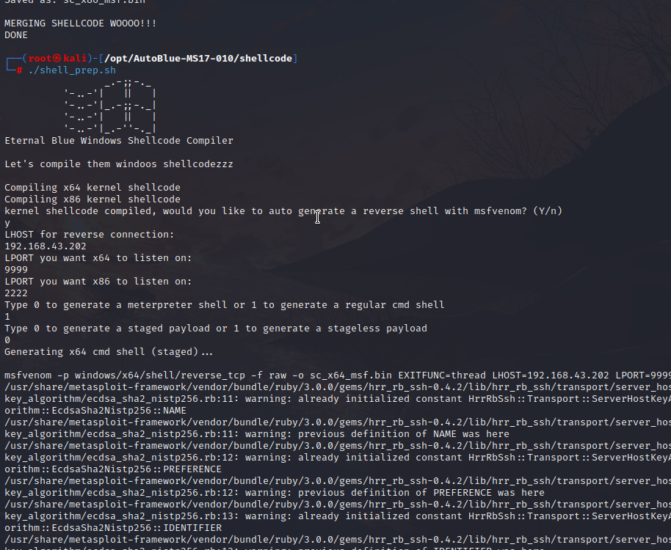

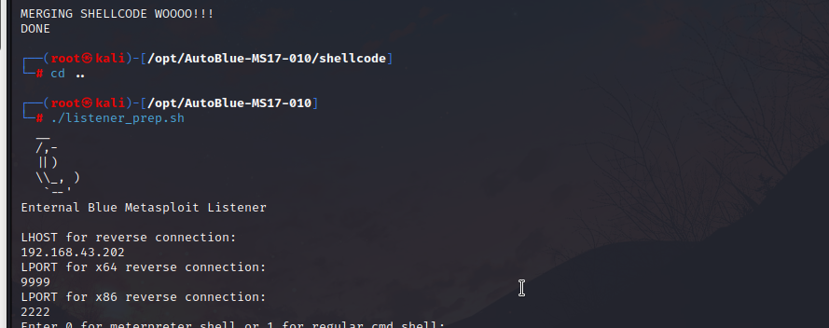

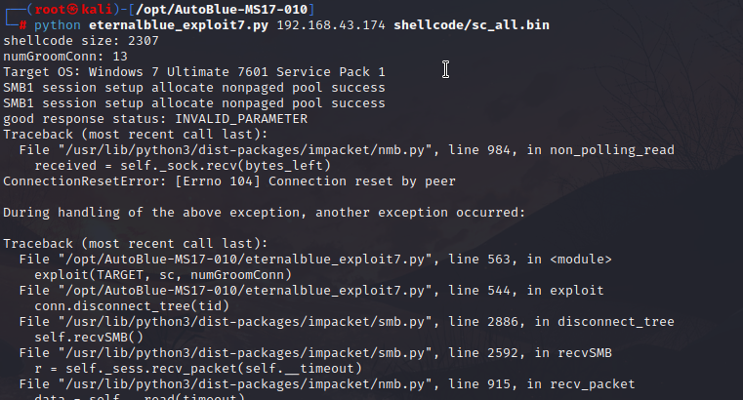

But the above method had a mistake and our host machine on which we are attacking started rebooting..

For this we need to know that are environment is safe before exploting a machine.

After this we are goind to exploit academy.

In case of academy we do the same thing first we do a netdiscover scan to get an ip

But we have a root login and passwd is tcm for academy – bty heath

Then we do a nmap aggressive scan and then we check for open ports like the below one of

Port 80 apache website.(note cmd_history Is there in the box

)

Academy exploit-------------------

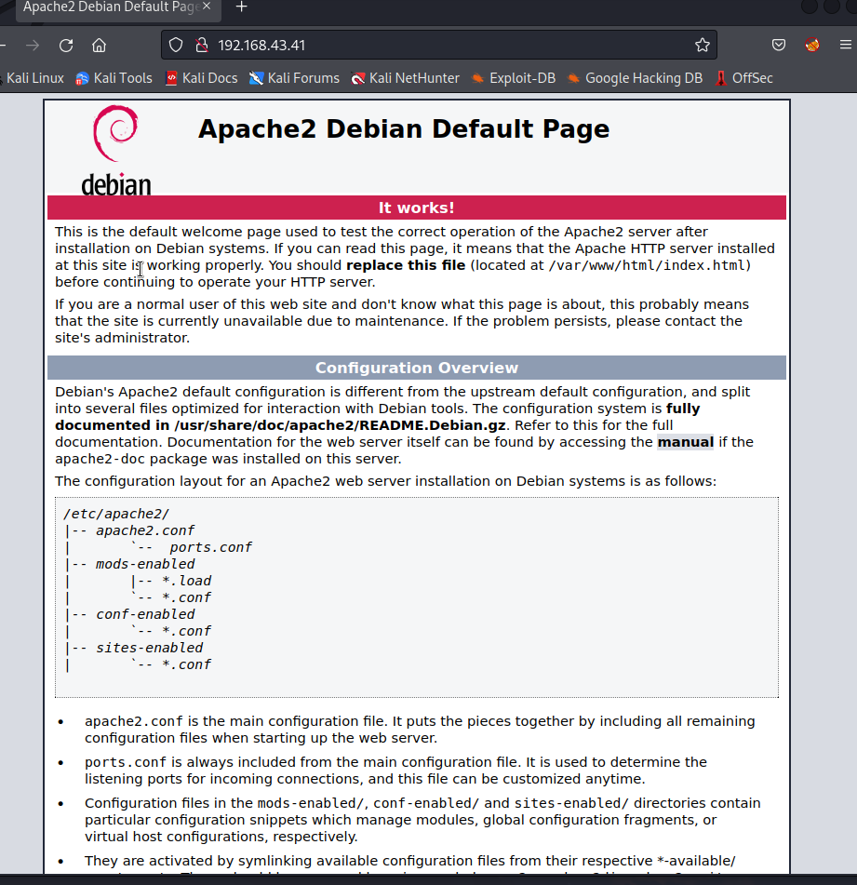

Then we use ftp internet file transfer program.

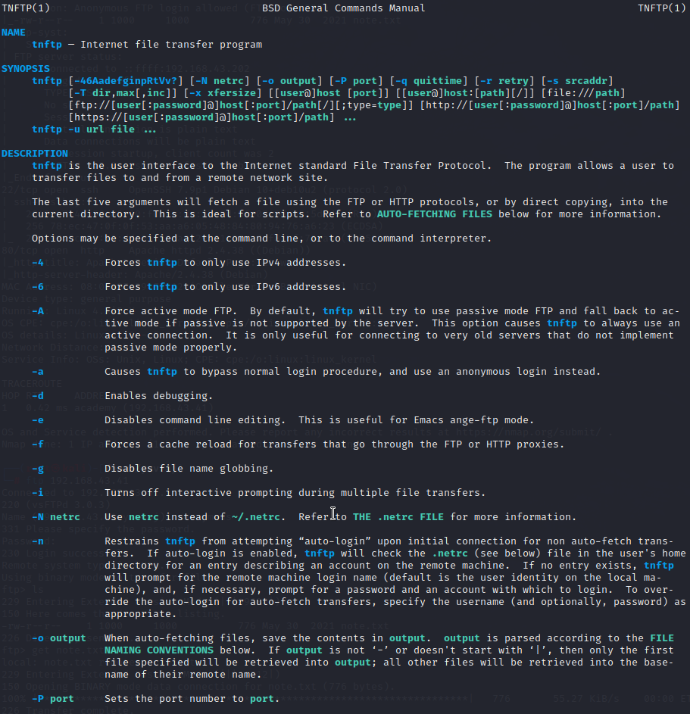

This doesn’t work unless we know where the file is we can fetch the file but cannot put another file.

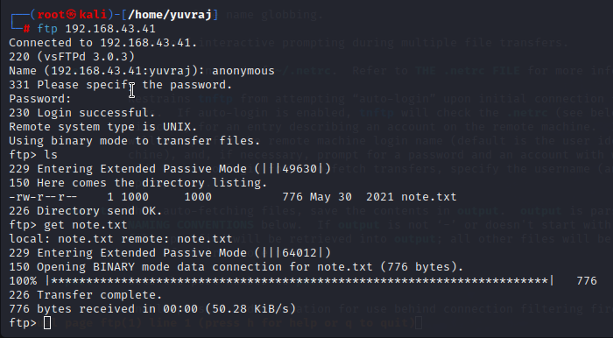

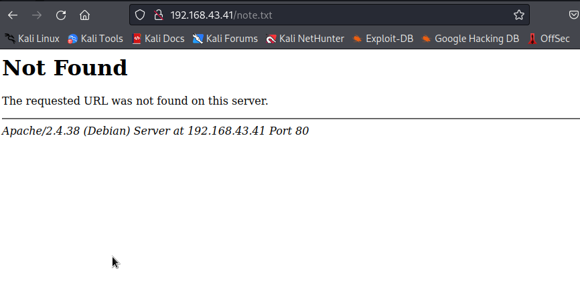

The data we got from the note.txt we are using that and converting it into actual by hash-identifier

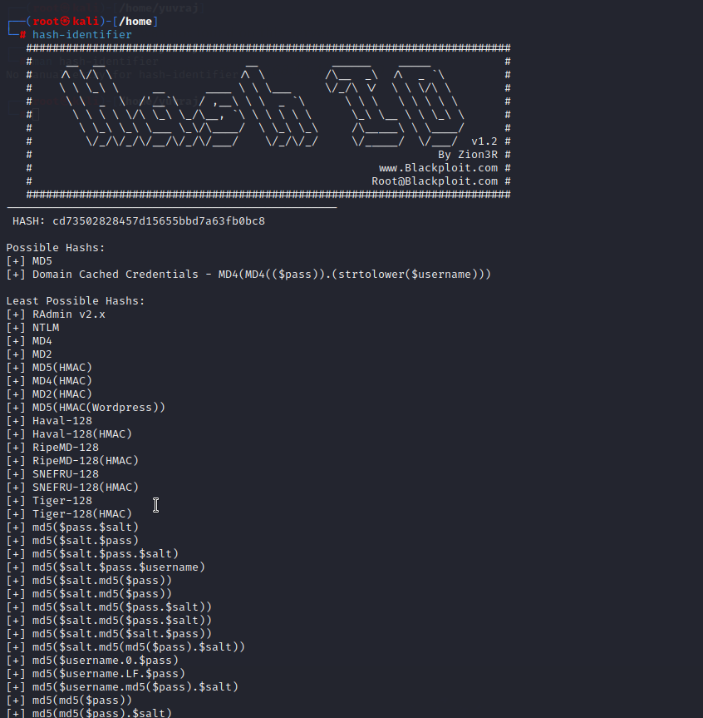

Note now we are going to use hascat but we must use hashcat in our actual system and not the virtual machine because it takes the gpu to run the hascat.

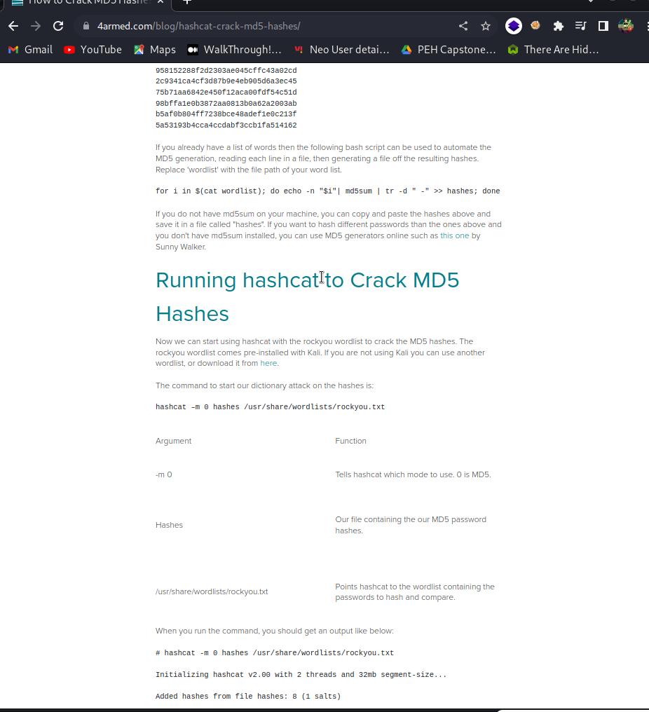

Hashcat runs on the gpu therefore it requires losts of space and runs slow on vm

It deocded the hash we had to the result student.

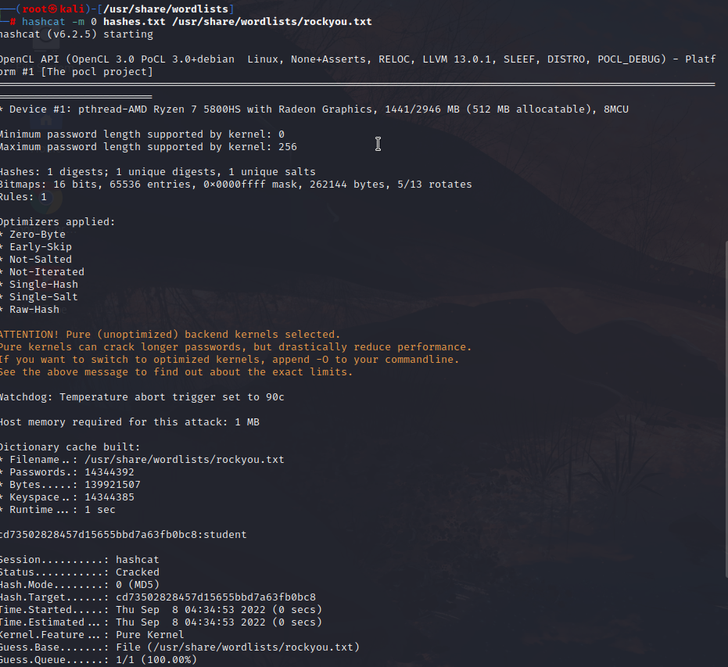

After finding the password we are using to ways to get the components of the apache website.

1..using dirb we can find the tree or the folder or the port where the website can have more info

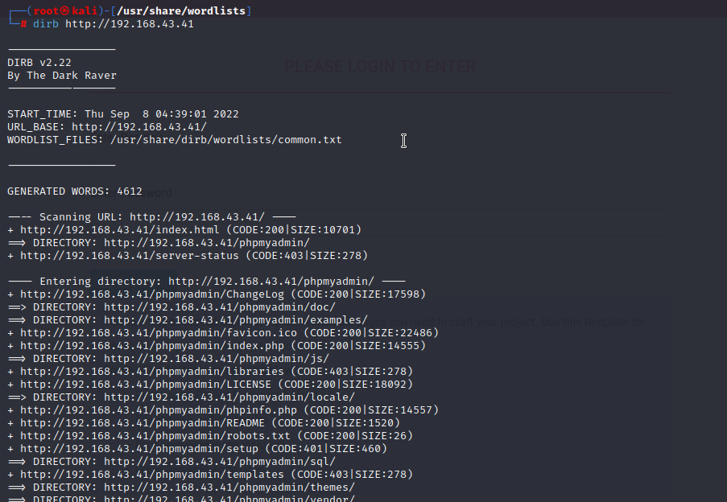

2.. we can use fuff

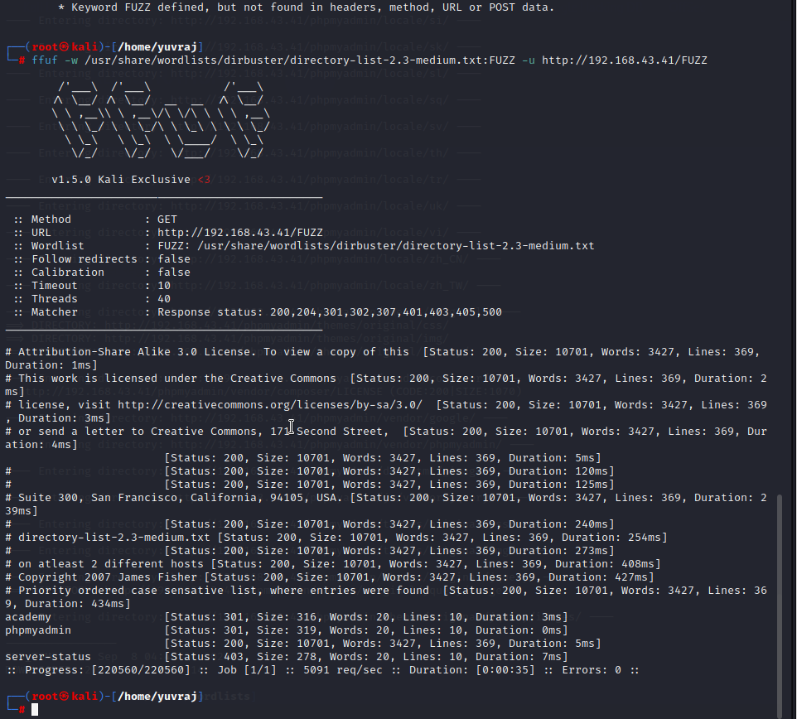

We can find exploits in website if they have a imgae submit button and we can upload a doc

Instead of a image this will have high chance of exploitations.

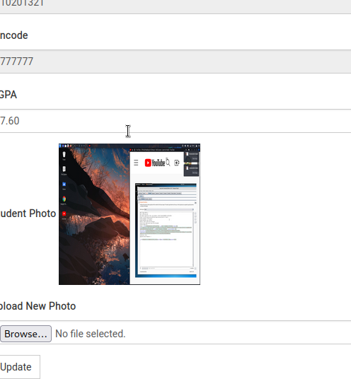

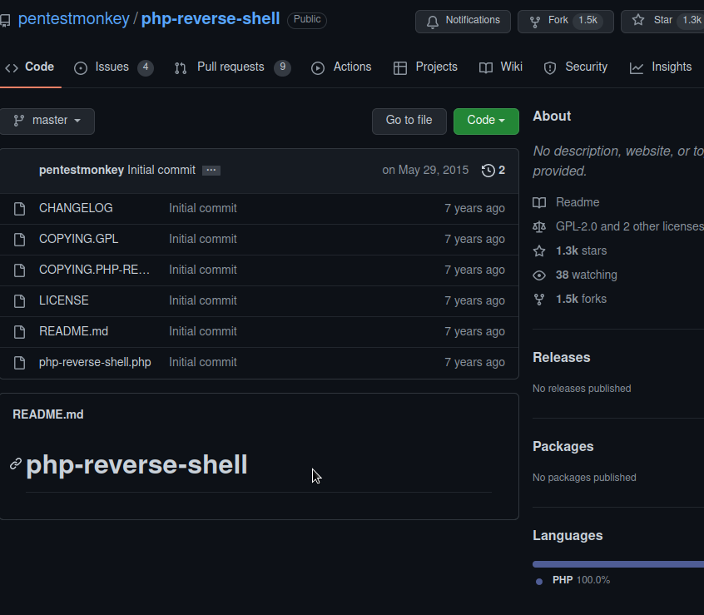

This is how we host a website in linux.

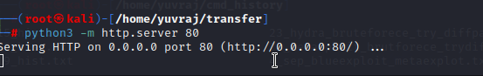

What we did is after the reverse_php we didn’t get the root access to the system therefore we

Searched linpeas.

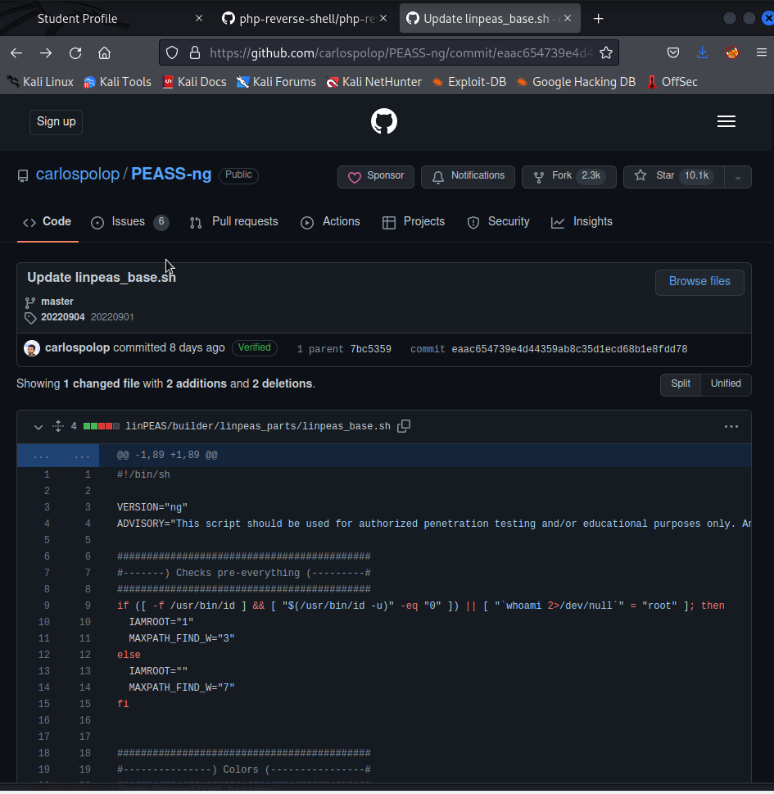

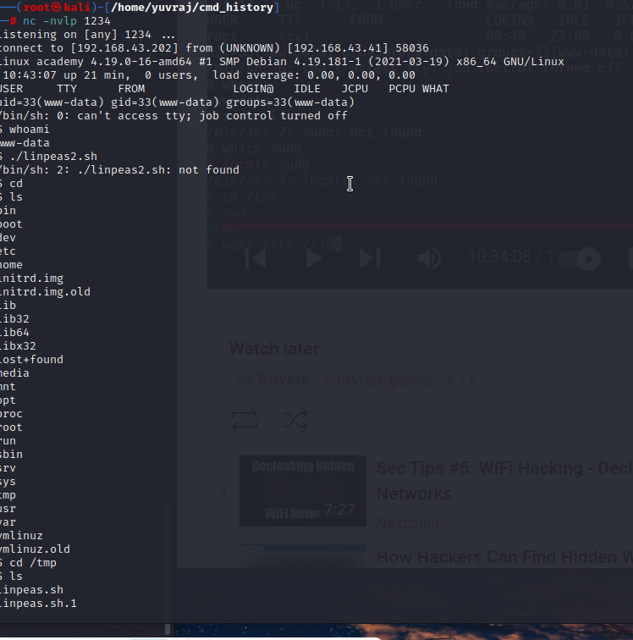

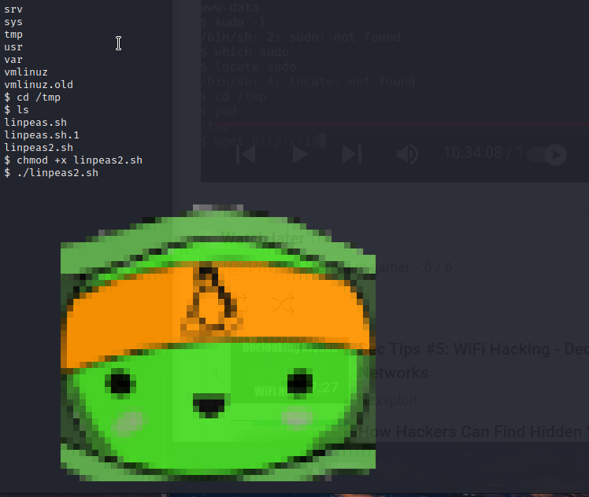

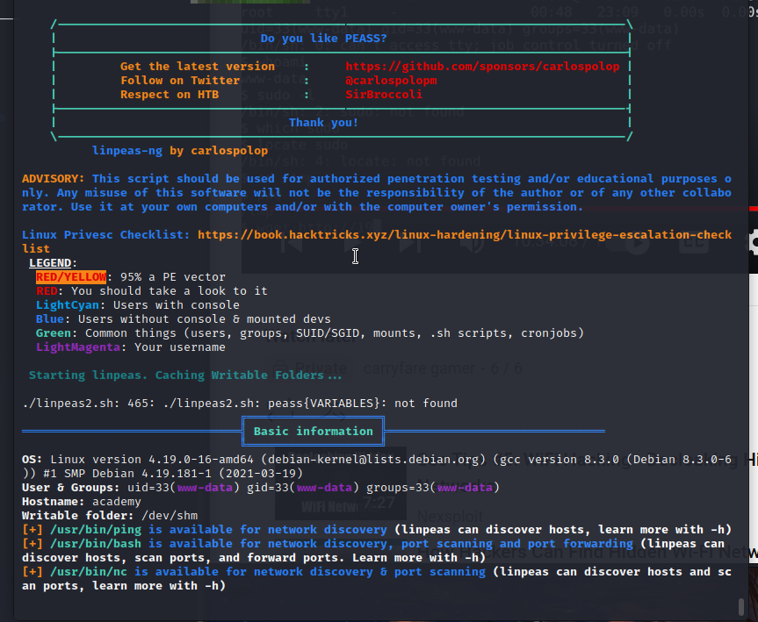

I am getting some error in this file therefore cant able to do it.

But these are the sceenshots of heaths.

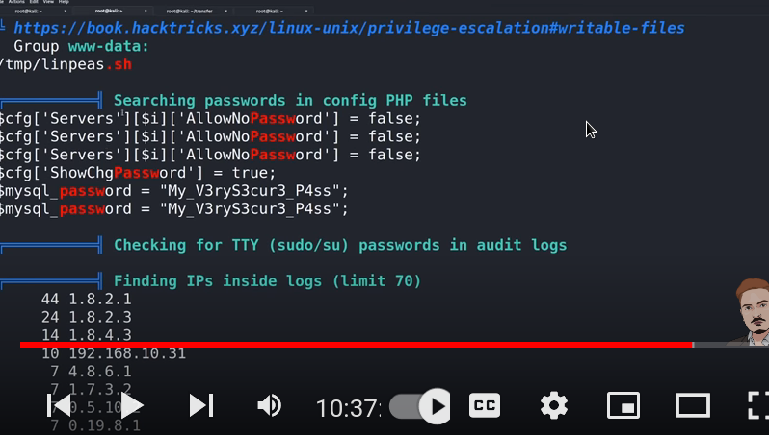

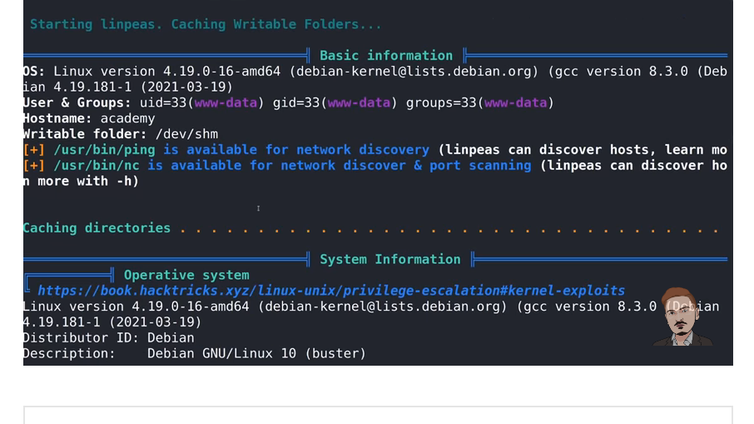

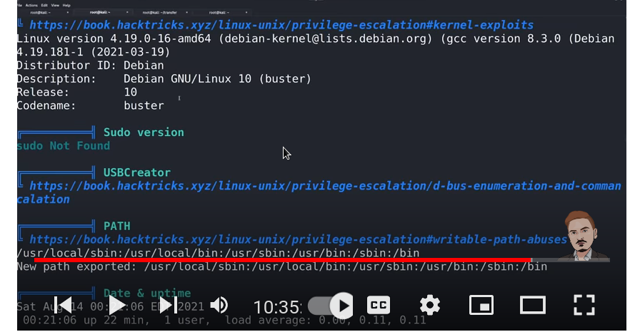

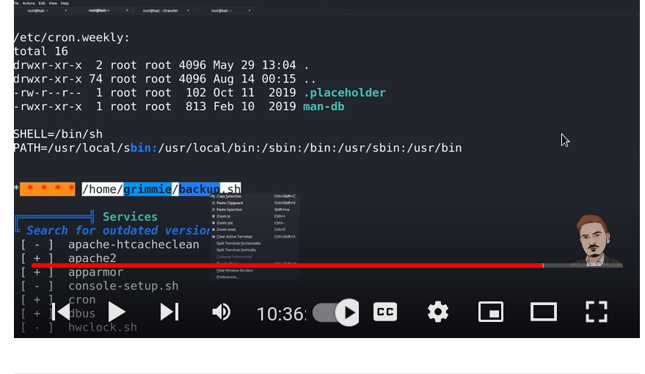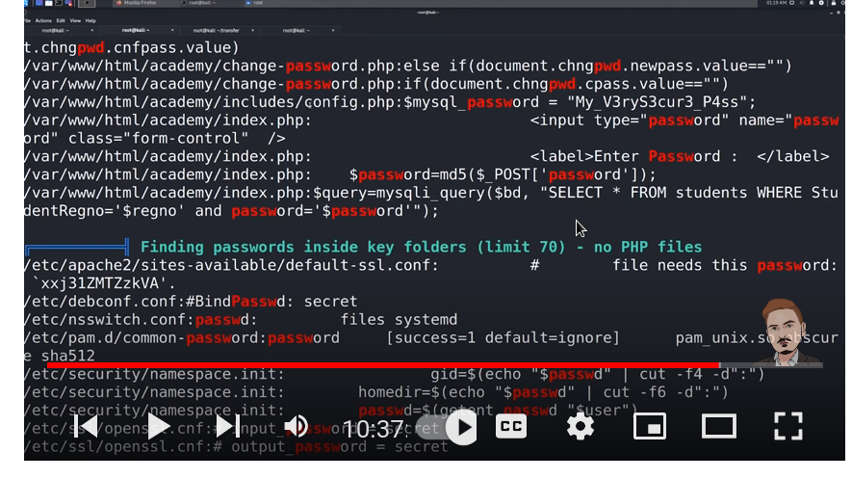

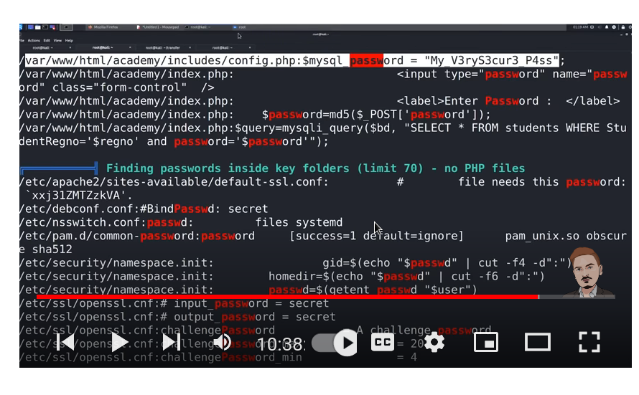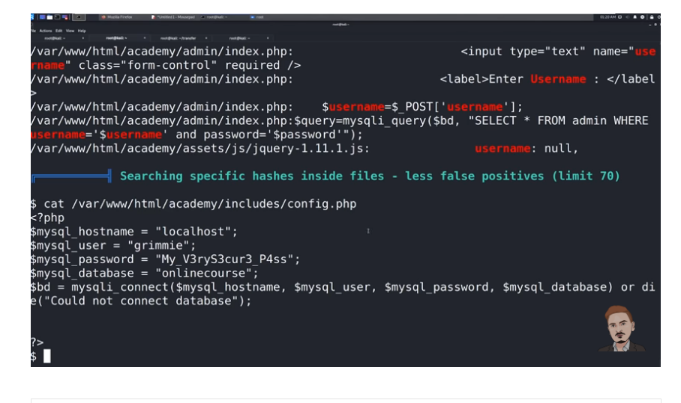

After that the searches of heath discovers grimmie so we did a quick ssh on grimmie at the host ip and entered the password form mysql passs heaths screenshot.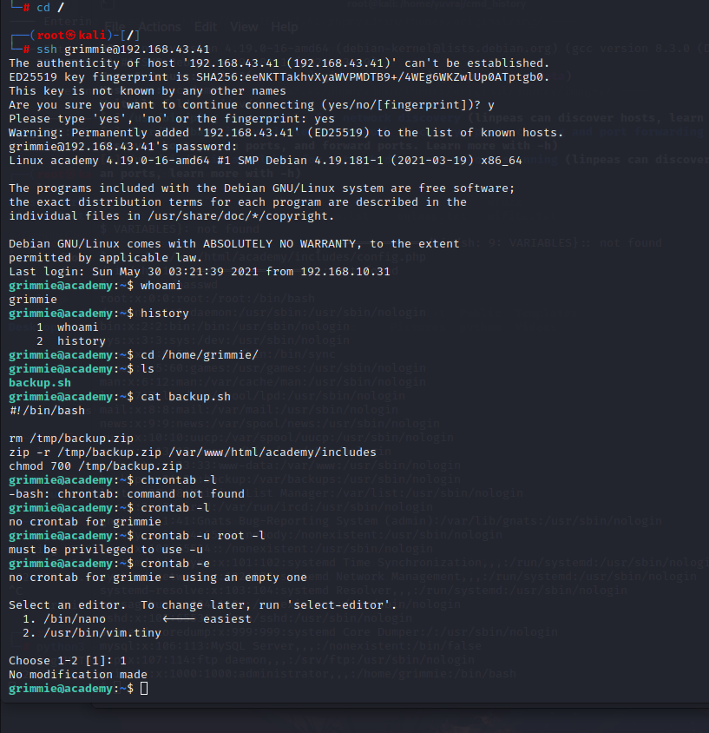

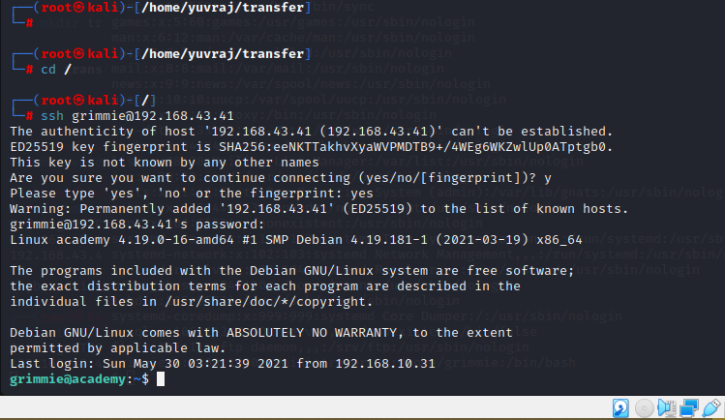

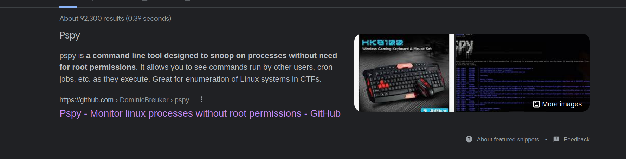

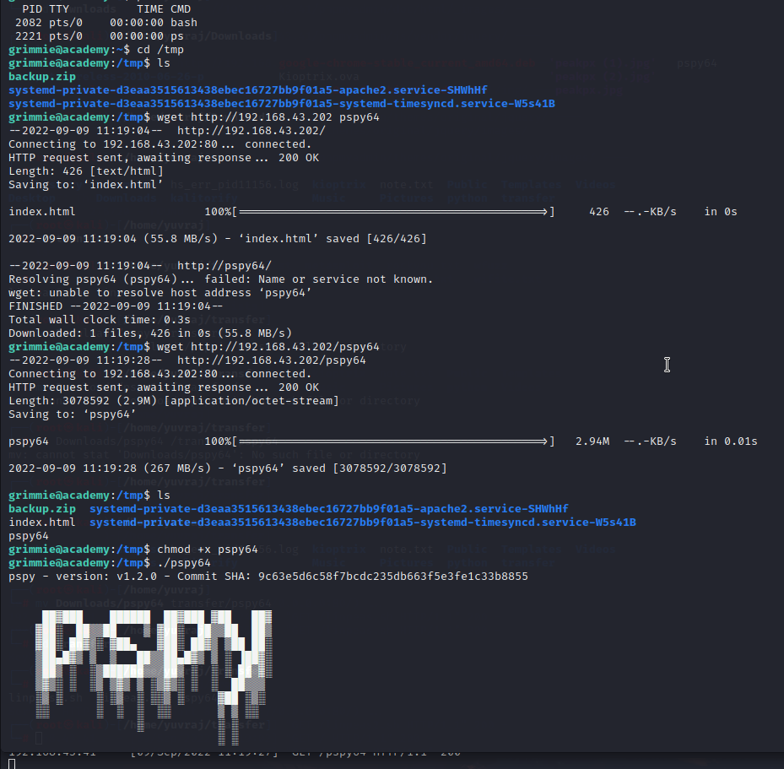

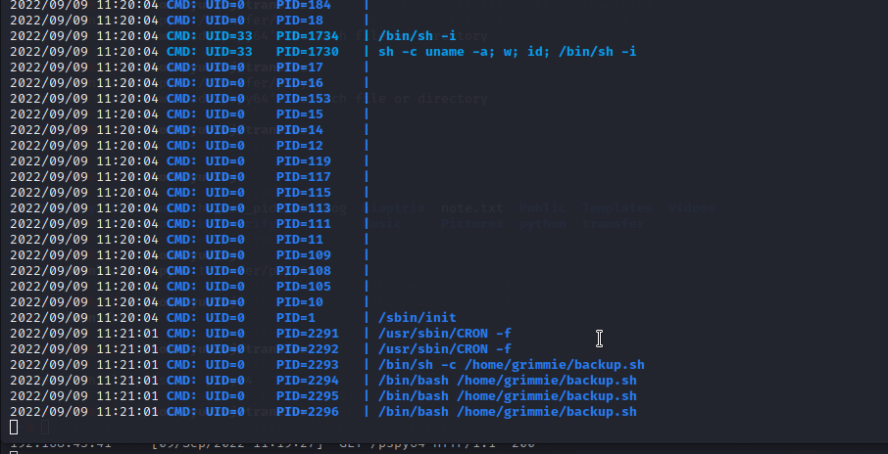

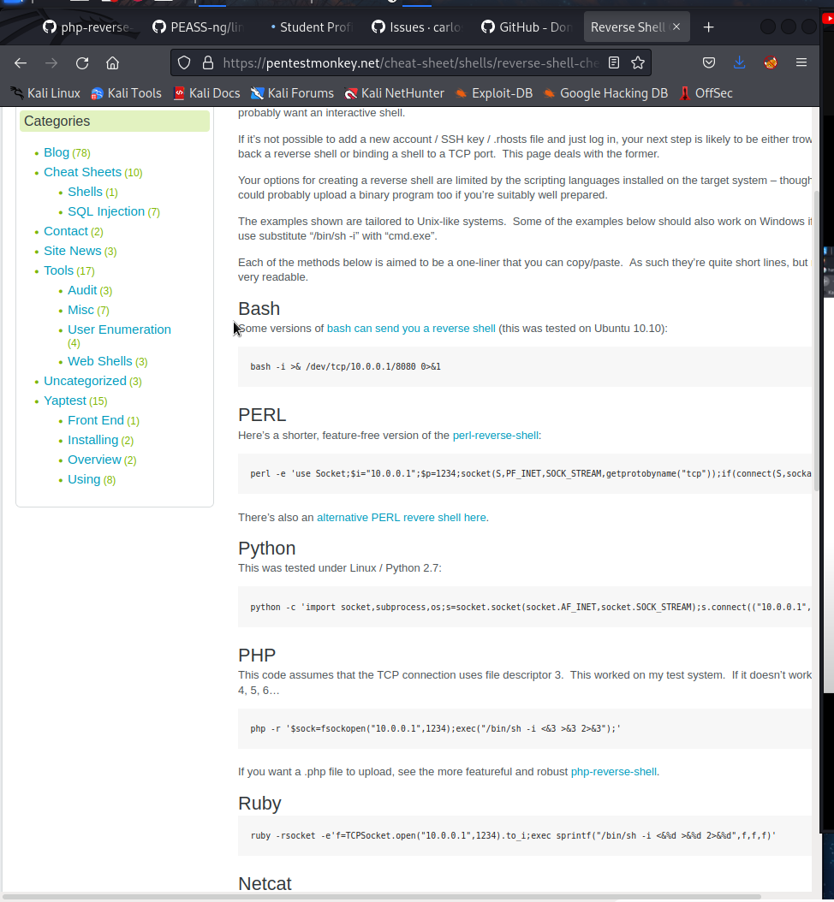

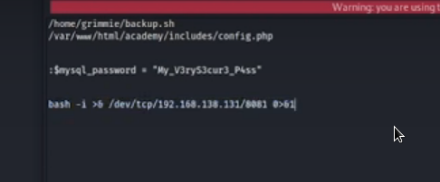

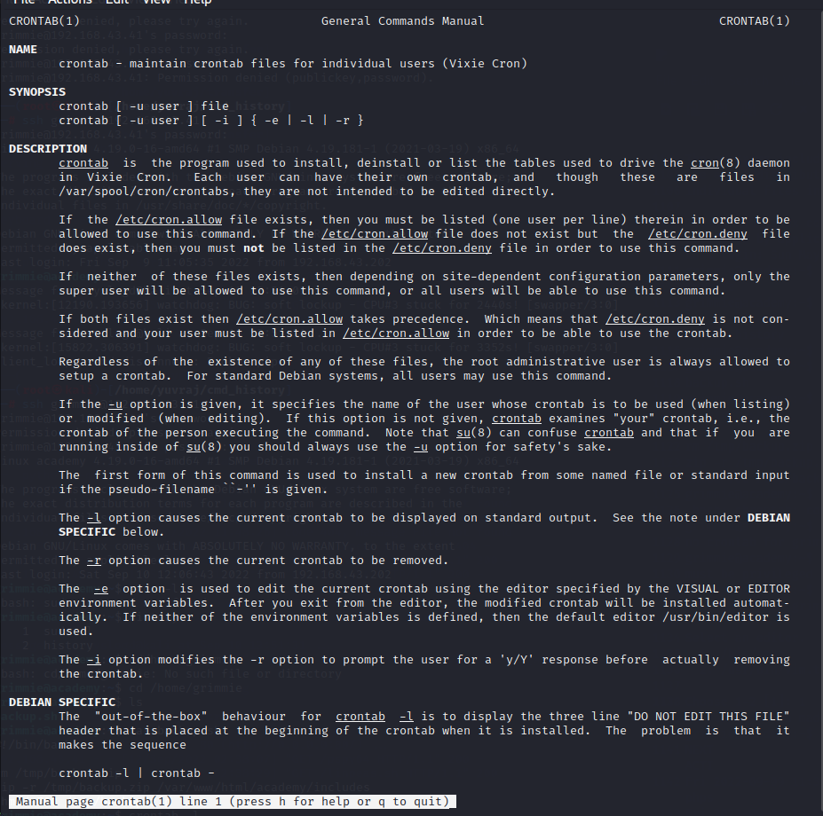

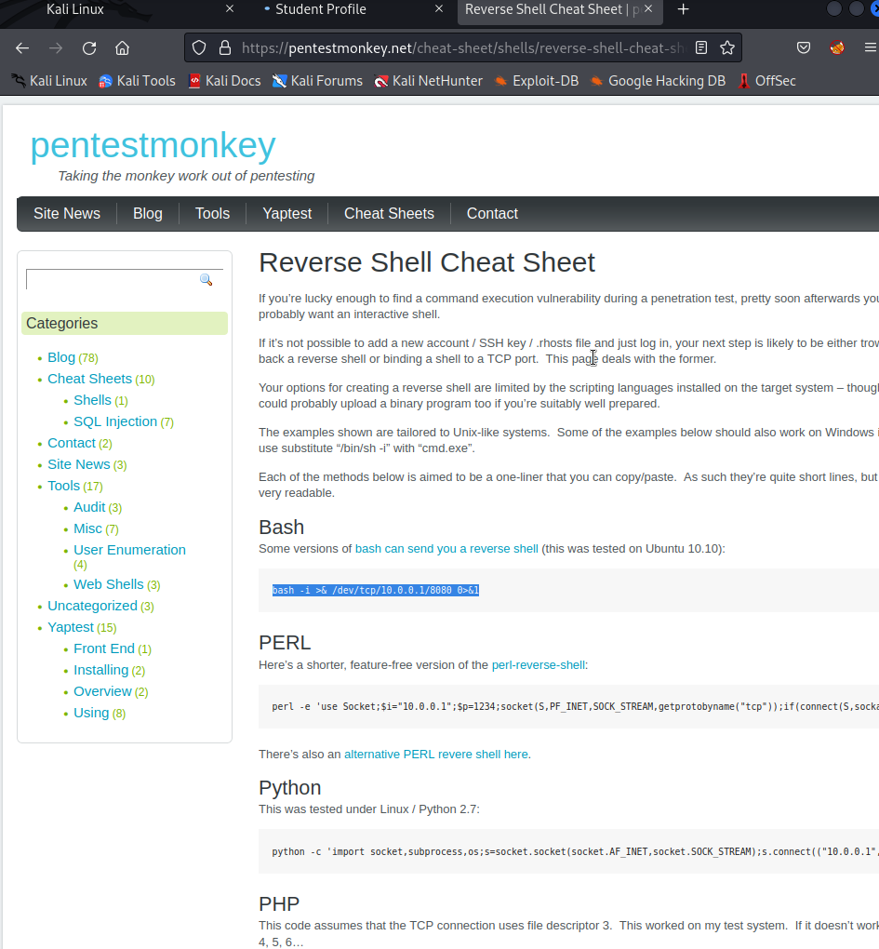

We finall gain the root access by changing the content of the backup.sh file in the grimme to the reverse shell cheat sheet of the bash and then open the reverse shell on port 8080 – or any port which you located in the bash in backup.sh and the we get the root access to the academy machine congrats.

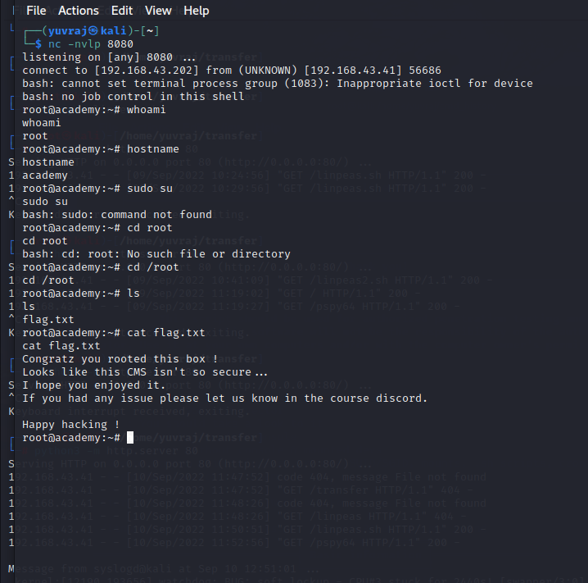

Dev exploit------------

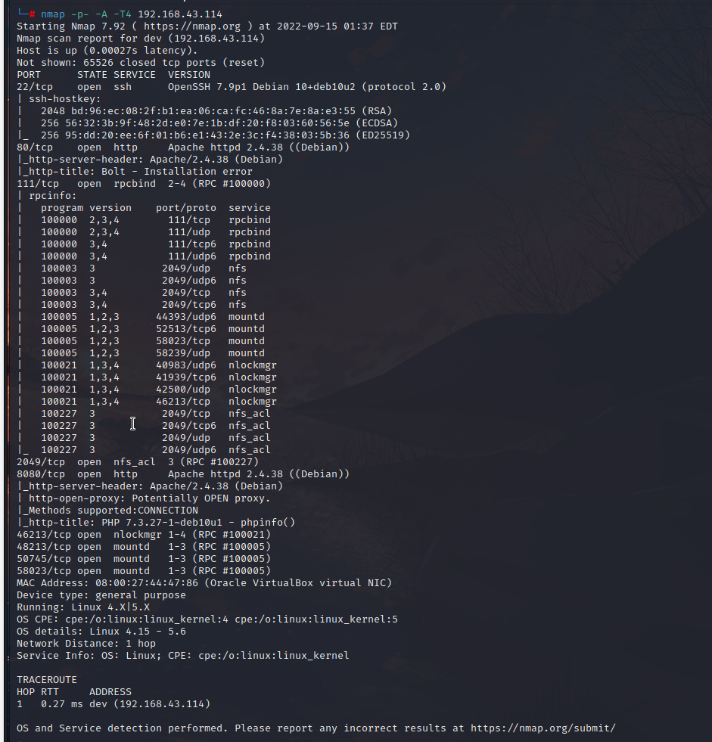

We are going to left rpc on port 111 because it is not for beginner stuff.

We are doing a ffuf scan on both the root and the port 8080

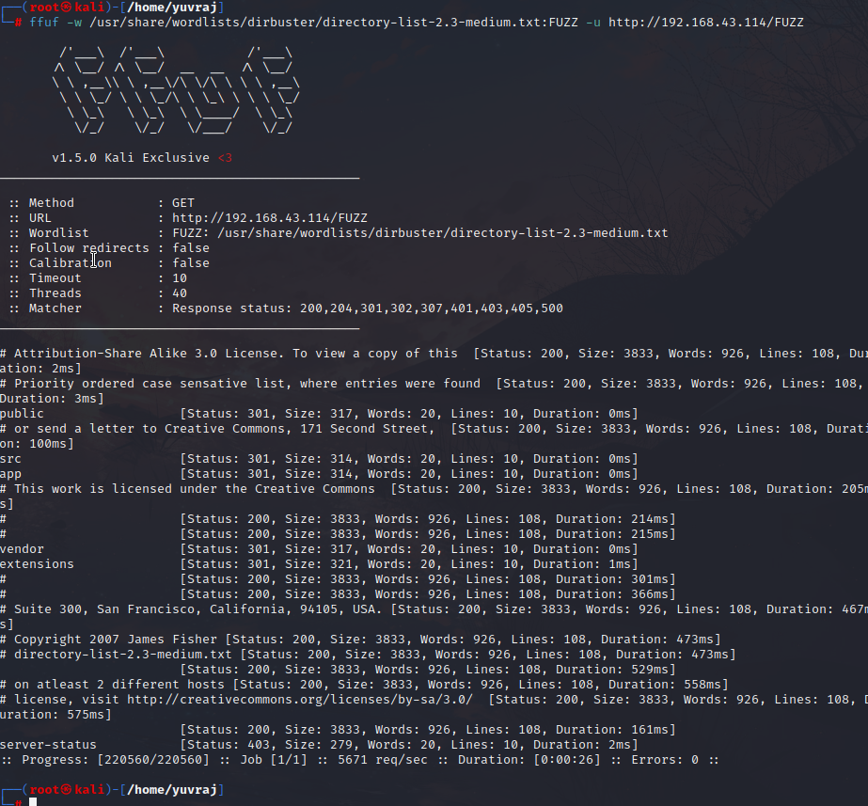

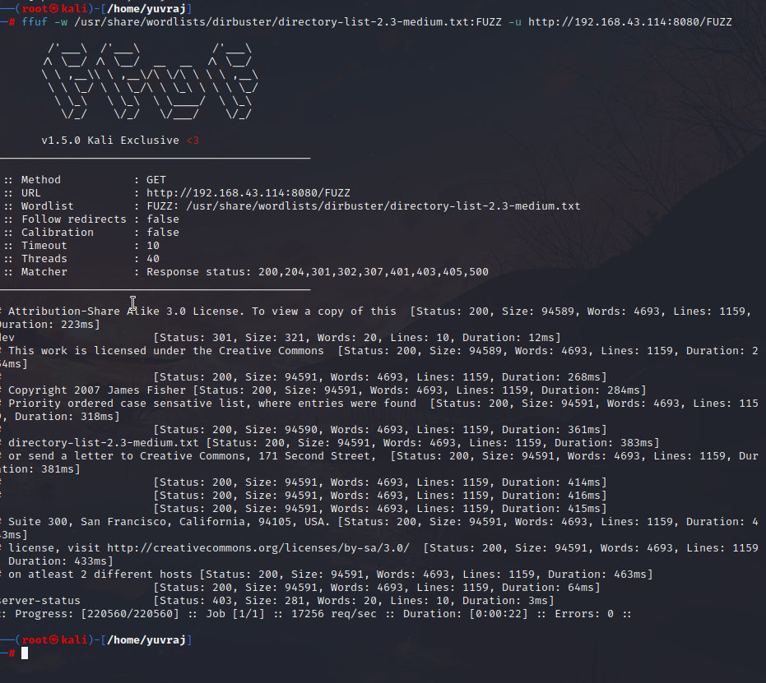

This is showmount-----

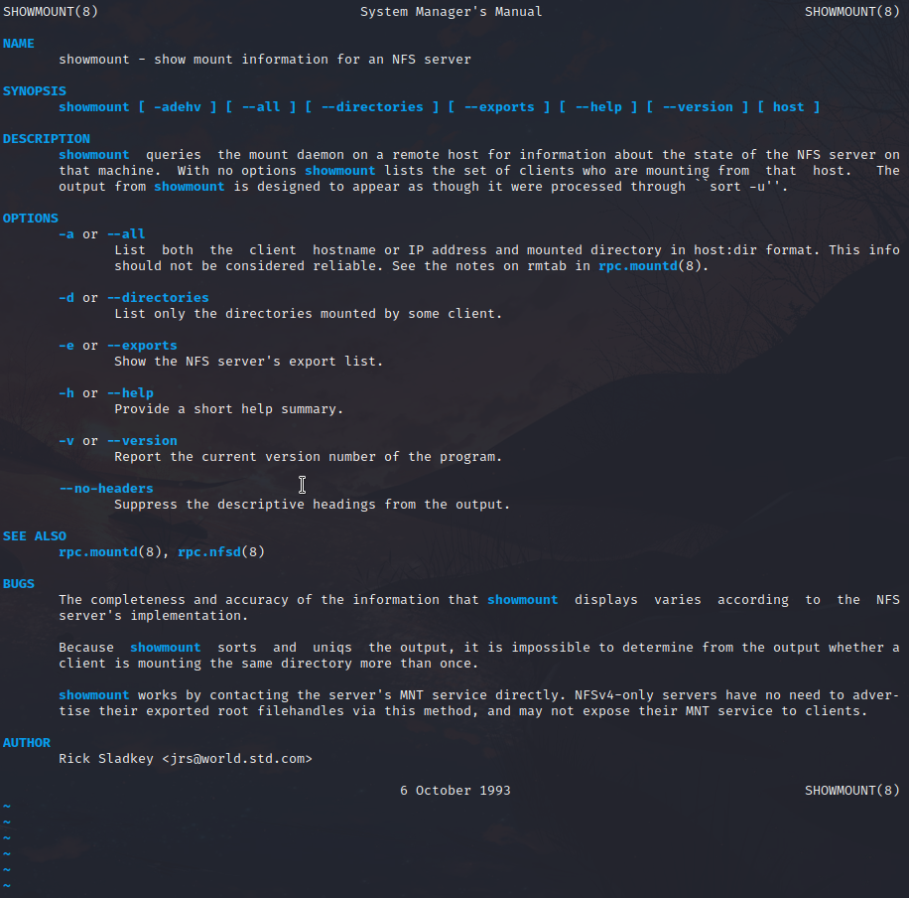

This is how we use showmount to get the desired nfs file

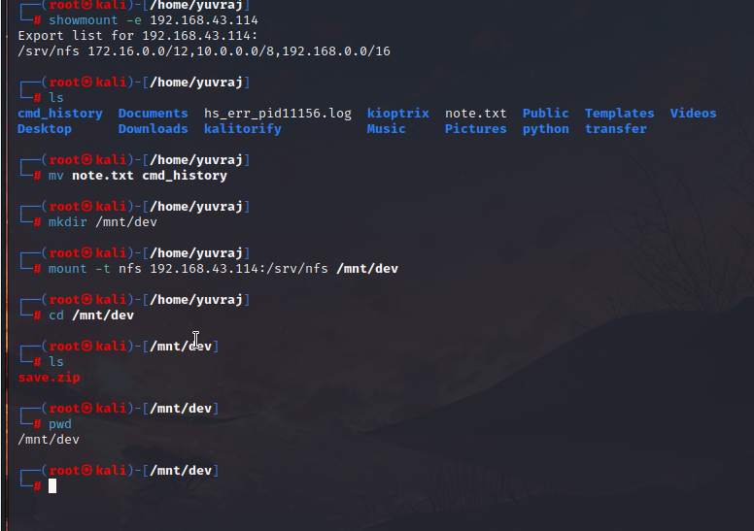

If we found a zip file which cannot be opened without password then we can use fcrackzip

Here -v is verbose means that we can see the working of the behind scences,,-u for zip file and -D for dictionary attack and -p for a file bascially we are using the wordlist to crack up the zip file.

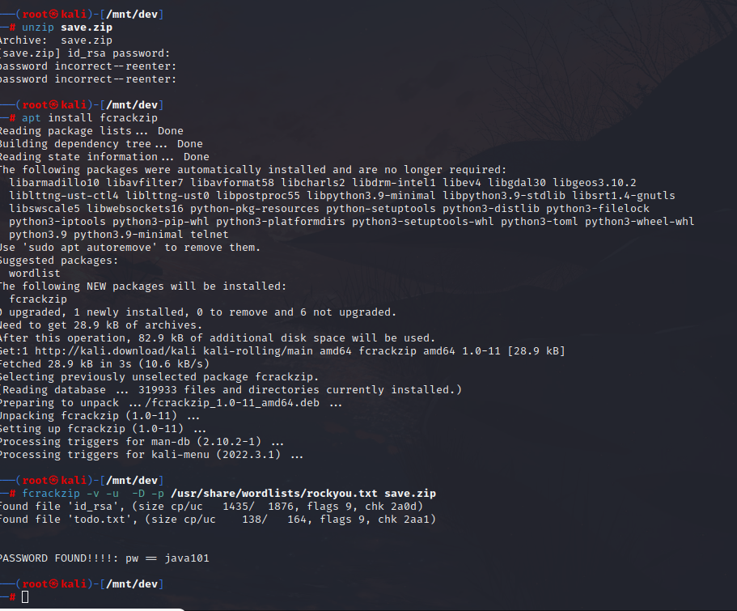

This idrsa file can be used to use ssh and get the access but we are not sure of it.

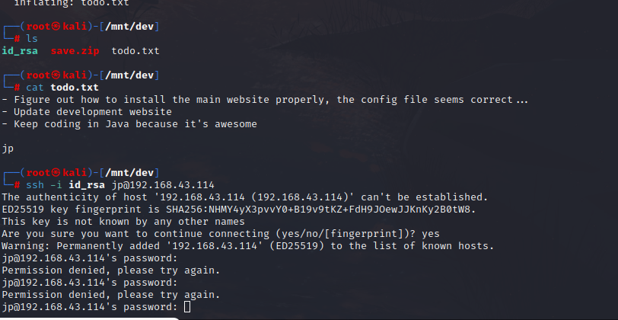

The different pages we fount out after the ffuf scan so we checked all manually.

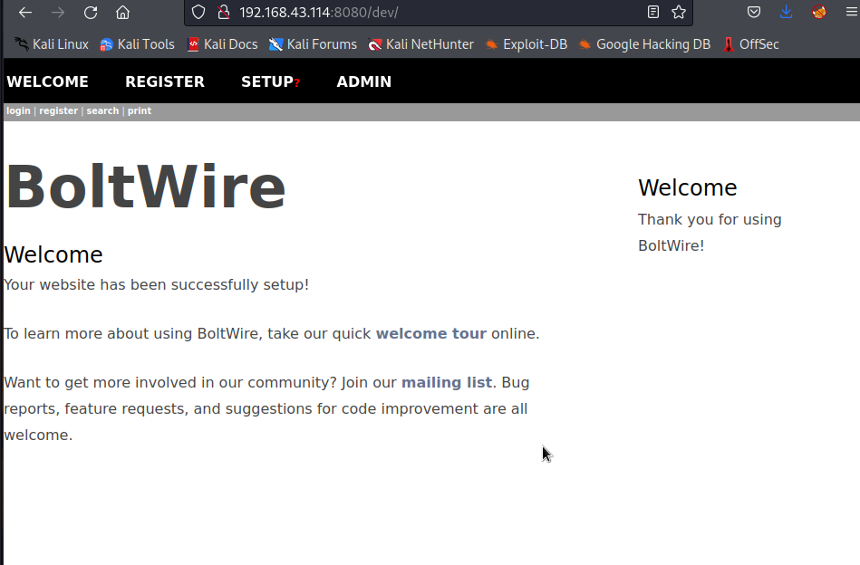

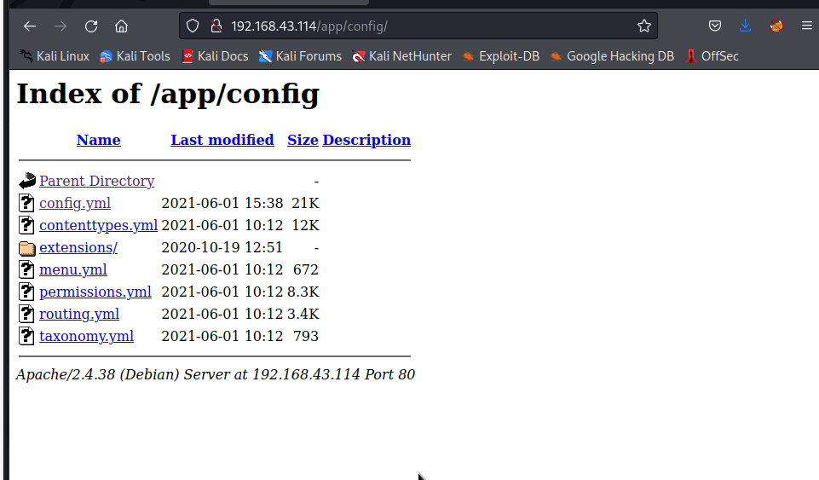

After getting the config.yml file copied and then going to the bolt wire page now we are trying to exploit boltwire.

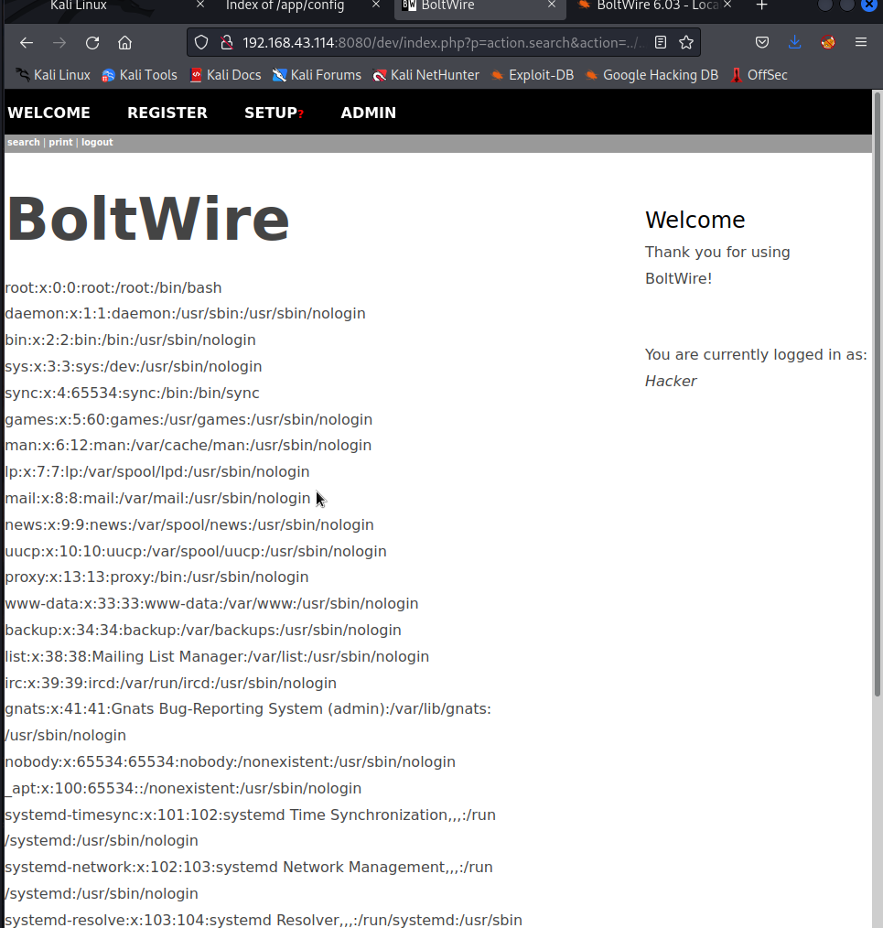

After gathering the info about the user we go the user exploit success.

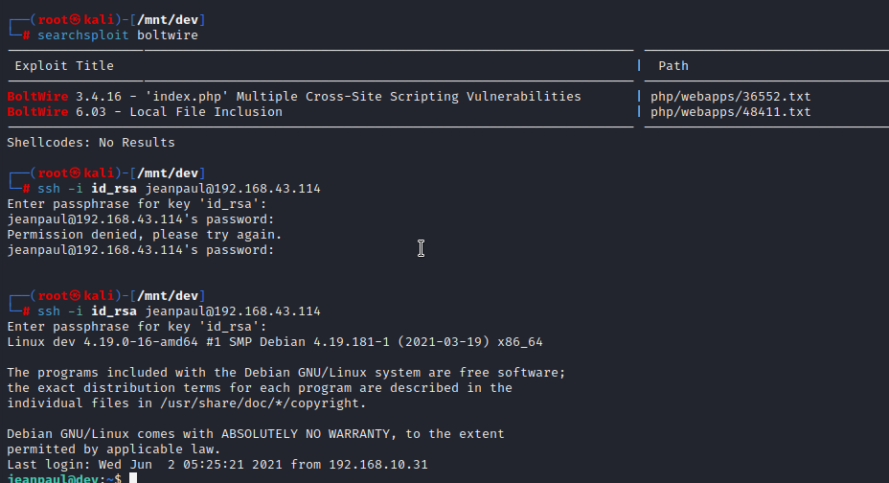

We got the user access but there is not root privilege there.

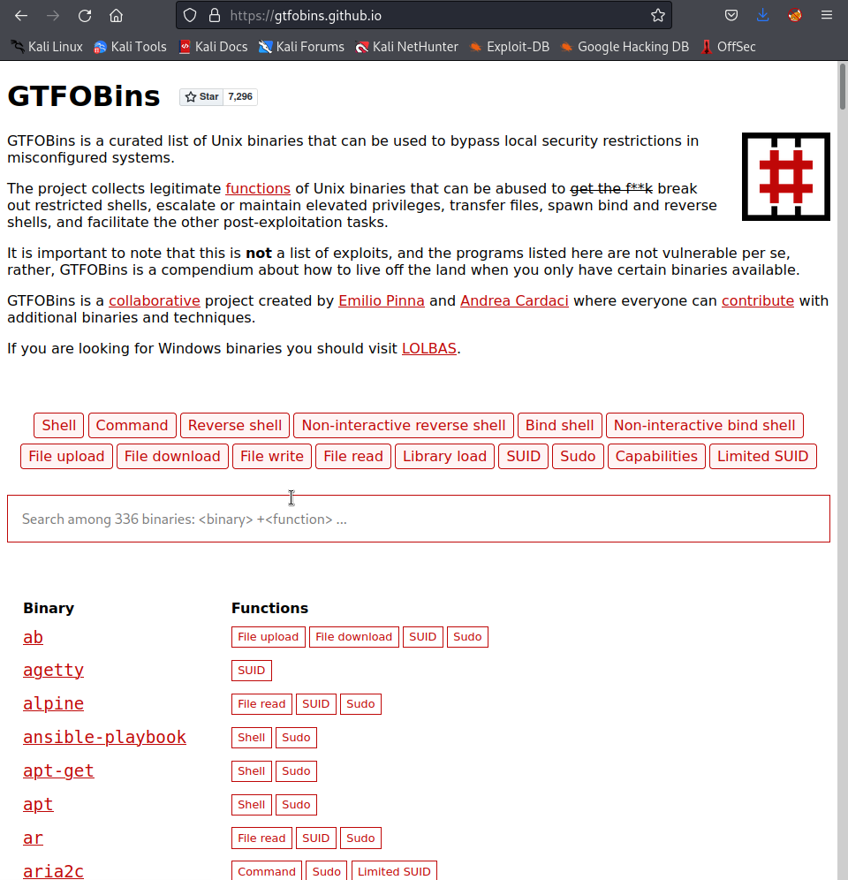

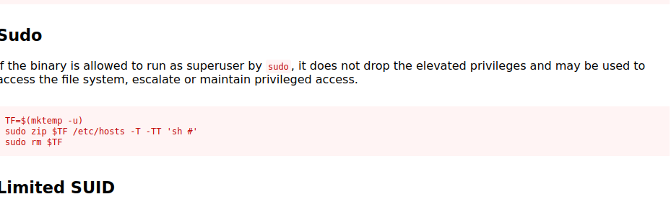

Since the user has given open privileges to the zip therefore we expoit it..

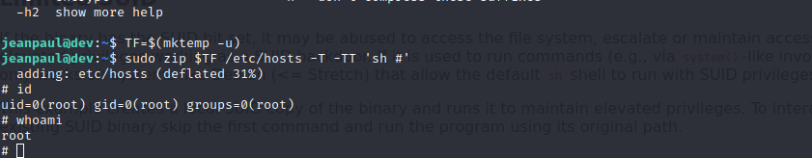

Finally we did the crack.

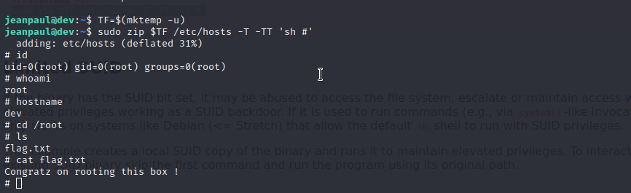

Butler exploit -------

1. As usual do a netdiscover scan for the ip
2. Then do a aggressive nmap scan on the ip.
3. 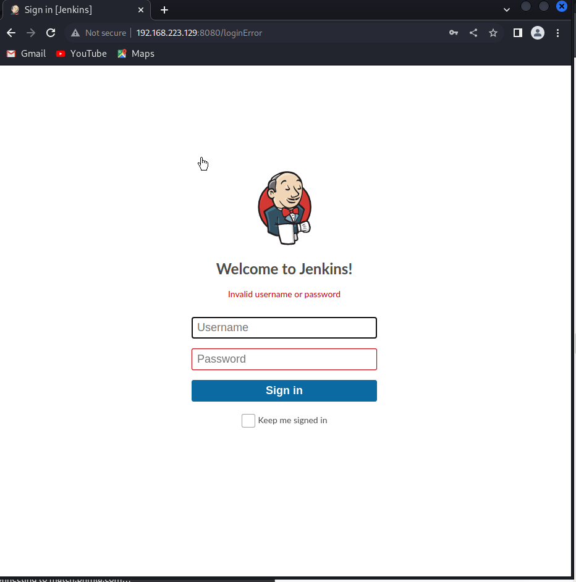
4. After the nmap scan we will go for the website open port and try to crack the website above.
5. We can do it by many ways try search for jenkins exploit .
6. 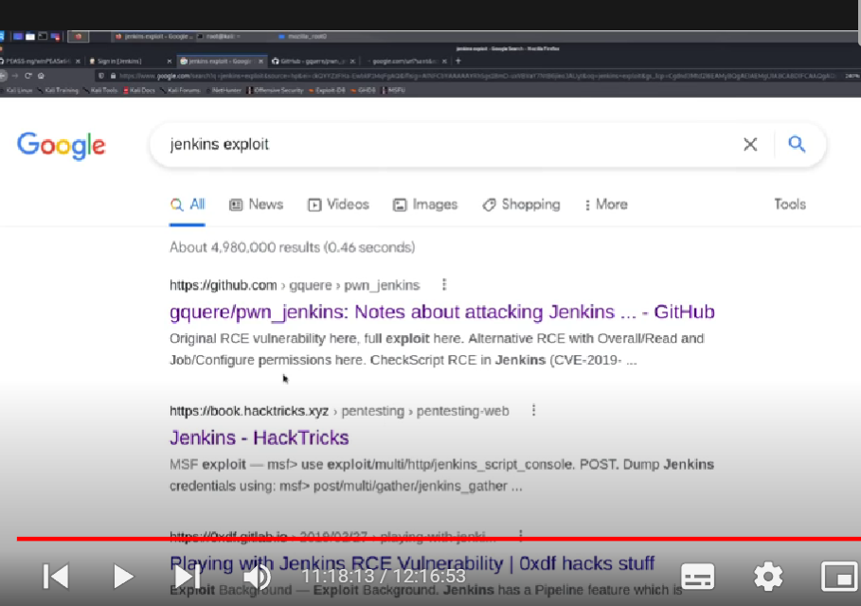
7. 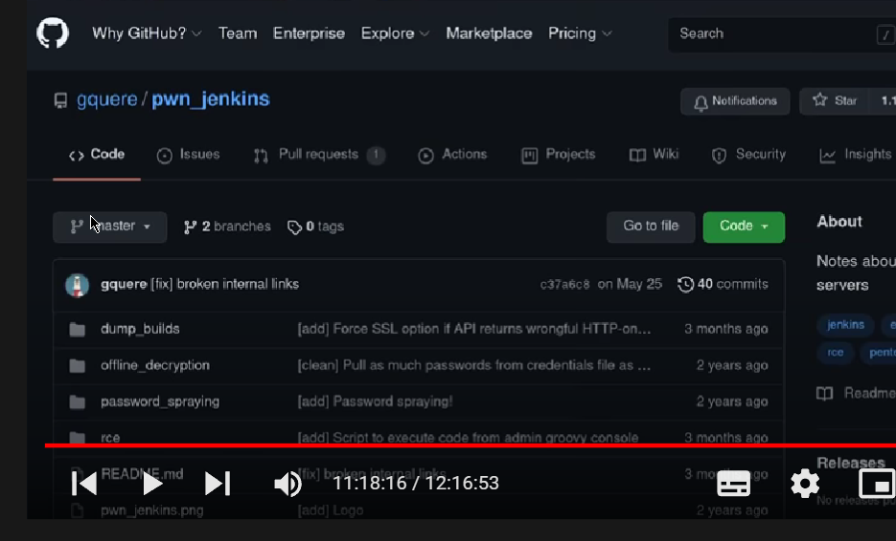
8. 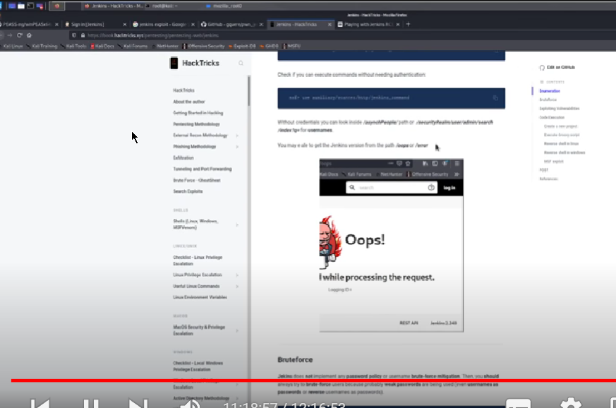
9. 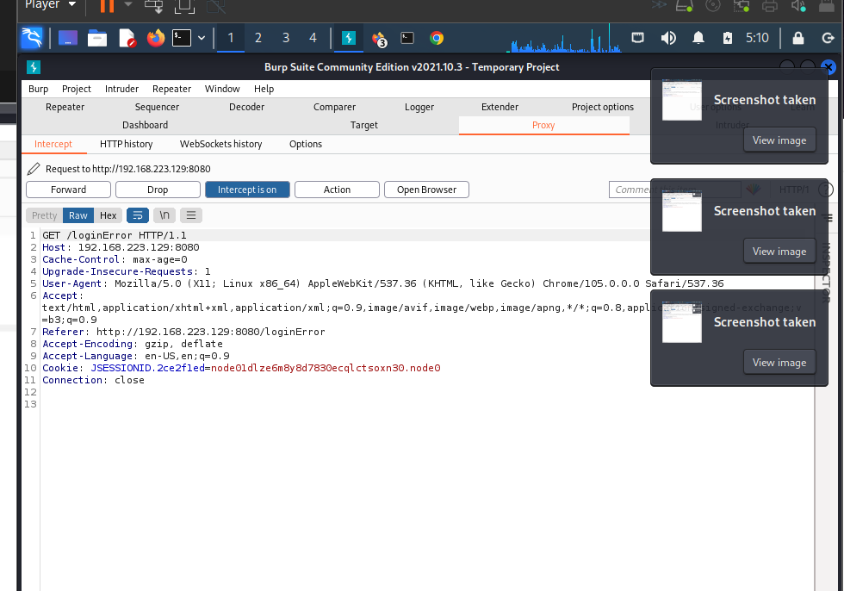
10. 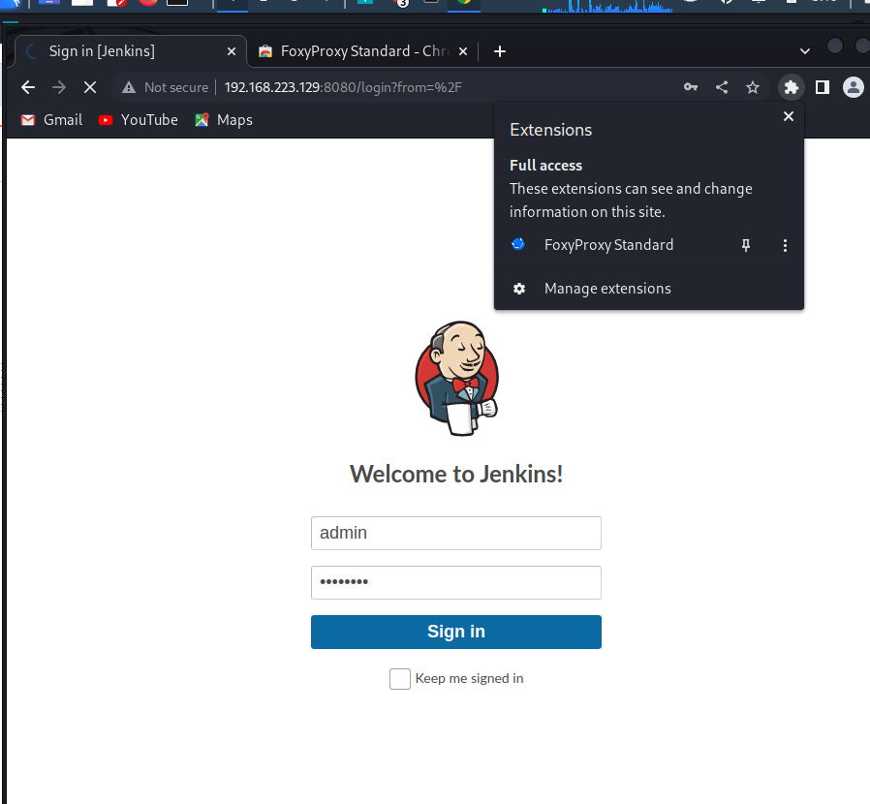

We are using froxy proxy and burp suite together.

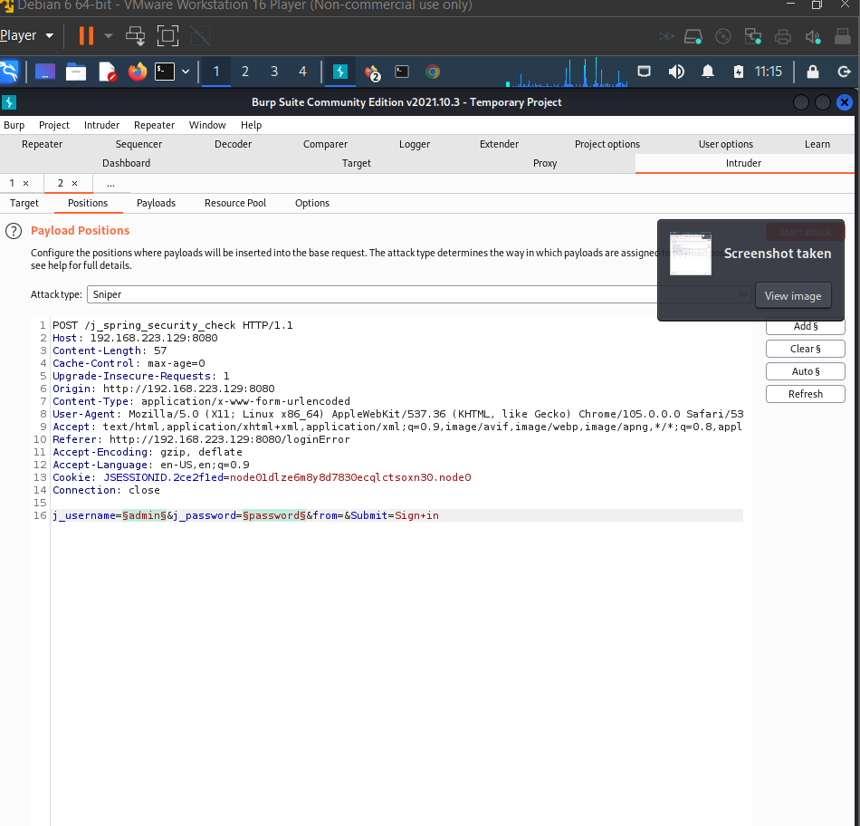

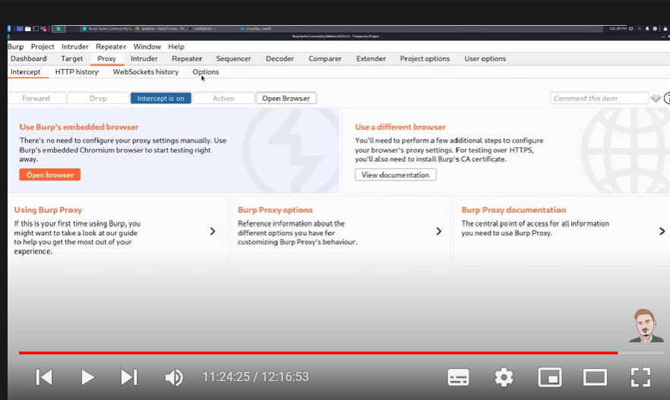

First make sure intercept is on.

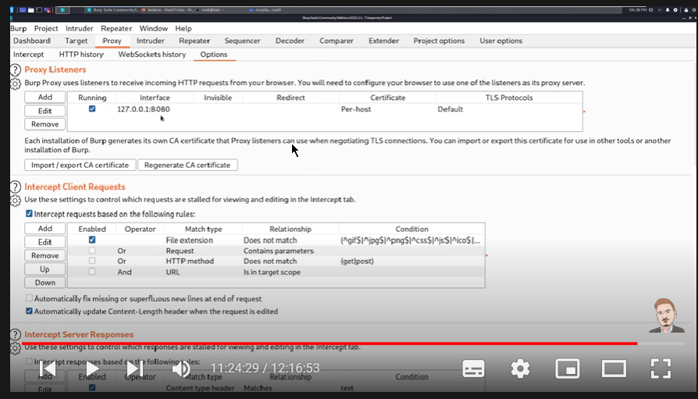

Next is to check the proxy settings and for that we use the foxy- proxy extension.

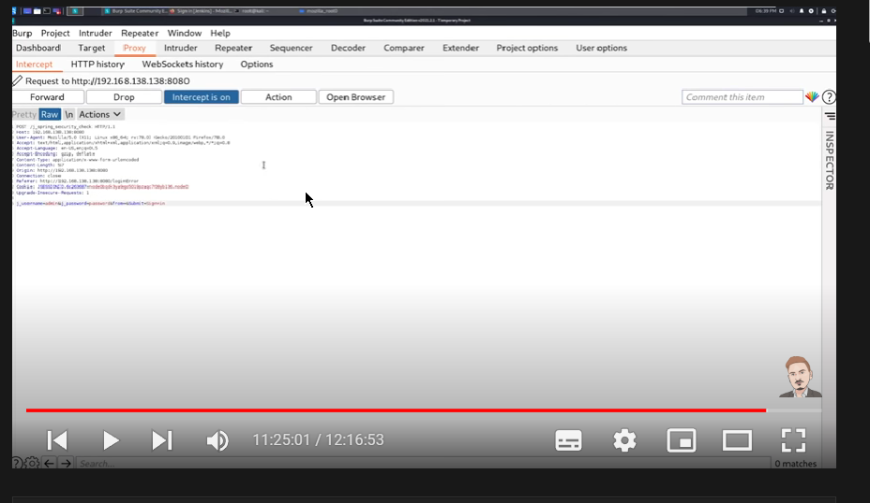

After this the above page will be opened directly

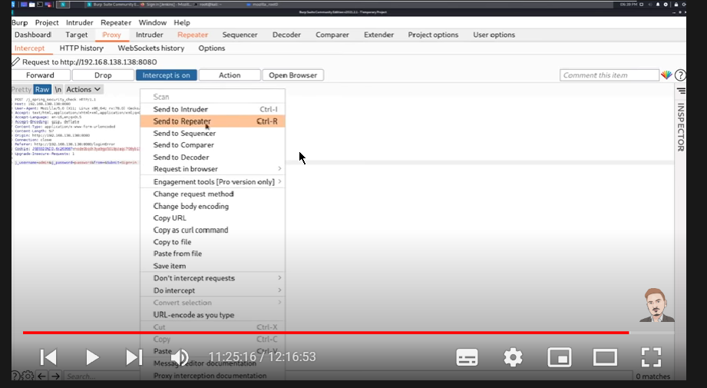

After that right click and send to the repeater first and than the intruder.

This the repeater.

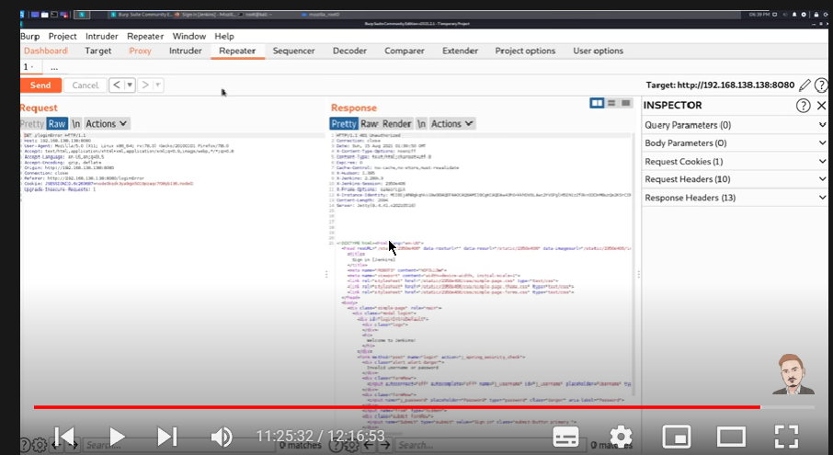

Note with the help of the repeater we can brute force but one at a time

So with the intruder we can brute force with a large number of user and passwords at the

Same time.

This is what intruder looks like than we can do differnet type of attacks.

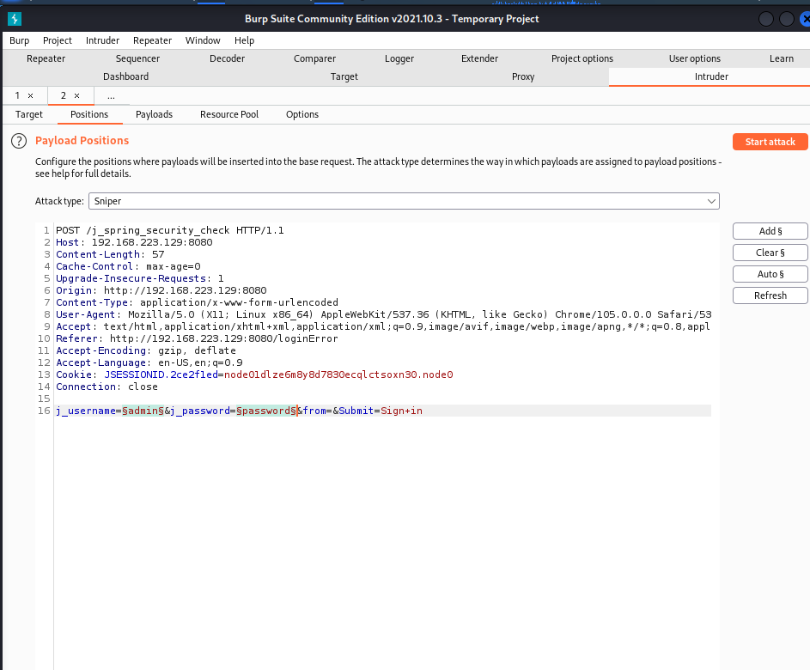

More about burpsuite and the attacks

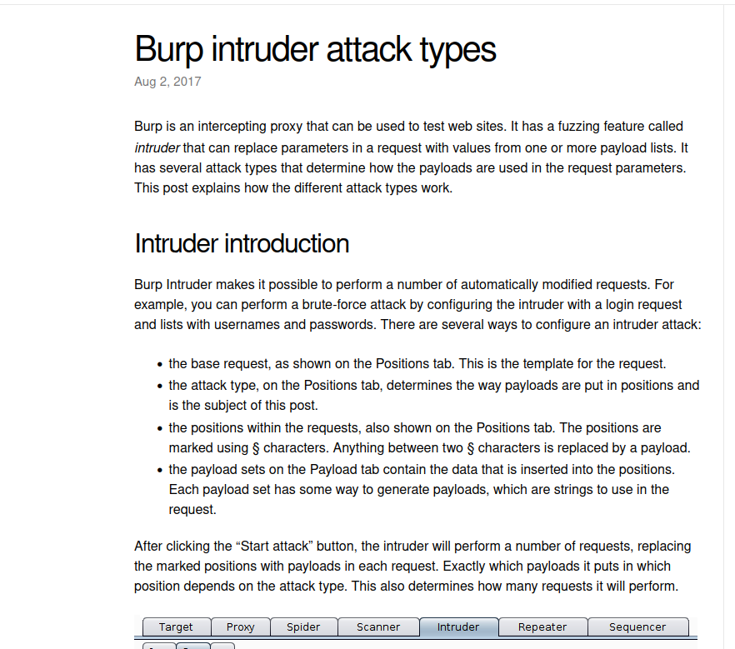

1.sniper

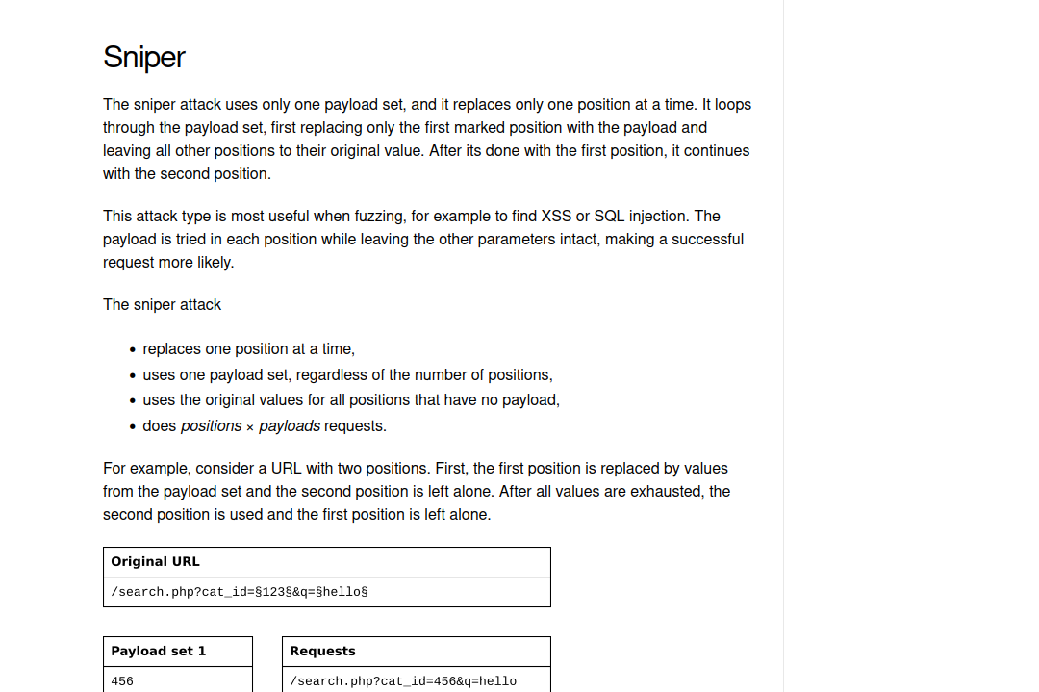

2.battering ram

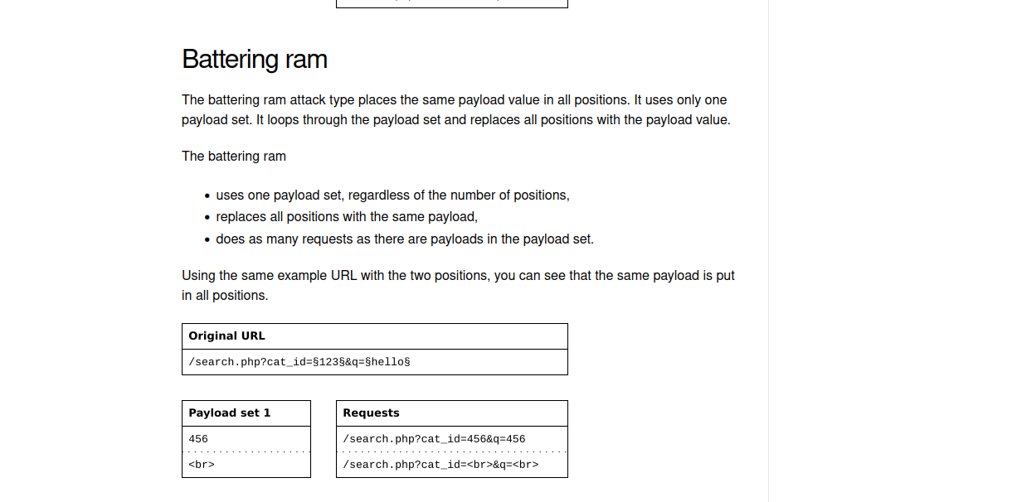

3.pitchfork

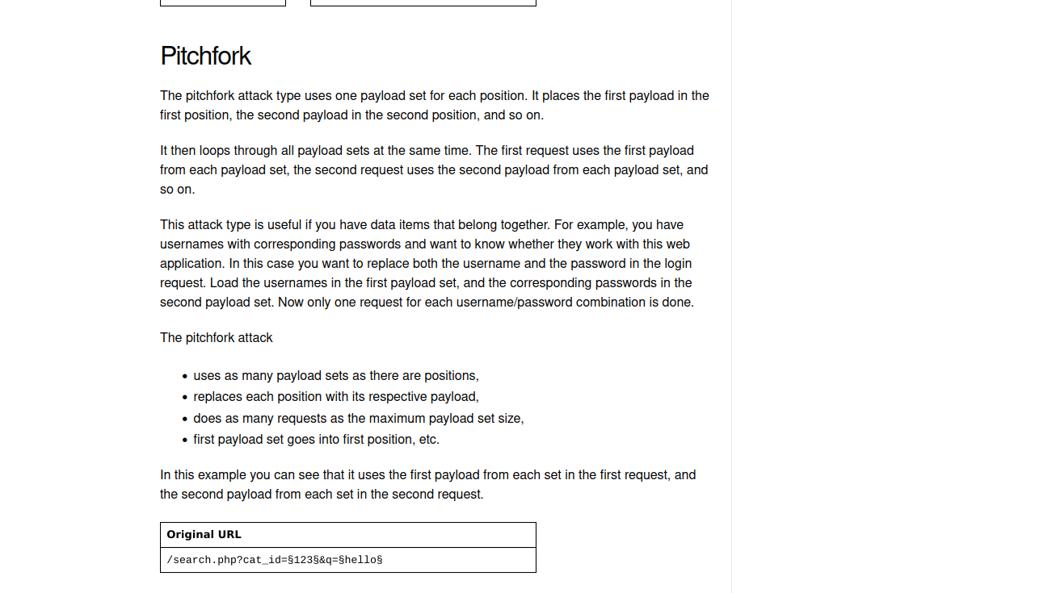

4.cluster bomb

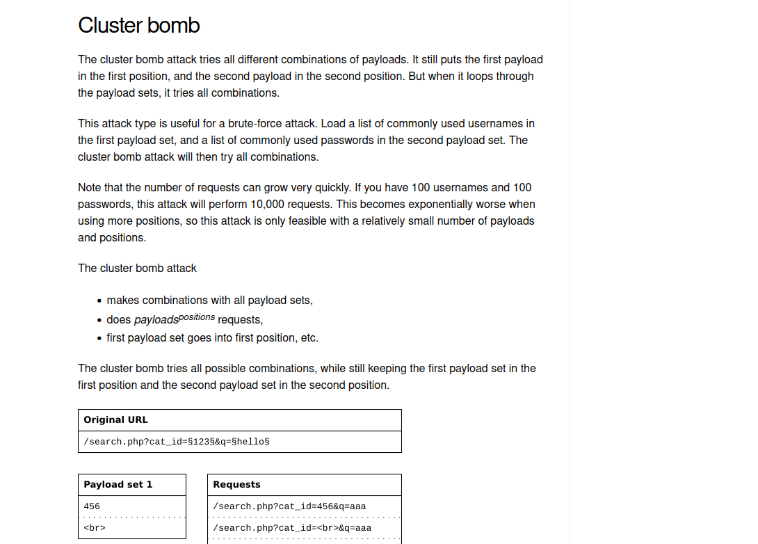

Here we did a cluster bomb attack and given a set of passwords with the user name.

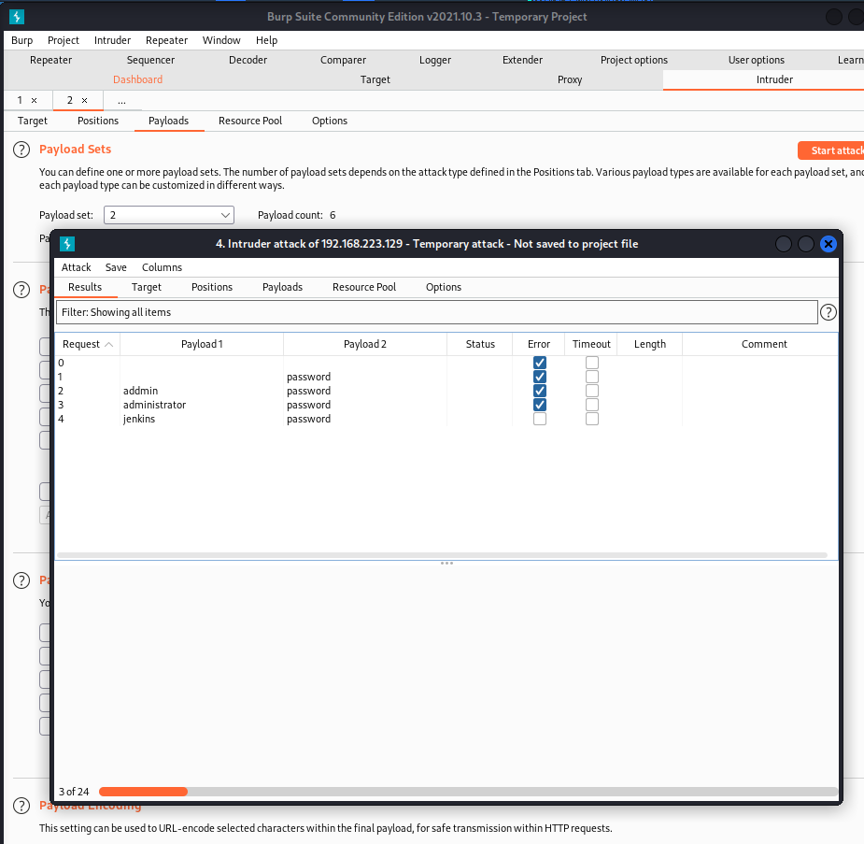

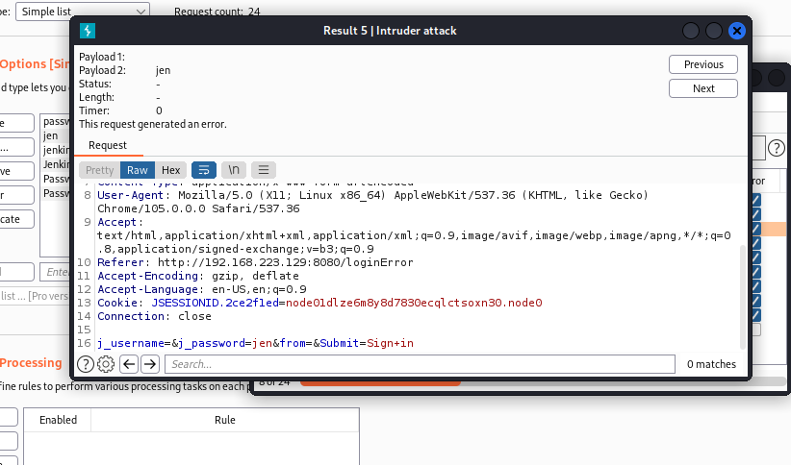

We have to see the lengths beetween different type of length or some changes in the attack.

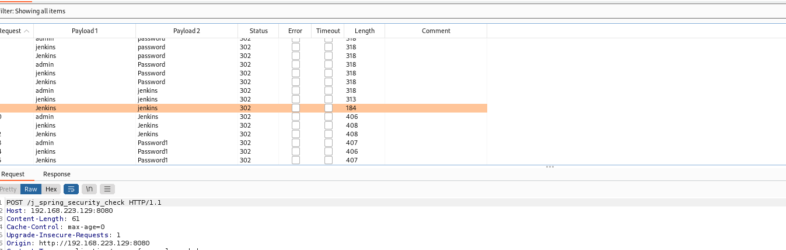

After this we saw the change in length therefore we conclude that jenkins jenkins could be the

Credentials.

And ya we nailed it.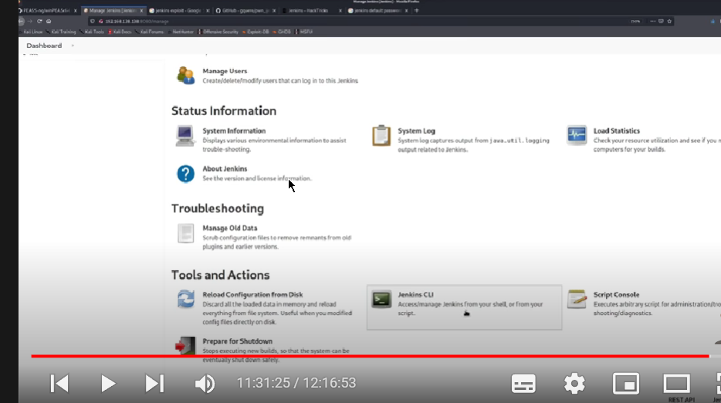

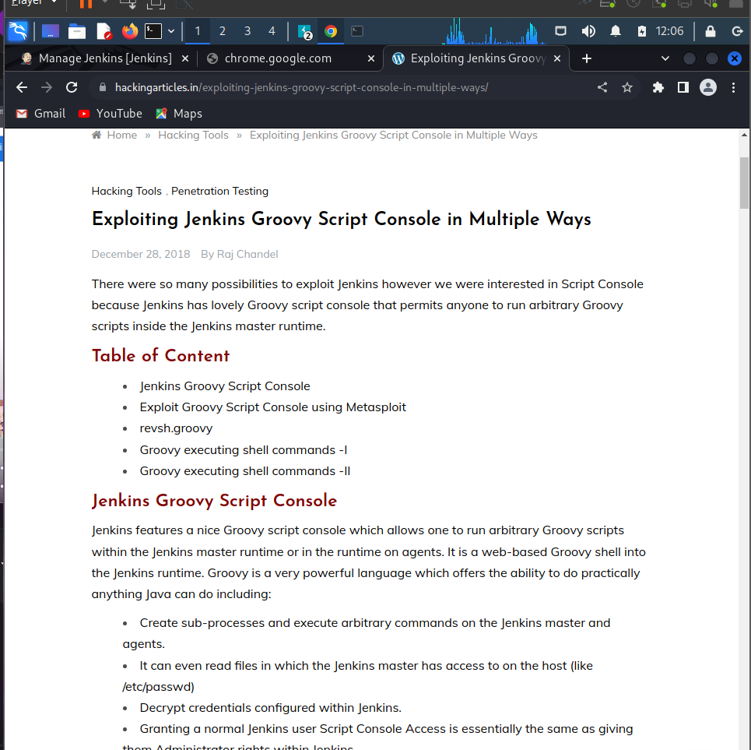

Here there are more than one way to exploit the jenkins script console which is grovy.

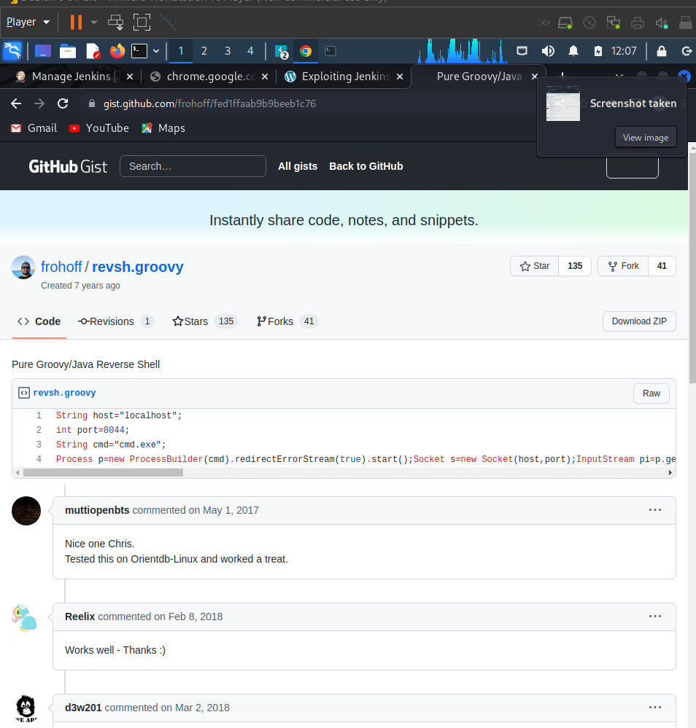

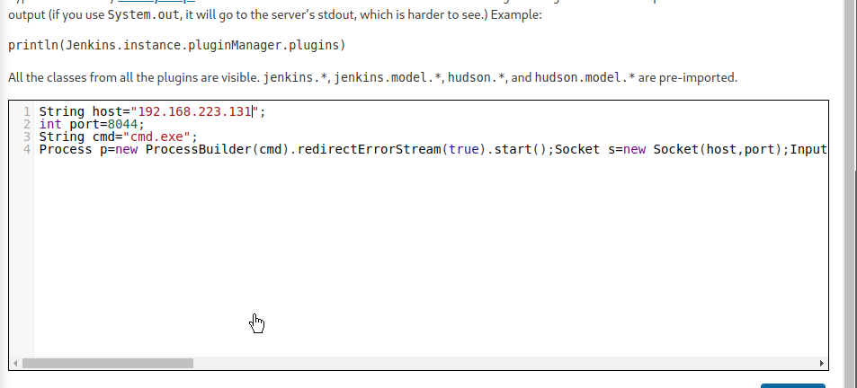

Running the code here but first setup the reverse shell

At the same port type the command at cmd

Nc -nvlp port same as that in the script console.

And ya we got the machine

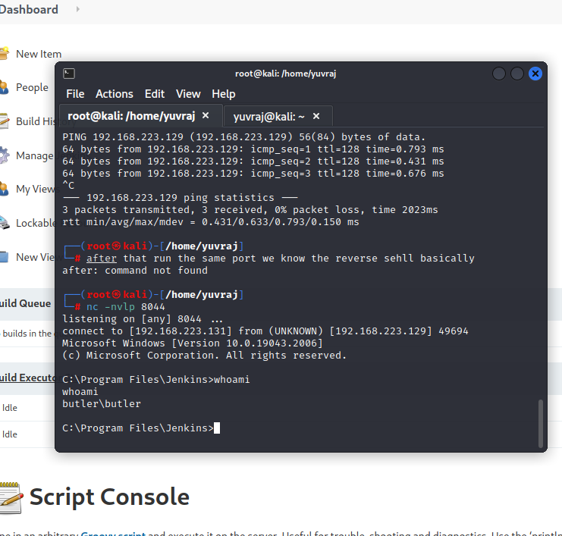

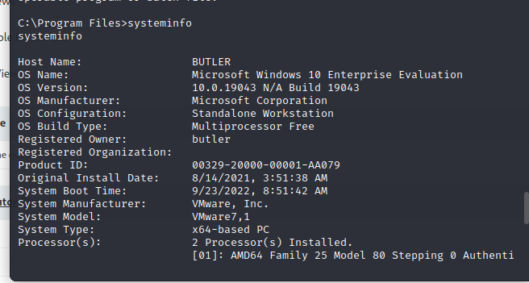

Command that we should consider after getting the user priviledge to get the root privildege.

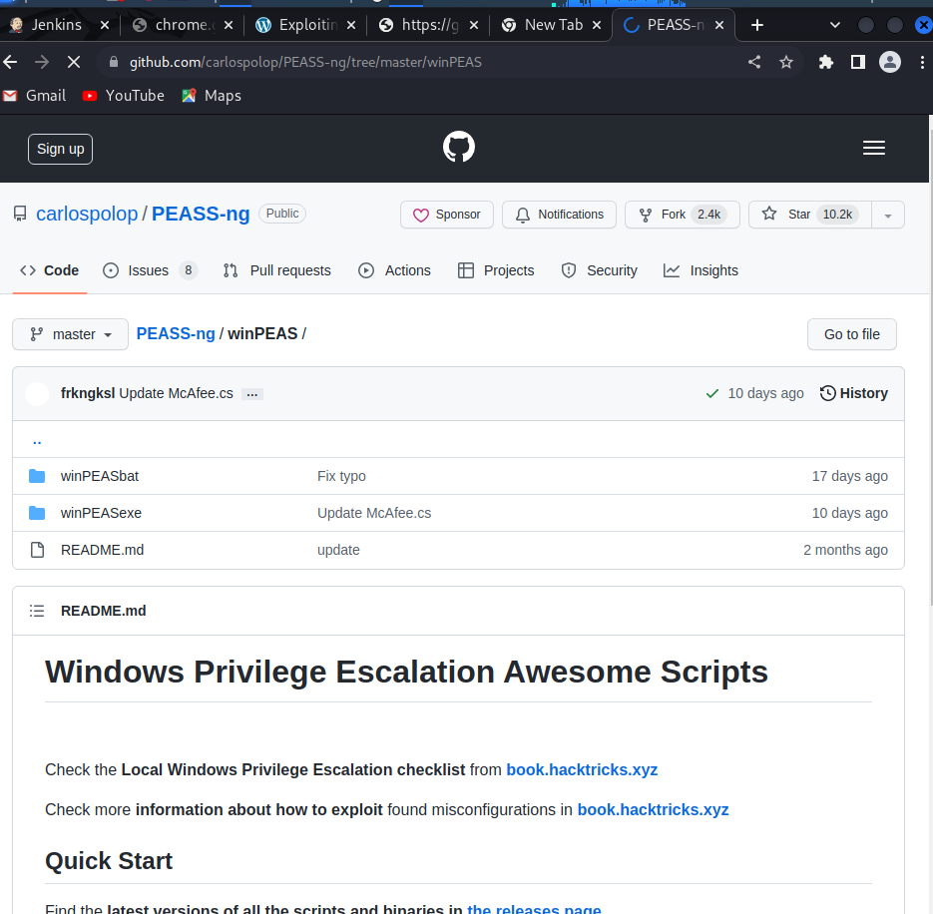

Winpeas or windows version of linpeas that we used before.

Hosting the server.

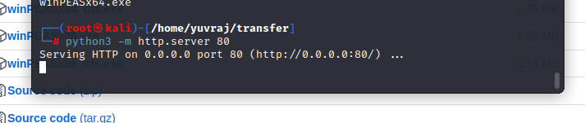

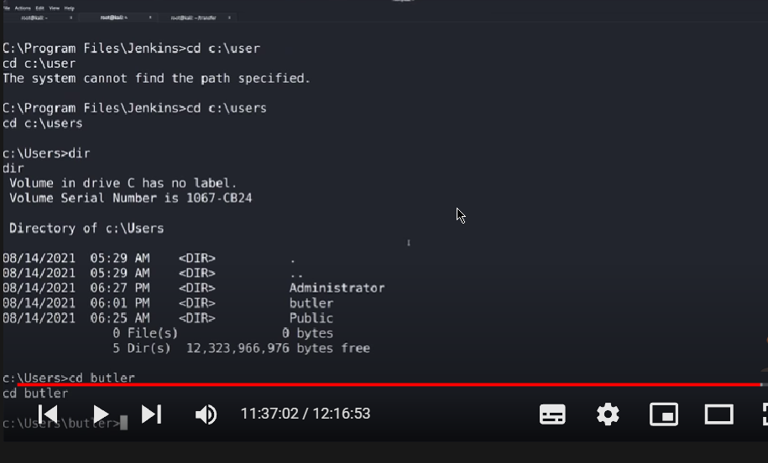

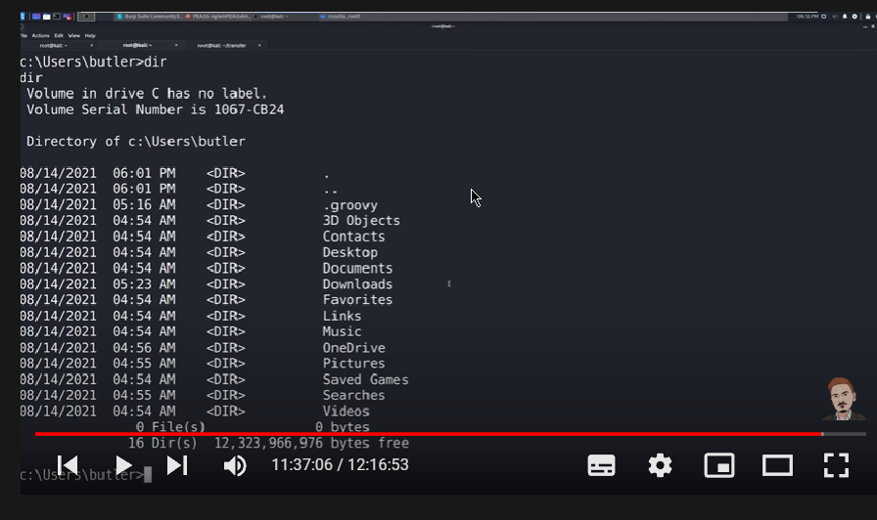

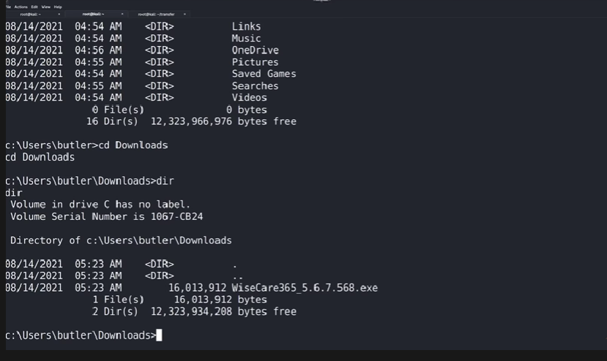

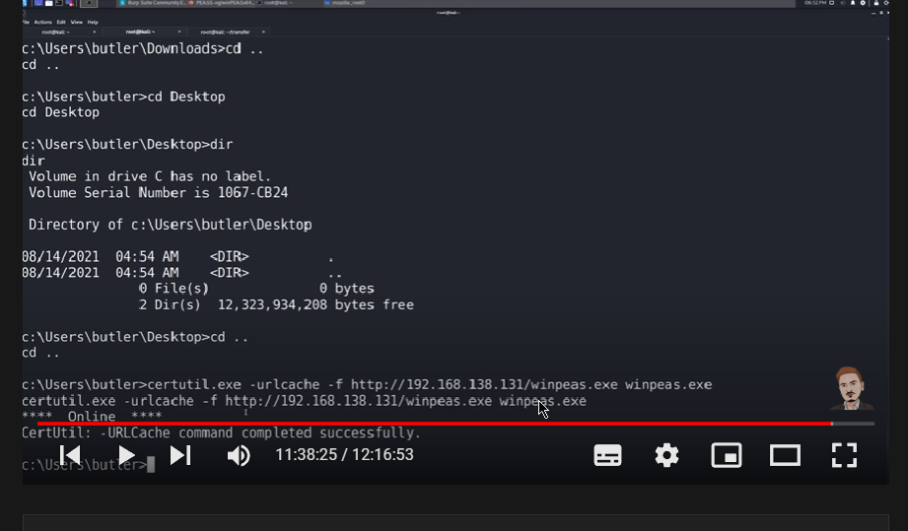

This is how we get the file from the our machine to the host machine.

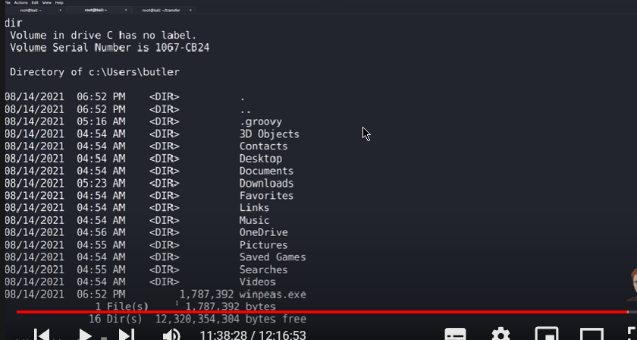

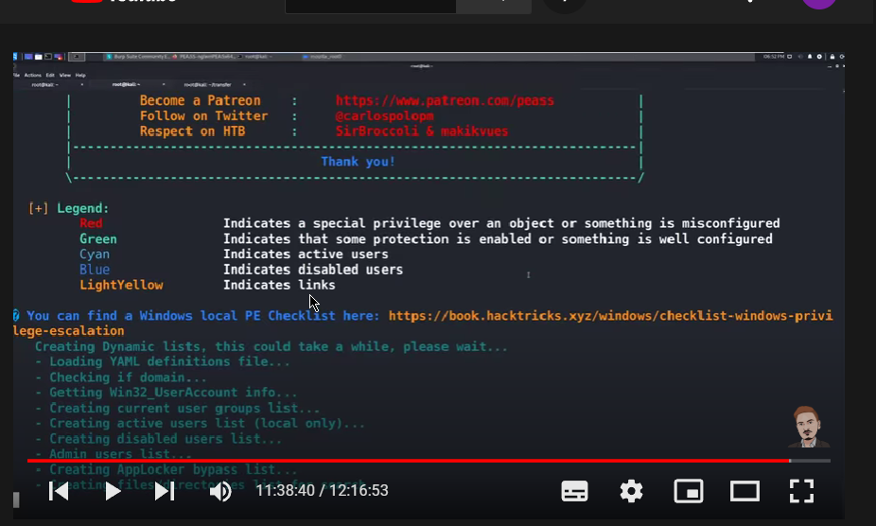

After putting winpeas run it.

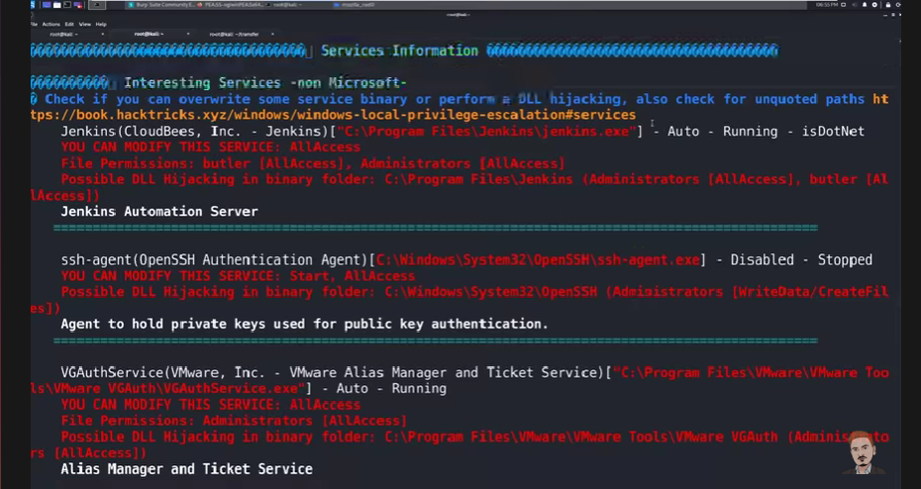

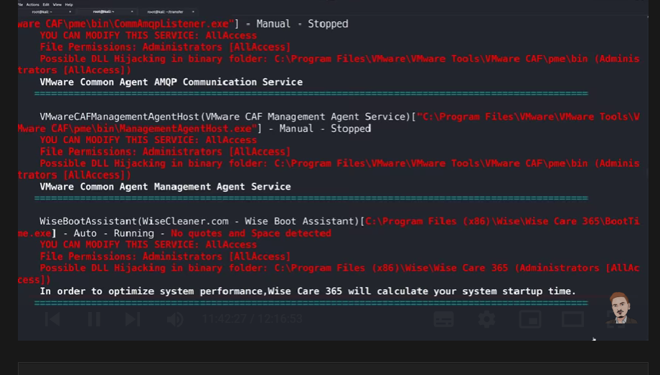

This file is important----

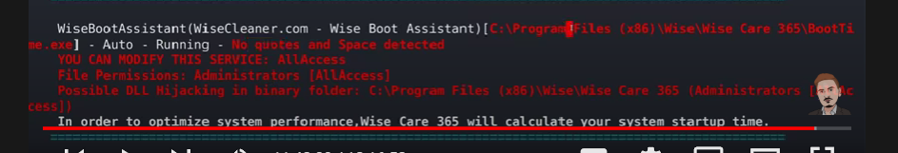

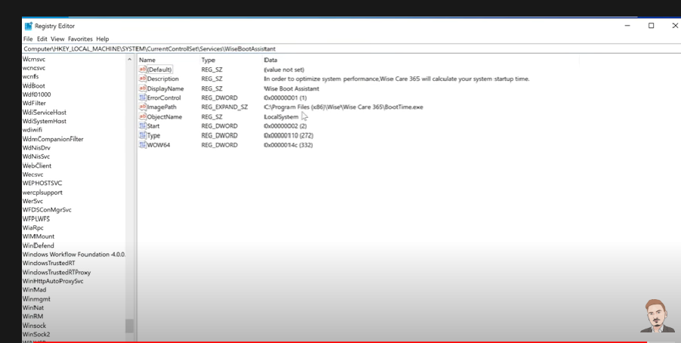

There should be quotes around the file path but there arent any.

Unquoted serive path means ther is no quotes to the path to protect it from being explioted.

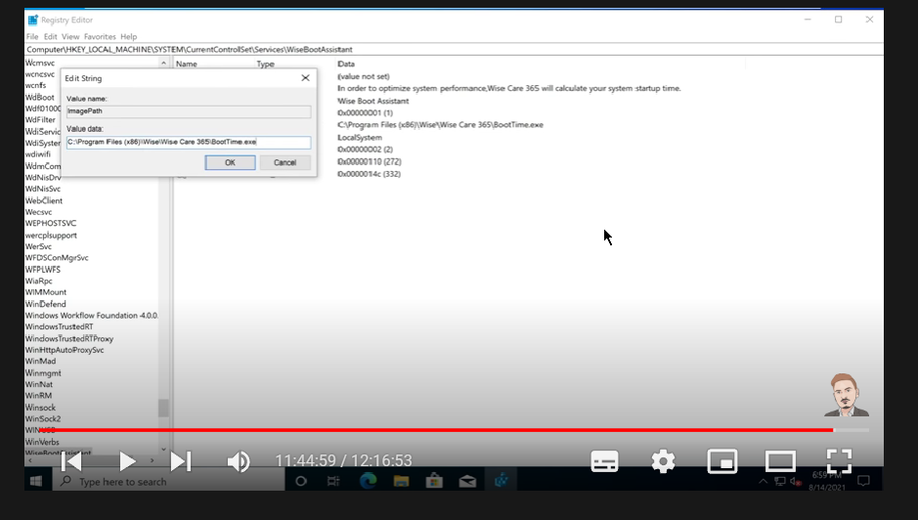

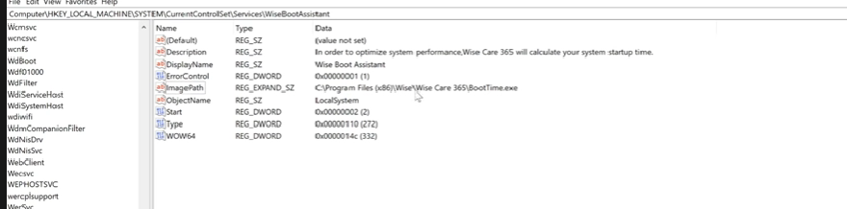

This files looks that we can manipulate it.

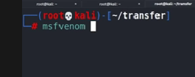

After this we are going to put some malware in the folder that we found can be manipulated.

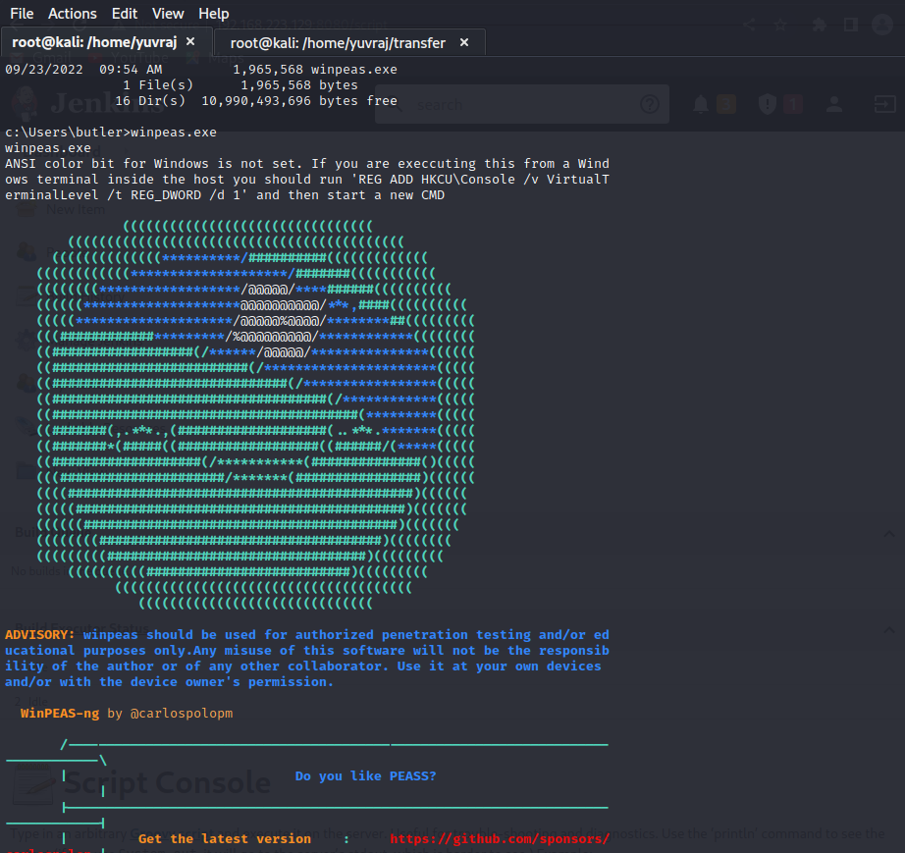

My linpeas worked to.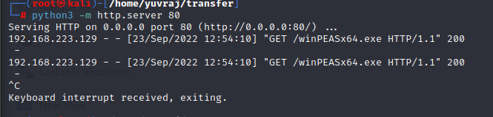

Note we also need to share the folder form our side or the attacker side.

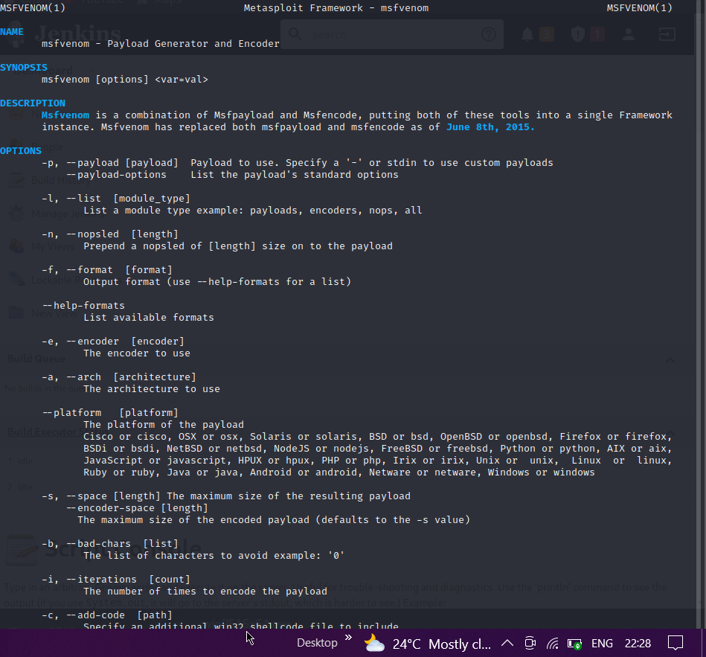

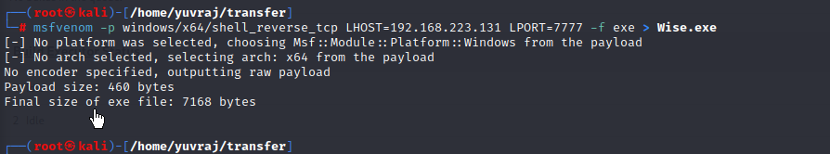

Droping a malware in the wise folder..

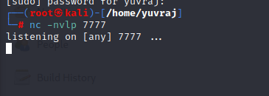

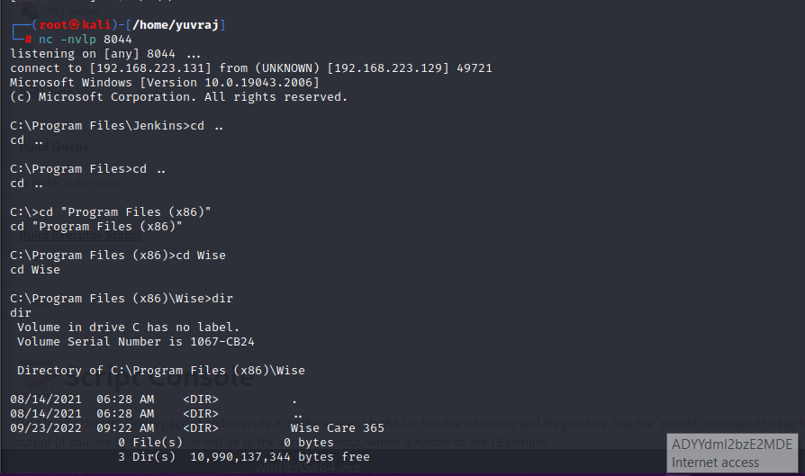

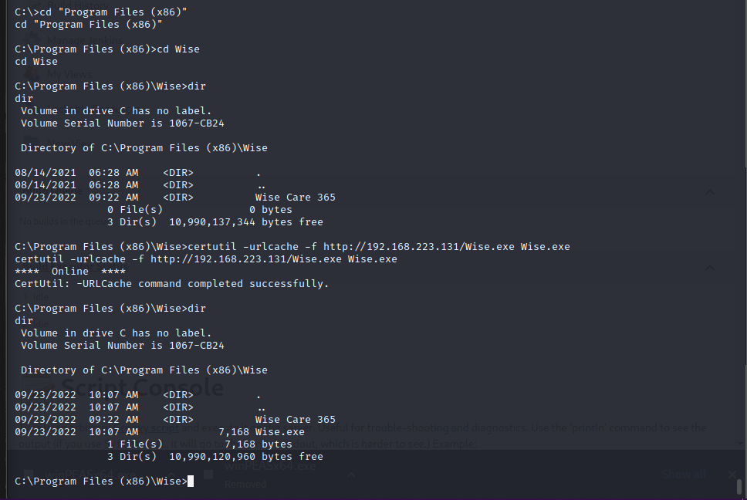

This is something differnet we can get the info in linpeas tho.

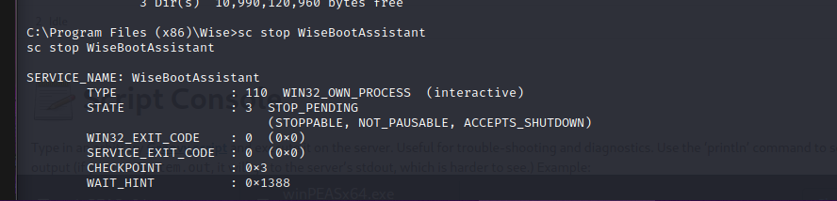

Note –l like we run any service in linux throught the systemctl here we are using the sc command.

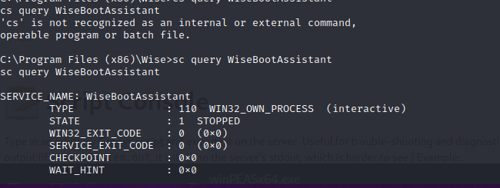

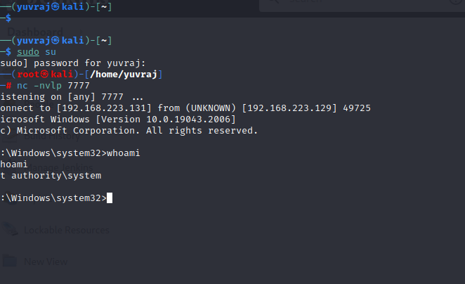

And there we exploit the machine.

If I conclude that after getting the butler priviledge or user one we

Get the winpeas from our machine and host it to the host machine

After that we run the winpeas and search for some beneficary content

And we got the wise.exe folder which we can manipulate without the root privilege

There fore shared or forced a malware in that folder and run the msfvenom at port 7777 on anyhing that we want we did it this time manulaly and then

After that we change the directory to the program files x86 and stooped the bootassistant service and then stareted again to get the root privilege.

---- Black pearl-----------------

--- dns recon dns enumerating and scanning tool --

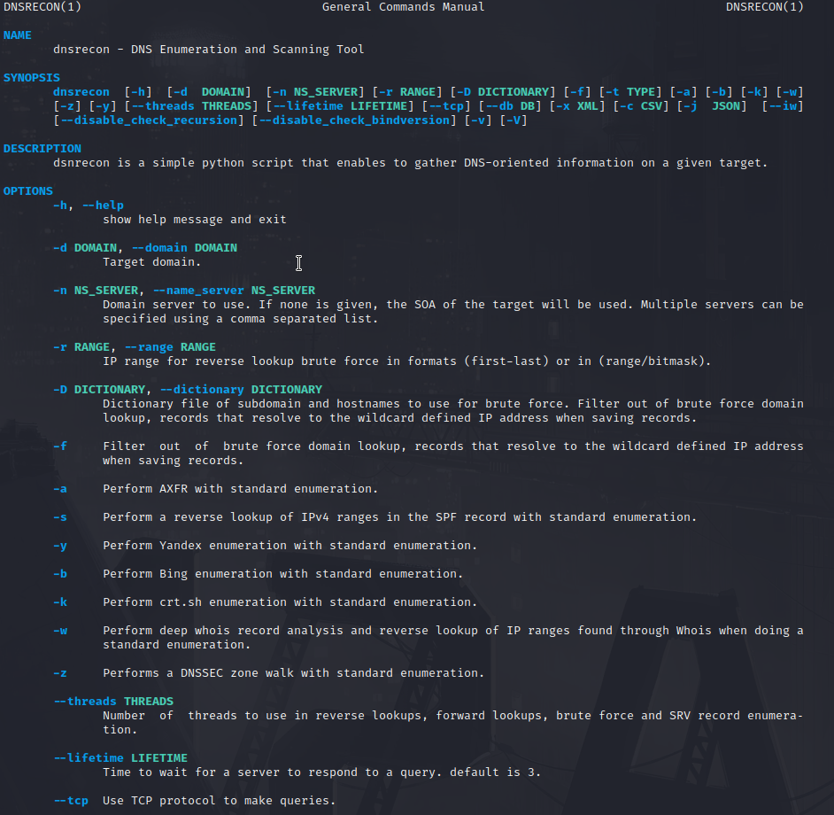

We will add the host ip in the /etc/hosts file. To complete the dnsrecon.

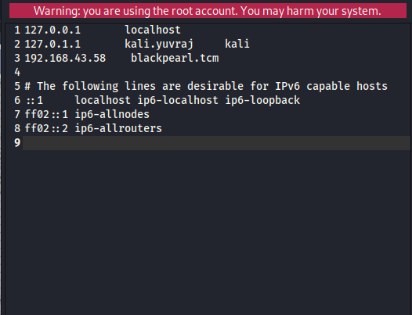

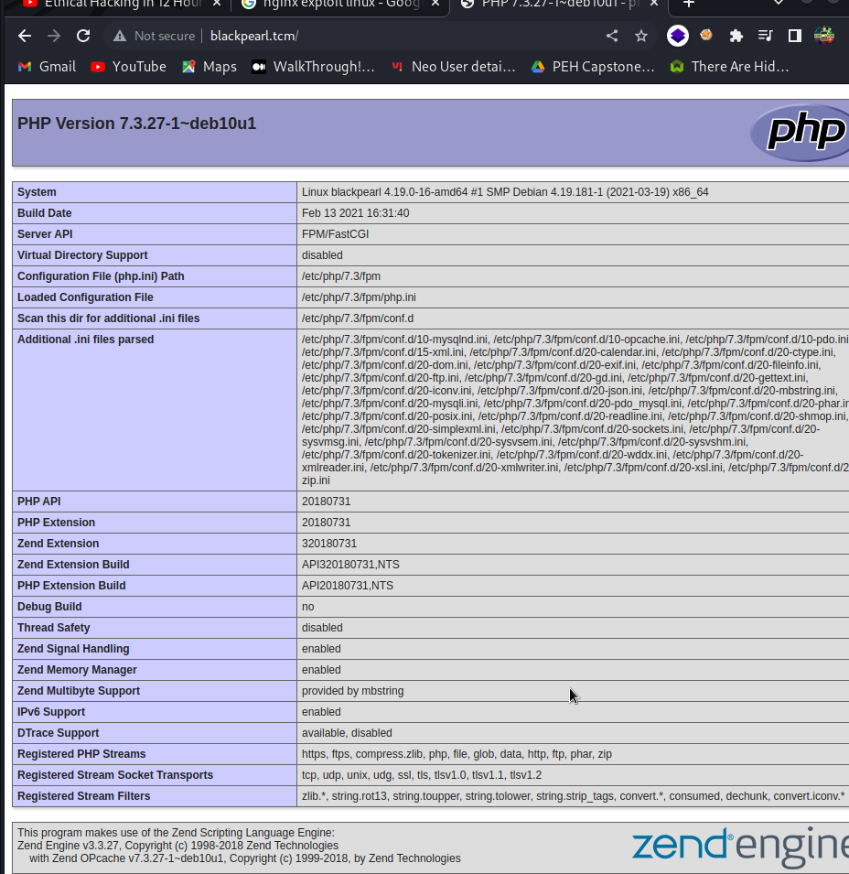

After this we go the http priviledge. After we get the php page on blackpearl.tcm we did a ffuf scan and got the navigator tree.

Where there is a login page.

Then we did google of the navigate csm and got the metsploit exploitation just copy that and run msfconsole

Set rhosts = the host machine ip

And vhost as the blackpearl.tcm

And run then the meterpretor shell poped up

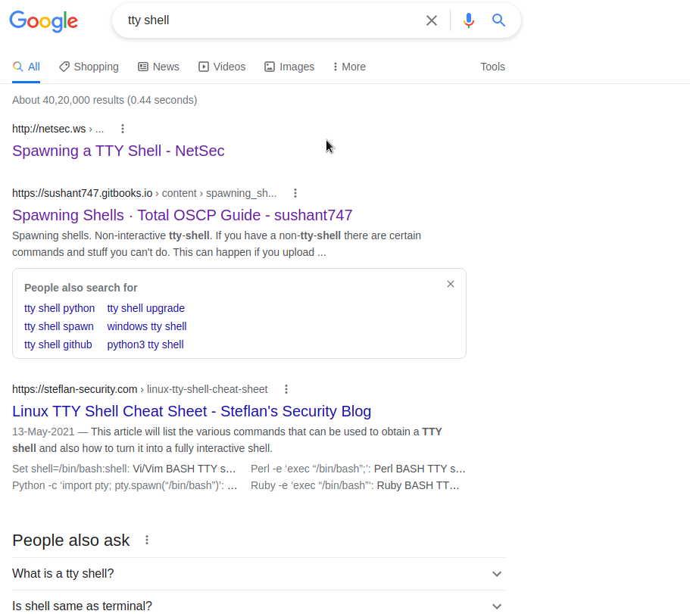

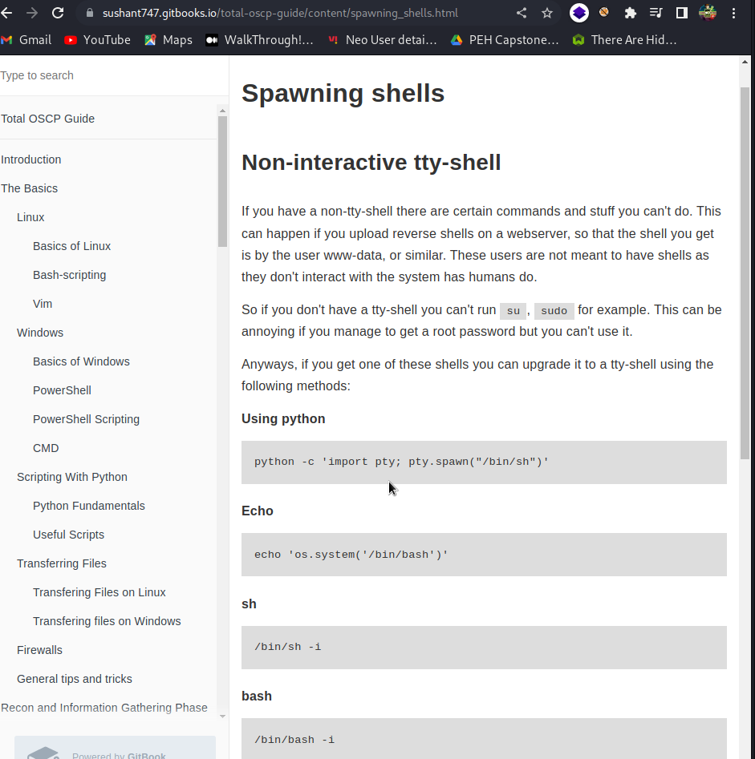

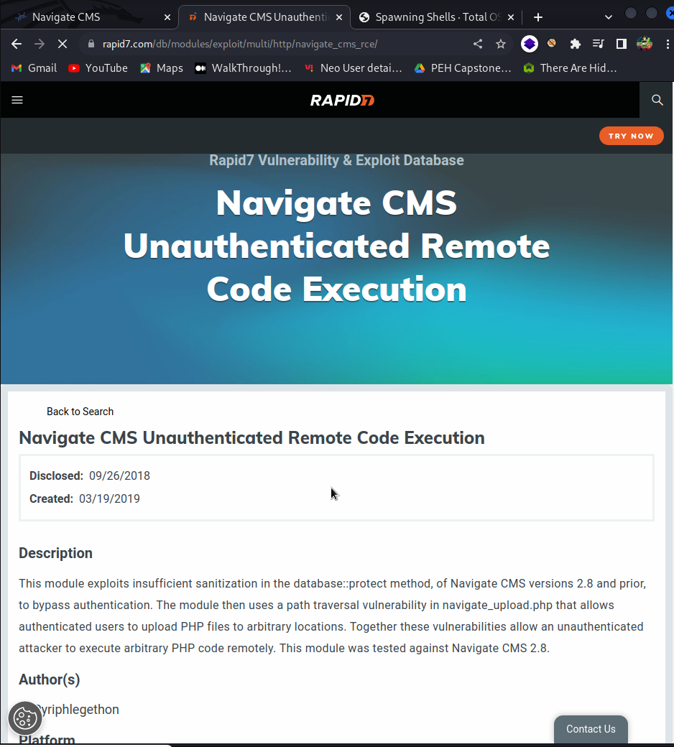

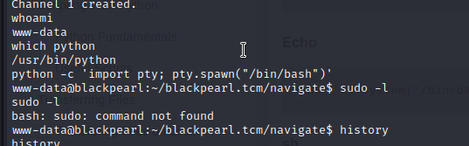

My linpeas is not working so I am using the screenshots.

Note – that we use linpeas or winpeas only for the privileged escalation

But we need to get the basic or user escalation first.

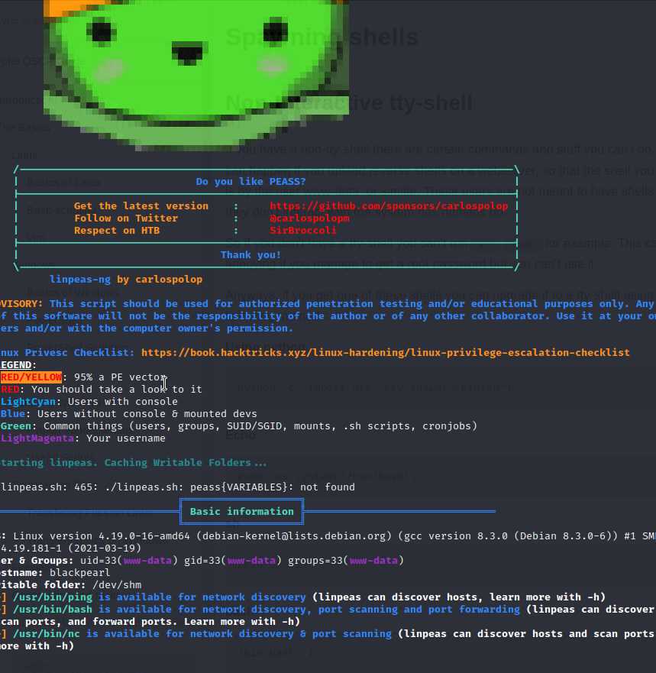

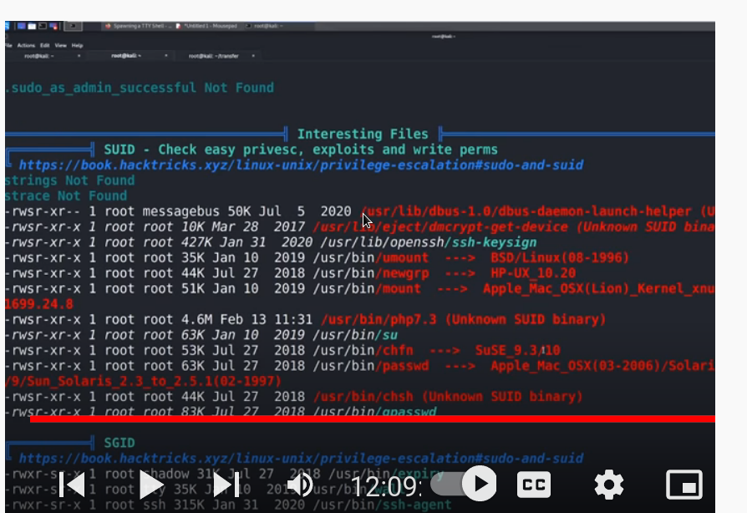

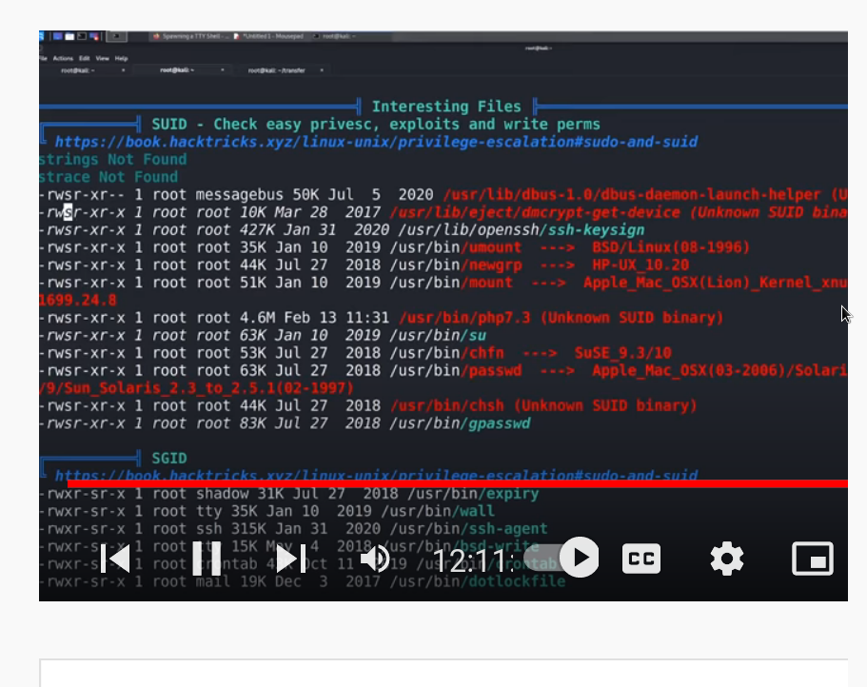



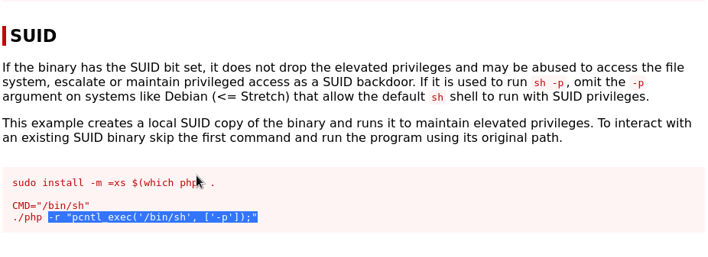

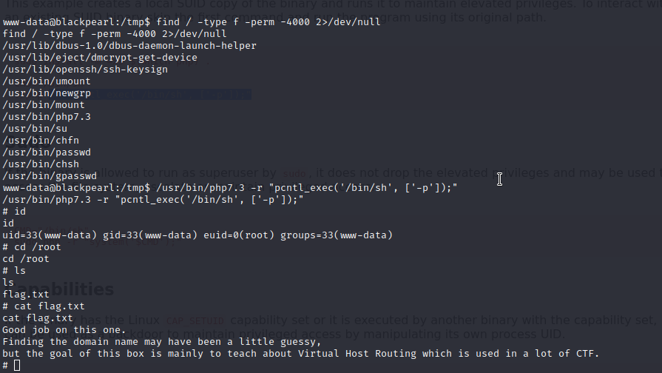

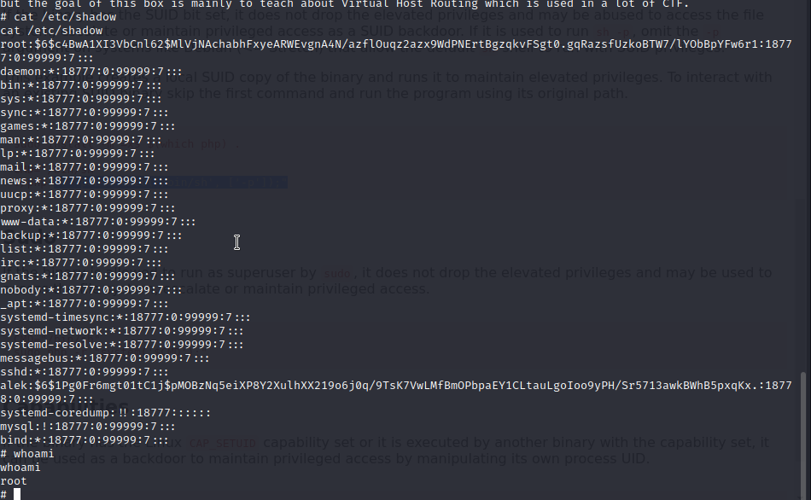

These are my network specifications from windwos.

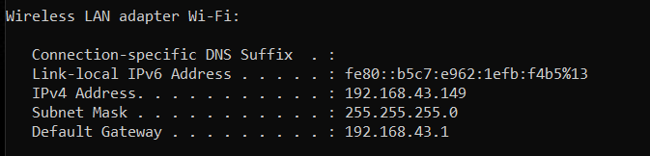

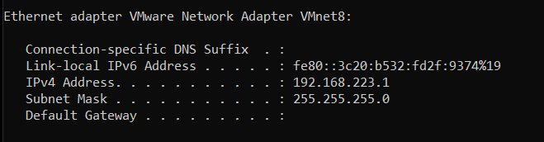

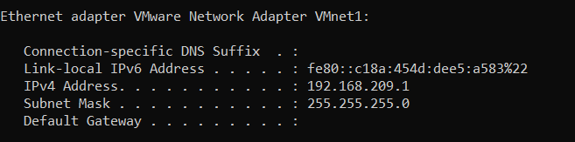

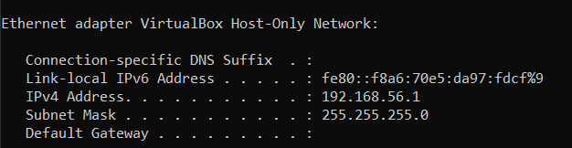

Some info about ip adress and the networking.

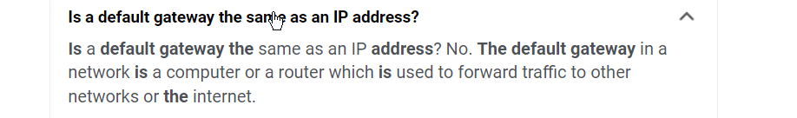

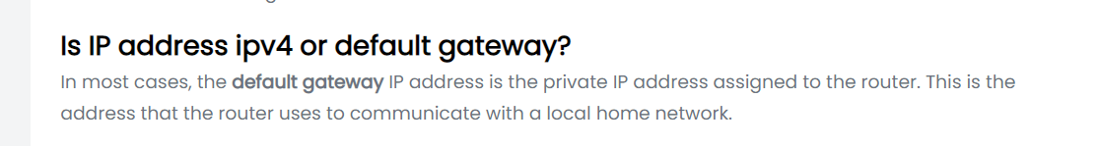

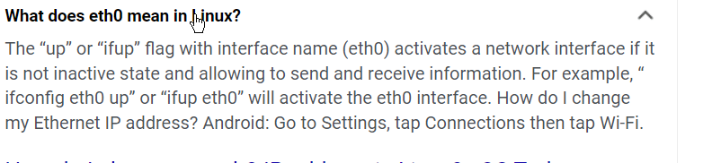

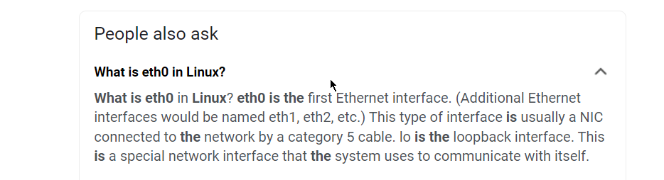

Breif on gateway ip –

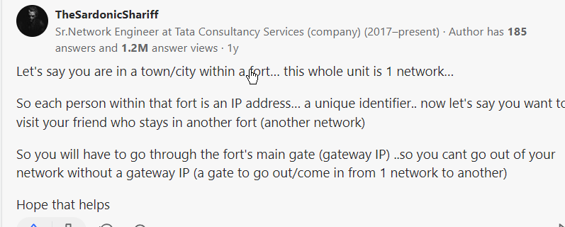

This refrence is good for kioptrix walkthrough.

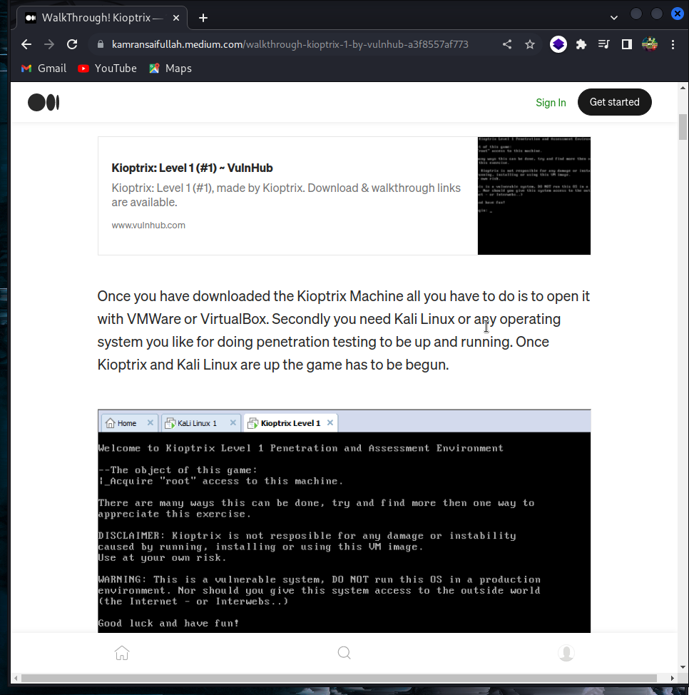

How to hide my ip(other than the cyber mentor)

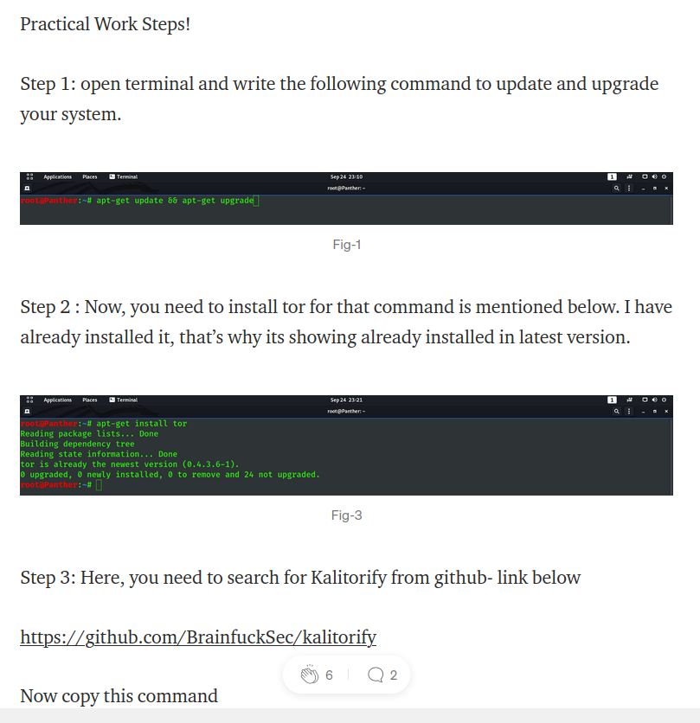

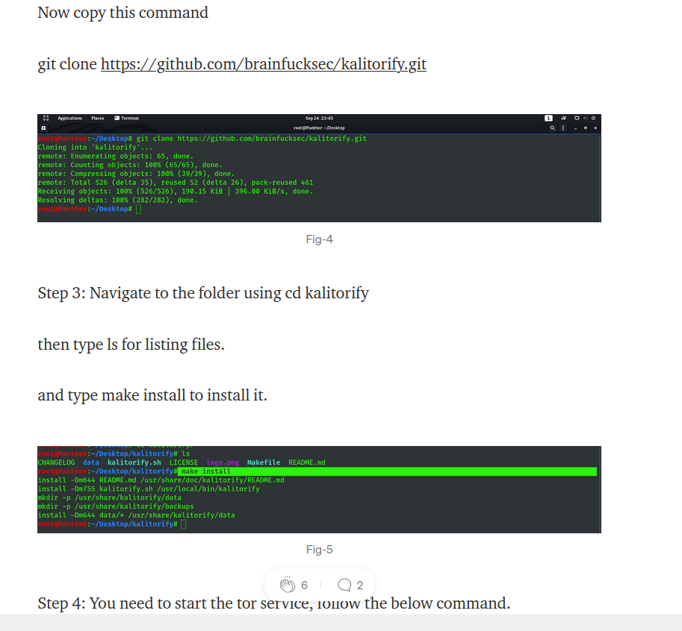

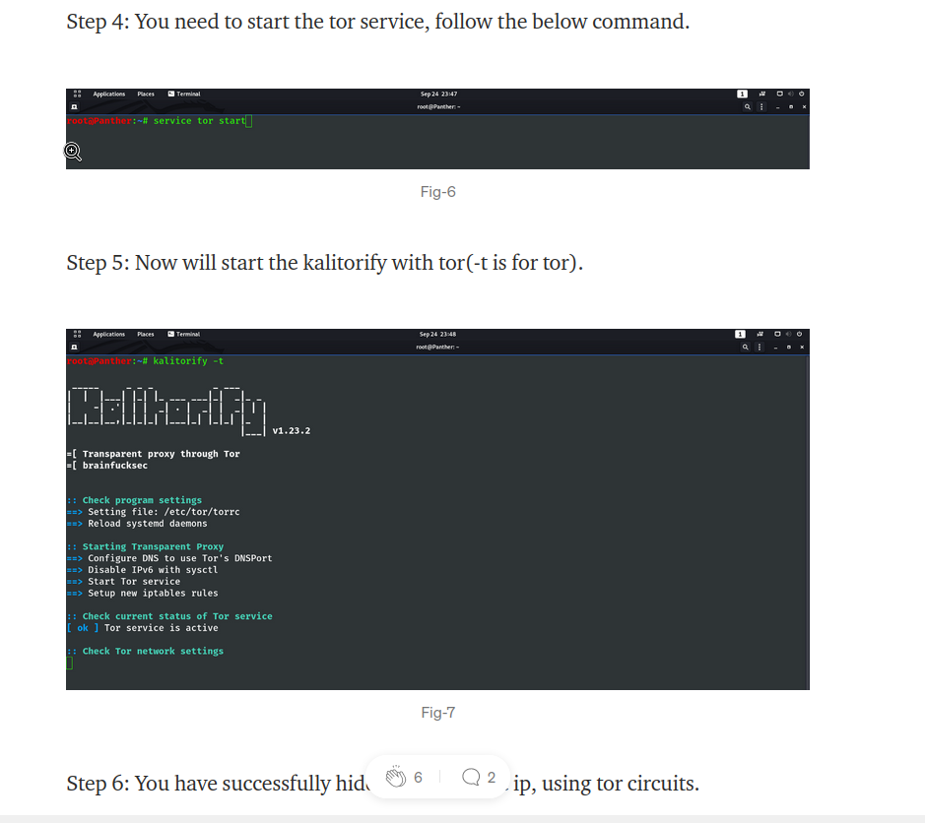

Now we have tor service to hide the public ip

Extras -------------------------

This is how we unzip a file.

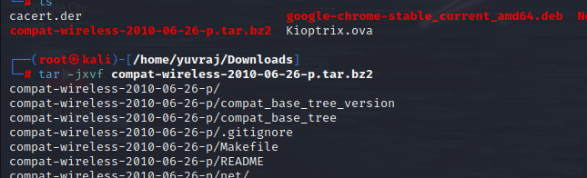

This is how we can unzip a .gz file





Now we have basically three solutions to make a wireless connection in our linux and this is through—

To purchase an external wifi adapter

--to use live linux using a pendrive and boot the linux in the pend-drive

To install linux directly to the hardive – basically I have to do a dual boot.

--due to unwanted shutdowm my system was not booting then I tried the following commands and also the reason for non-booting.

[The root filesystem on /dev/sda5 requires a manual fsck [duplicate]](https://askubuntu.com/questions/1256813/the-root-filesystem-on-dev-sda5-requires-a-manual-fsck)

It's showing this every time.

(i.e., without -a or -p options)

fsck exited with status code 4

The root filesystem on /dev/sda5 requires a manual fsck.

[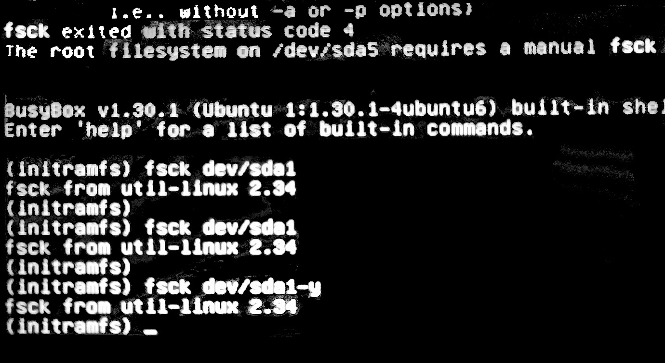](https://i.stack.imgur.com/s4FQr.jpg)

This indicates that a manual file system check should be done of your partition /dev/sda1. To attempt that, give the command

fsck -y /dev/sda1

then reboot with the reboot command.

Chances are it won't work. That a manual check is required points to pretty bad damage of the file system. Even if the file system can be returned to a consistent state, there is no certainty that no files have been damaged or are missing. Reformatting the partition and reinstalling the system is the only certain recovery option from this issue

So early shutdown or abnormal shutdown is harmful for the linux.